**LFEV-Y5**

v0.6

**Lafayette College: Electrical and Computer Engineering**

Acceptance Test Plan: v0.6

Greg Flynn

This document outlines all of the tests required to deliver LFEV-Y5. The plan is presented as an overview with the ATP number next to the test. This refers to the document that describes the test procedure. The requirements are from the SoW for 2017

08

**Fall**

Table of Contents

ATP overviews 6

Compliance Matrix 9

Deliverables 11

D000: PDR 11

D001: CDR 11

D002: User Manuals 11

D003: Final Report and Maintenance Manual 11

Final report 11

Maintenance manual 12

D004: ATP 13

D005: ATR 13

D007: Project Website 13

D008: Final Presentation and Delivery 13

D009: Conference Paper, Presentation, and Video 13

D010: Project Poster 14

D012: Software Maintainability Plan 14

D013: Purchasing Report 14

D014: Project Management and Status Letters 14

Waived or modified requirements and questions 15

ATP-01 checklist: Accumulator integration 16

ATP-02 checklist: Charging Accumulator 17

ATP-03 checklist: CAN Bus link 18

ATP-04 checklist: Safety loop 19

ATP-07 checklist: Shutdown 20

ATP-08 checklist: GLV grounding 21

ATP-09 checklist: Documentation 22

TSV: Pacman 23

TSV: AMS 23

TSV: Pack 23

TSV: Pack panel 24

TSV: Bus bar 24

TSV: Control panel PCB 24

TSI: Container 25

TSI: Front Panel 25

TSI: Back Panel 25

TSI: Bus bar 1 (AIR to connector) 26

TSI: Bus bar 2 (connector to connector) 26

TSI: PCB 26

TSI: Dyno panel 27

GLV: Container 28

GLV: Front panel 28

GLV: Back panel 28

GLV: PCB 29

GLV: Dyno panel 29

Cooling: Assembly 29

ATP-10 checklist: Hazmat 30

ATP-11 checklist: Safety practice 30

Wires 30

Internal wiring 30

W1 30

W2 30

W3 31

W6 32

W7 33

W11 33

W12 33

W13 34

W15 34

W18 34

W20 34

W21 34

W22 35

W23 35

W24 35

W25 35

W26 35

W28 36

W31 36

W32 37

W33 37

W34 37

W35 37

W36 37

Indicators 38

IMD fault light 38

Fault light 38

AIRs Light 38

Drive light 38

Safety light 38

Cruise light 39

High Voltage Present light 39

Grounded Low Voltage Present light 39

Tractive System Energized Light 39

Tractive System Active Light 39

Brake light 40

Buttons and switches 40

FWD/REV switch 40

Driver Reset 40

Driver BRB 40

Inertial switch 40

Drive button 41

Cruise button 41

Scroll button 41

Select button 41

GLV Master Switch 41

TSV Master Switch 42

RHSBRB 42

RHS MReset 42

LHSBRB 42

PCBs 43

AMS 43

Pacman 43

TSI PCB 43

GLV PCB 43

Fuses 44

Accumulator fuse 44

Pacman fuse 44

TSI precharge relay fuse 44

GLV high current fuse 44

GLV low current fuse 45

Enclosures 46

Pack 46

TSI 46

GLV 46

ATP-12 checklist: Maintainability 47

Software 47

Pacman code 47

AMS code 47

VSCADA code 47

Cell application code 48

TSI code 48

Remote software code 48

Hardware 49

Packs 49

TSI 49

GLV 49

Cooling 49

ATP-13 checklist: Demonstration 50

ATP-14 checklist: Disposal 51

Formula-Hybrid 2016 Electrical Inspection 52

Accumulator Data 53

ACCUMULATOR DATA FOR BATTERIES 53

ACCUMULATOR DATA FOR CAPACITORS 53

Preliminary Electrical Inspection (required prior to Mechanical Inspection) 54

Operating Voltage 54

Safety Circuit 54

Indicator Operation 54

TSMPs 54

Ground Low Voltage 55

Vehicle Grounding 55

Tractive System Wiring 55

TSMPs 55

Indicators and Safety Labels 55

Safety Components 55

Full Inspection: Documentation/ESF 58

Full Electrical: Inspection 61

Full Electrical: Pouch Cells 63

Final Demonstration 64

Inspectors Reference 67

# ATP overviews

None of these tests can be viewed as completed until appropriate documentation has been uploaded to the webpage.

|  |  |  |  |  |
| --- | --- | --- | --- | --- |
| Item | Item description | Demonstrated Requirements | Successful Test Criteria | Verification Method |
| ATP-01 | Accumulator integration | R001a  R001c  R001d  R001e  R002a  R002c  R004a (TSV part)  R005a  R005b (Manual) | Packs power motor and all telemetry is recorded by VSCADA. Control by using the throttle.  Verify by accelerating and looking at dash, pack screens, and log files remotely | Test |
| ATP-02 | Charging Accumulator | R001b  R001g  R002b  R002h | Packs charge by the charging port and open the safety loop  VSCADA reacts correctly  Verify by looking at the dash | Test |
| ATP-03 | CAN Bus link | R002a  R002c  R002d  R002e  R002f  R002g  R002j  R002k  R003a(8)  R003d  R004a (CAN Bus part)  R005a (CAN Bus part)  R005c (CAN Bus part)  R007c  R007d | DAQ by VSCADA of TSI, GLV, TSV, Cooling. Verify by looking at cell phone and looking at dash and remote computer in each mode of VSCADA. All DAQ methods should happen simultaneously | Test |
| ATP-04 | Safety loop | R001g  R002b  R002c  R002d  R002k  R002m  R003b  R003c  R003d  R004a (Safety loop part)  R005c (IMD fault)  R007b | Fault by:  Crashing  BRB  IMD  Cooling  VSCADA limit  Pack fault  Throttle fault  Brake fault  User defined limit (warn)  User defined limit (halt)  Pack charging  Verify by looking at the dash, the remote computer and the cellphone | Test |
| ~~ATP-05~~ | ~~Cruise Control~~ | ~~R002l~~  ~~R005b (Software)~~ | ~~Motor can maintain desired speed~~  ~~Verify by checking motor speed compared to target~~ | ~~Test~~ |
| ~~ATP-06~~ | ~~24h endurance test~~ | ~~GPR006~~ | ~~At the end of all other tests leave the car running for 24h~~ | ~~Test~~ |
| ATP-07 | Shutdown | R002k  R002i | VSCADA works after unexpected GLV shutdown  All hardware in safe state  Packs stop powering motor with GLV shutdown  TSI works after unexpected TSV shutdown | Test |
| ATP-08 | GLV grounding | R003a(2) | Ensure that there is only 1 connection between ground and chassis ground | Inspection |
| ATP-09 | Documentation | GRP001 | Complete and accurate documentation | Inspection |
| ATP-10 | Hazmat | GPR004 | No hazardous materials used | Analysis |
| ATP-11 | Safety practice | GPR005 | Good practice used for safety | Inspection |
| ATP-12 | Maintainability | GPR007 | Ensure that the project is maintainable | Analysis and test |
| ATP-13 | Demonstration | GPR011 | Have a video and demo setup | Inspection |
| ATP-14 | Disposal | GPR012 | Dispose of all materials as required | Inspection |

# Compliance Matrix

All requirements should also have a QA by each subsystem before integration.

|  |  |
| --- | --- |
| Requirement | Test(s) to demonstrate acceptance |
| R001a | ATP-01 |
| R001b | ATP-02 OR https://sites.lafayette.edu/ece492-sp16/files/2016/05/QAR001b.pdf |
| R001c | ATP-01 |
| R001d | ATP-01 |
| R001e | ATP-01 |
| R001f | https://sites.lafayette.edu/ece492-sp16/files/2016/05/QAR001e.pdf |
| R001g | ATP-02 |
| R002a | ATP-01 or ATP-03 |
| R002b | ATP-02 |
| R002c | ATP-01 OR ATP-03 OR ATP-04 |
| R002d | ATP-01 OR ATP-03 OR ATP-04 |
| R002e | ATP-03 |
| R002f | ATP-03 |
| R002g | ATP-03 |
| R002h | ATP-02 OR ATP-03 |
| R002i | ATP-02 |
| R002j | ATP-03 |
| R002k | ATP-03 |
| R002l | Waived |
| R002m | ATP-04 |
| R003a(1) | Any ATP |
| R003a(2) | ATP-08 |
| R003a(3) | QA by GLV |
| R003a(4) | ATP-02 |
| R003a(5) | ATP-02 |
| R003a(5) | ATP-02 |
| R003a(6) | ATP-02 |
| R003a(7) | ATP-02 |
| R003a(8) | ATP-03 |
| R003b | ATP-04 |
| R003c | QA by GLV |
| R003d | ATP-03 |
| R004a | ATP-01 AND ATP-03 AND ATP-04 |
| R004b | QA by Interconnect |
| R005a | ATP-01 AND ATP-03 |
| R005b | ATP-01 AND ATP-07 |
| R005c | ATP-04 |
| R005d | QA by TSI |
| R006 | Any ATP |
| R007a | QA by Cooling |
| R007b | ATP-04 |
| R007c | ATP-03 |
| R007d | ATP-03 |
| R007e | Waived |
| R007f | QA by Cooling |
| R007g | QA by Cooling |
| GPR001 | ATP-09 |
| GPR003 | Waived |
| GPR004 | ATP-10 |
| GPR005 | ATP-11 (MTBF + power waived) |
| GPR006 | ATP-06 and ATP-11 |
| GRP007 | ATP-12 |
| GPR008 | ATP-09 |
| GPR011 | ATP-13 |
| GPR012 | ATP-14 |

# Deliverables

## D000: PDR

<https://sites.lafayette.edu/ece492-sp17/files/2017/01/PDR_Presentation_v2.pdf>

## D001: CDR

<https://sites.lafayette.edu/ece492-sp17/files/2017/02/2017_CDR_Presentation.pdf>

## D002: User Manuals

Note this is a checklist for the video

|  |  |  |  |  |
| --- | --- | --- | --- | --- |
| System | Getting started | FAQ | Functions and controls | Troubleshooting calibration and maintenance |
| TSI |  |  |  |  |
| TSV |  |  |  |  |
| GLV |  |  |  |  |
| Cooling |  |  |  |  |
| VSCADA |  |  |  |  |
| Dyno room |  |  |  |  |

Attach link to each of the videos to demonstrate competing the deliverable.

## D003: Final Report and Maintenance Manual

### Final report

|  |  |
| --- | --- |
| Check | Completed |
| Maintenance manuals completed |  |
| 3x DVD presented (or flash drive) |  |
| DVD artwork |  |
| ATP-09 completed |  |

Attach image of DVD or flash drive. Attach link to the final report with all of the documentation.

### Maintenance manual

|  |  |  |  |  |  |  |  |
| --- | --- | --- | --- | --- | --- | --- | --- |
| Part | TSI | TSV | GLV | Cool | VSCADA | Dyno | Andriod |
| Maintenance |  |  |  |  |  |  |  |
| Calibration |  |  |  |  |  |  |  |
| PCB schematic |  |  |  |  |  |  |  |
| PCB BOM |  |  |  |  |  |  |  |
| Mechanical drawing |  |  |  |  |  |  |  |
| Mechanical BOM |  |  |  |  |  |  |  |
| Block diagram |  |  |  |  |  |  |  |
| Wiring diagram |  |  |  |  |  |  |  |
| Gerber files |  |  |  |  |  |  |  |
| QA testing |  |  |  |  |  |  |  |
| Principal of operation |  |  |  |  |  |  |  |
| Software binaries |  |  |  |  |  |  |  |
| Software source |  |  |  |  |  |  |  |
| Software make file |  |  |  |  |  |  |  |
| ATP-12 completed |  |  |  |  |  |  |  |

Attach link to each of the maintenance manuals for this document.

## D004: ATP

|  |  |
| --- | --- |
| Check | Completed |
| Compliance matrix |  |
| Forms present |  |

<http://sites.lafayette.edu/ece492-sp17/testing/atp/>

## D005: ATR

|  |  |
| --- | --- |
| Check | Completed |
| All tests included |  |
| Test date for all tests |  |
| Photos as required |  |
| Tester named |  |
| Witness signature if available |  |
| Test results |  |

Attach link to the ATR.

## D007: Project Website

|  |  |
| --- | --- |
| Check | Completed |
| All documents as portable static documents (PDF/TXT/XML) |  |
| Original version present |  |
| Links to any cloud storage |  |

Attach link to the site for each document required.

## D008: Final Presentation and Delivery

|  |  |
| --- | --- |
| Check | Completed |
| GPR006 |  |
| GPR007 |  |
| GPR008 |  |
| GPR011 |  |
| D010 |  |
| Video for D009 |  |
| Video of GPR011 |  |
| Delivered per GPR012 |  |
| Any other items disposed per GPR012 |  |

Links to the final presentation provided. Link to the video.

## D009: Conference Paper, Presentation, and Video

|  |  |
| --- | --- |
| Check | Completed |
| Conference video compiled |  |
| Conference paper submitted |  |
| Conference delivered |  |

Link to the paper. Link to the video.

## D010: Project Poster

|  |  |
| --- | --- |
| Check | Completed |
| Poster dimensions 47"x35" |  |
| QR code to webpage |  |
| Web link present |  |

Link to the poster provided.

## D012: Software Maintainability Plan

<https://sites.lafayette.edu/ece492-sp17/files/2017/02/MaintainabilityPlanFinal.pdf>

## D013: Purchasing Report

|  |  |
| --- | --- |
| Check | Completed |
| Table for all purchases |  |
| Summary based on team |  |
| Summary based on week |  |

Link to purchasing reports provided.

## D014: Project Management and Status Letters

|  |  |
| --- | --- |
| Check | Completed |
| Status letter submitted |  |
| WBS delivered |  |

Link to WBS and status letter provided.

# Waived or modified requirements and questions

|  |  |
| --- | --- |
| Requirement | Reason |
| R003a(4) | Cannot tell if GLV is from the battery or 24VDC |
| R002h | Cannot tell if GLV is from the battery or 24VDC |
| R007e | Waived |
| R005d | We’ve changed the switches |
| R002l | Waived |
| GPR003 | Waived |
| GPR005 | (Power and MTBF/MTTR waived) |

# ATP-01 checklist: Accumulator integration

|  |  |
| --- | --- |
| Test | Pass |
| 1. Packs can deliver 200A through TSI |  |
| 1. Voltage measured at TSVMP is as expected |  |
| 1. Throttle controls RPM |  |
| 1. Throttle implausibility causes exit of drive mode |  |
| 1. Two moves required to enter drive mode |  |
| 1. Throttle and brake together prevent drive mode from starting |  |
| 1. Throttle and brake together exit drive mode |  |
| 1. TSAL lights come on when HV present outside packs |  |
| 1. TSEL lights come on when AIRS closed |  |
| 1. RTDS come on for 1-3 seconds when drive mode entered |  |
| 1. HV present light comes on when HV present |  |
| 1. Packs display telemetry on screen |  |
| 1. VSCADA can set the throttle |  |
| 1. VSCADA can set the valve on the dyno |  |

Pass count: /14

|  |  |
| --- | --- |
| (Test) Variable to measure | Value |
| (a) Current according to current sensor |  |
| (a+l) Current according to pack 1 |  |
| (a+l) Current according to pack 2 |  |
| (a+l) Current according to pack 3 |  |
| (a+l) Current according to pack 4 |  |
| (a) Current according to TSI |  |
| (b) Voltage at TSVMP with 50A load |  |
| (b) Voltage at TSVMP with no draw |  |
| (c) Max RPM |  |
| (d) APPS1 voltage at implausibility |  |
| (d) APPS2 voltage at implausibility |  |
| (m) Max RPM |  |
| (n) Max torque |  |

# ATP-02 checklist: Charging Accumulator

|  |  |
| --- | --- |
| Test | Pass |
| 1. Safety loop opens when charging |  |
| 1. Dash board shows that packs are charging |  |
| 1. Packs can be left charging after they are full |  |
| 1. VSCADA can acquire charging graphs |  |

Pass count: /4

Attach VSCADA data dump showing voltage and current with respect to time. This should be an excel document with data as well as a graph.

# ATP-03 checklist: CAN Bus link

|  |  |  |  |
| --- | --- | --- | --- |
| Test | Seen by VSCADA | Seen by Remote | Seen by android |
| Cell Temperature | /28 | /28 | /28 |
| Cell Voltage | /28 | /28 | /28 |
| Pack Current | /4 | /4 | /4 |
| Pack SoC | /4 | /4 | /4 |
| Pack Status | /4 | /4 | /4 |
| Pack Voltage | /4 | /4 | /4 |
| GLV Voltage |  |  |  |
| GLV SoC |  |  |  |
| GLV Current |  |  |  |
| GLV Temperature |  |  |  |
| Safety loop status |  |  |  |
| RPM gauge (Dyno) |  |  |  |
| Strain gauge |  |  |  |
| Throttle position |  |  |  |
| Brake status |  |  |  |
| IMD resistance |  |  |  |
| FWD/REV status |  |  |  |
| Precharge status |  |  |  |
| MC temp |  |  |  |
| MC current |  |  |  |
| Cooling temp in |  |  |  |
| Cooling flow |  |  |  |
| Cooling temp out |  |  |  |
| TSI temp |  |  |  |
| Speed |  |  |  |
| Safety loop status |  |  |  |

Pass count: /78

Attach excel document of data for VSCADA receiving data. Attach graphs from the android application. Attach screen shots of the remote computer in operation.

# ATP-04 checklist: Safety loop

|  |  |  |  |  |
| --- | --- | --- | --- | --- |
| Fault | Safety loop trip  (Fault lit) | Seen on VSCADA | Seen on Remote | Seen on Android |
| Driver resettable BRB |  |  |  |  |
| Non driver resettable BRB |  |  |  |  |
| Crash protection |  |  |  |  |
| Over temperature cooling |  |  |  |  |
| Under flow cooling |  |  |  |  |
| IMD fault |  |  |  |  |
| Cell overtemp |  |  |  |  |
| Cell overcurrent |  |  |  |  |
| Cell overvoltage |  |  |  |  |
| Cell undervoltage |  |  |  |  |
| Brake overtravel |  |  |  |  |
| VSCADA defined violation |  |  |  |  |

Pass count: /48

Add logs from VSCADA showing faults. Add screen shots from the remote computer showing the faults. Add screen shots from the android application showing the faults.

# ATP-07 checklist: Shutdown

|  |  |
| --- | --- |
| Test | Pass |
| VSCADA powers up with no user input |  |
| GLV shutdown prevents TSV being present at TSVMP |  |
| TSVMS shutdown prevents TSV being present at TSVMP |  |
| VSCADA has recorded data up to the shutdown |  |
| TSVMS shutdown while under load does not create any issues |  |
|  |  |

Pass count: /5

Shutdown time (yyyy-mm-dd hh:mm:ss UTC):

Attach log from VSCADA showing data up until GLV shutdown.

# ATP-08 checklist: GLV grounding

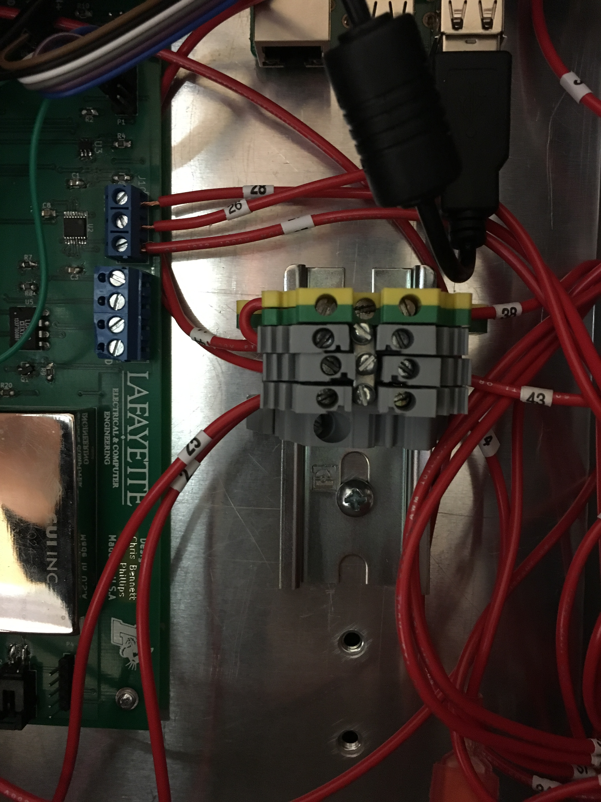

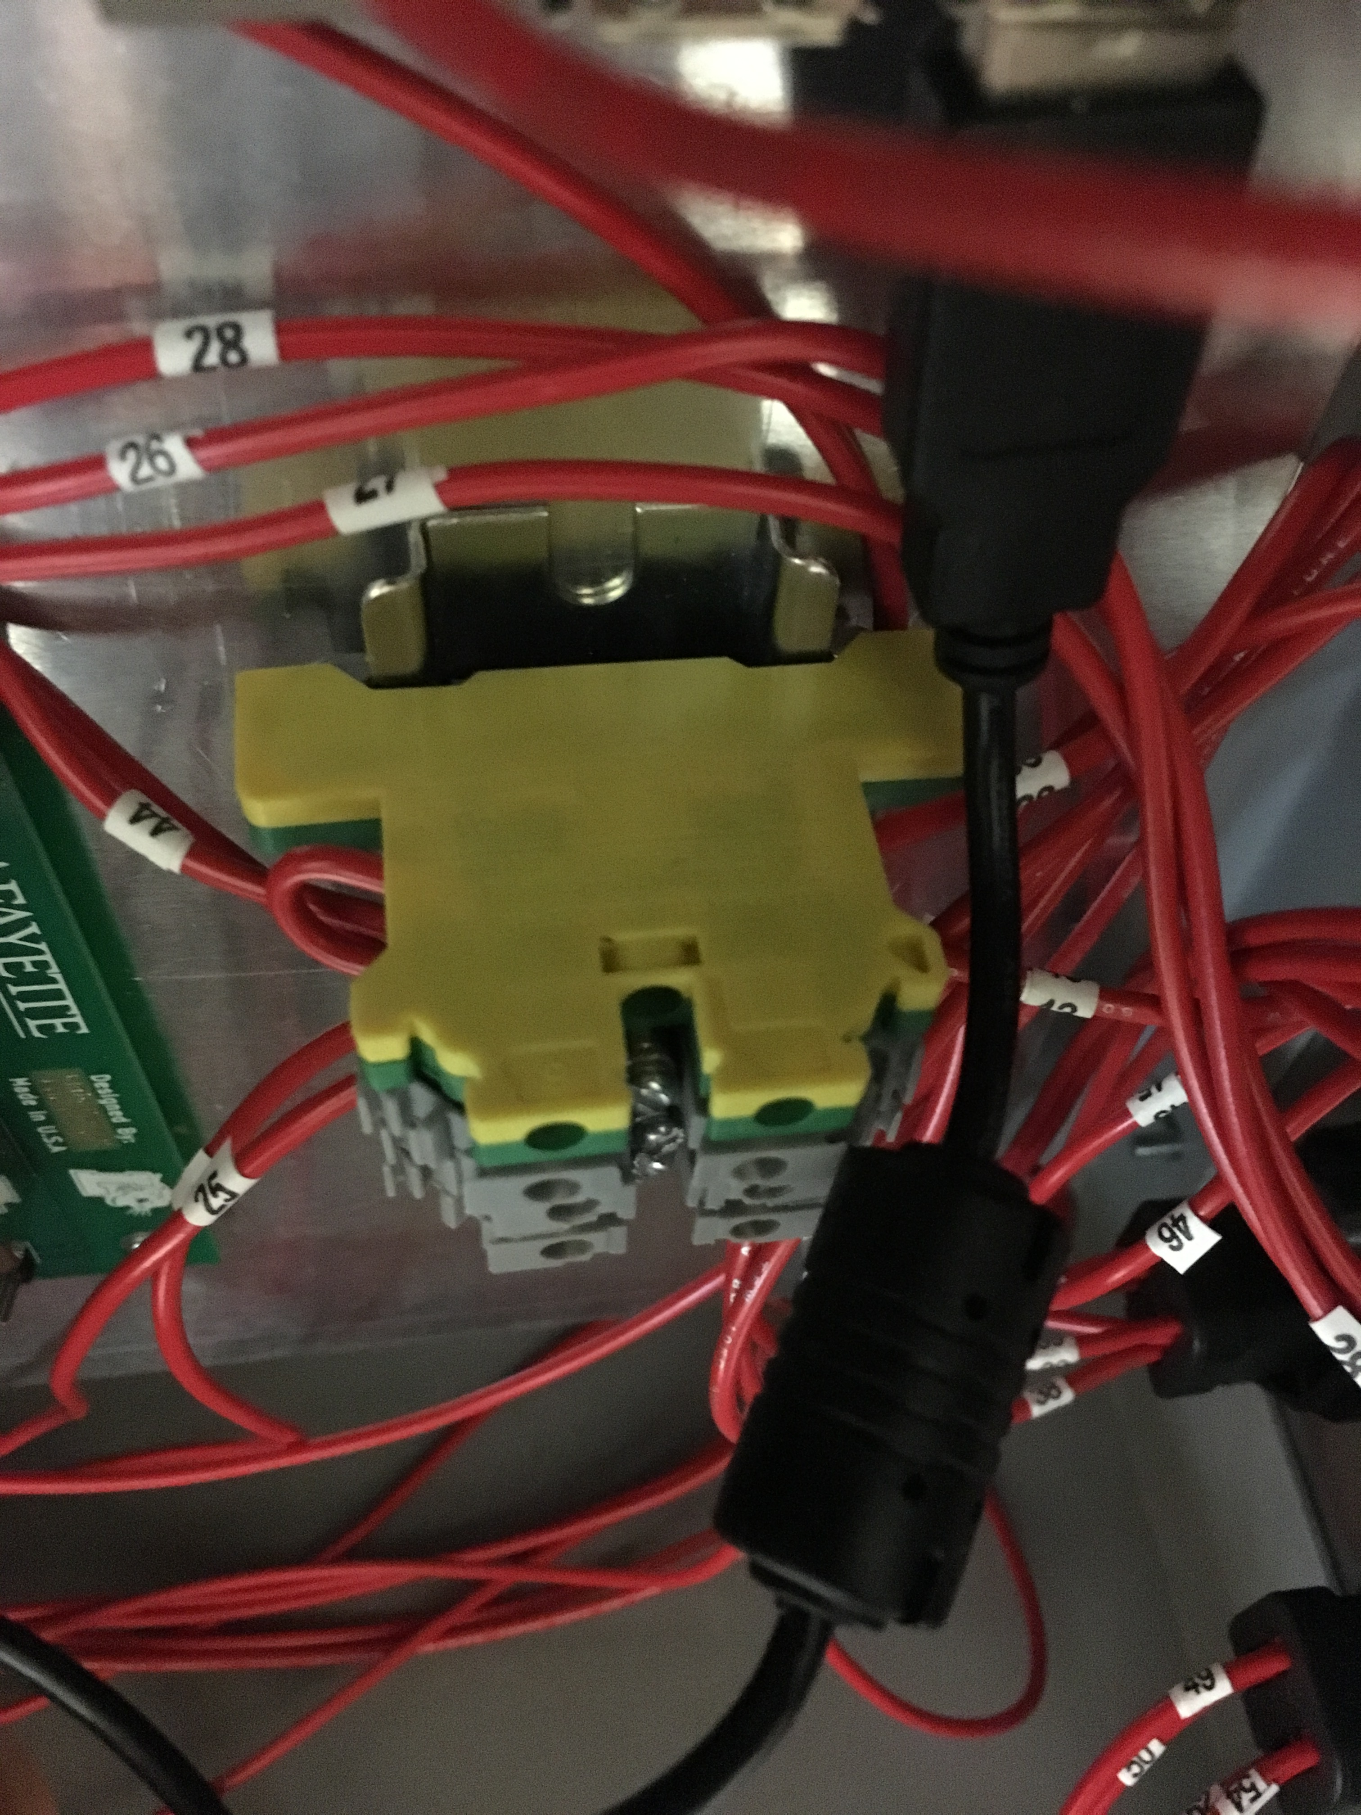

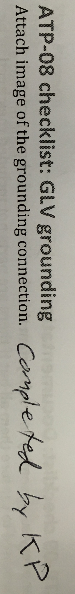

# ATP-09 checklist: Documentation

For every subassembly in a subsystem this checklist should be completed. I have attempted to capture them all but if there are parts not included they need to be added. Part numbers should go in a tree structure all the way down to commercial parts.

## TSV: Pacman

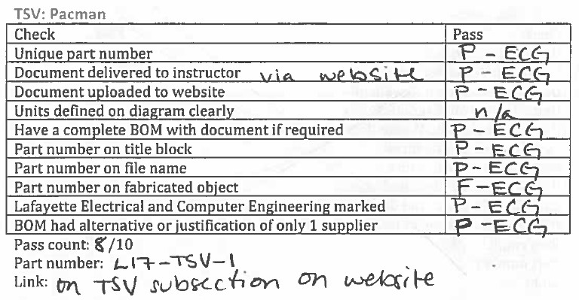

## TSV: AMS

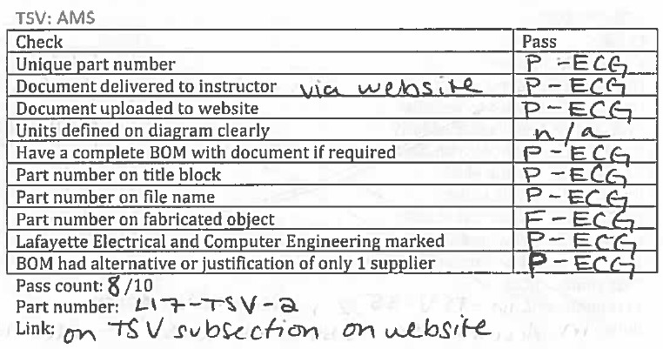

## TSV: Control panel PCB

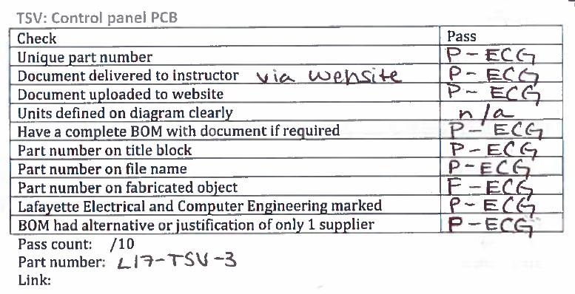

## TSV: Cell Retainer Positive End

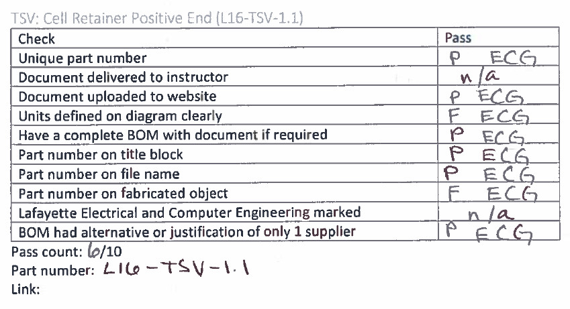

## TSV: Cell Retainer Negative End

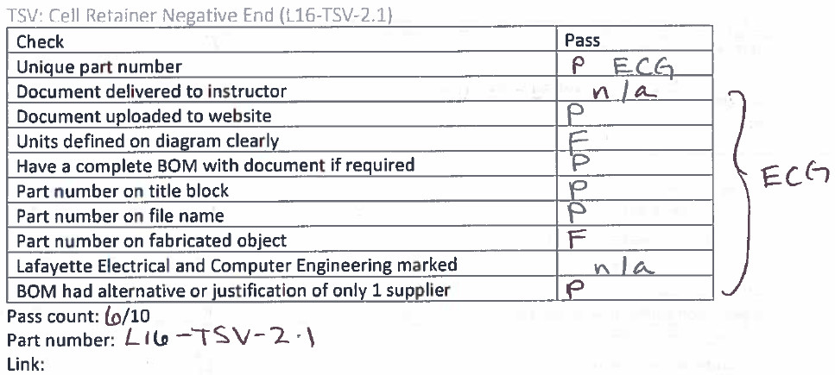

## TSV: Top Bar of Cell Retainer

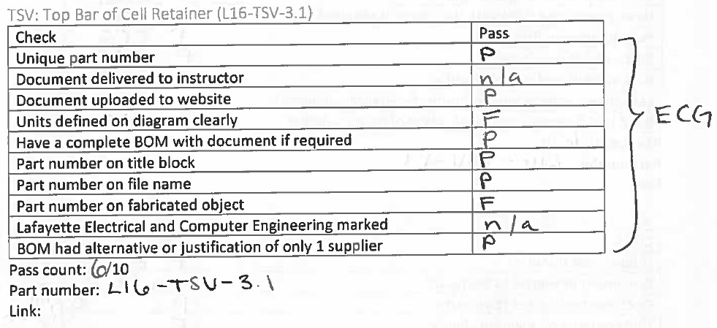

## TSV: Top Bar of Cell Retainer

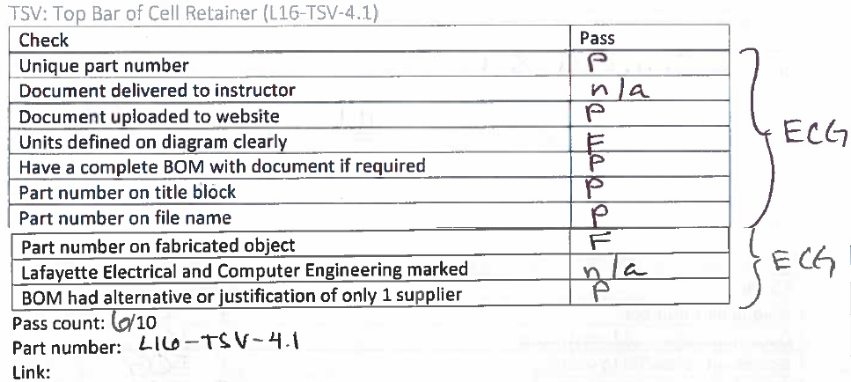

## TSV: Mid Cell Internal Wall

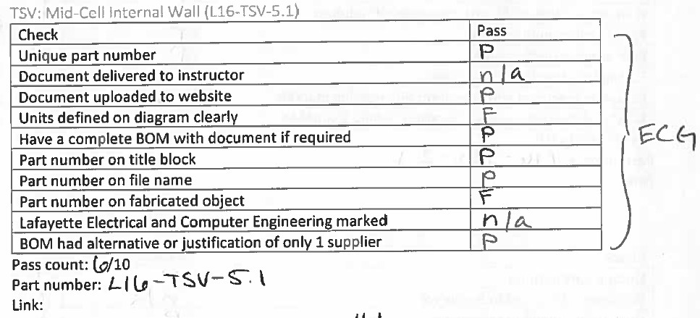

## TSV: Mounting Bar of Internal Wall

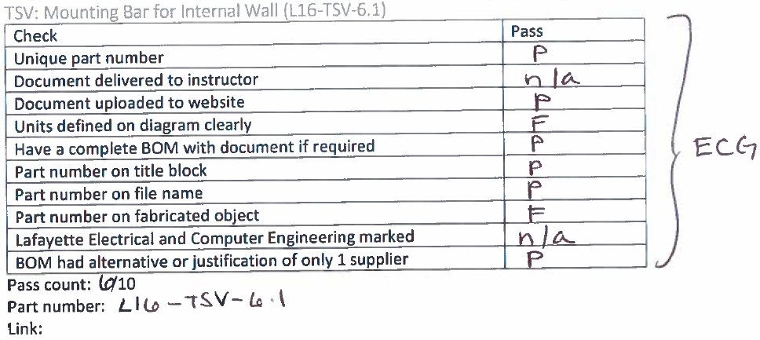

## TSV: Side Bar of Cells

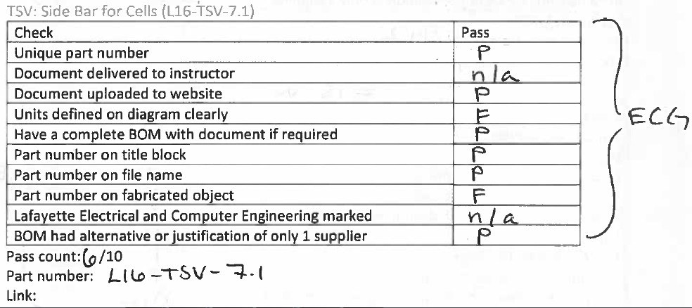

## TSV: T-Slot Aluminum Extrusion Long

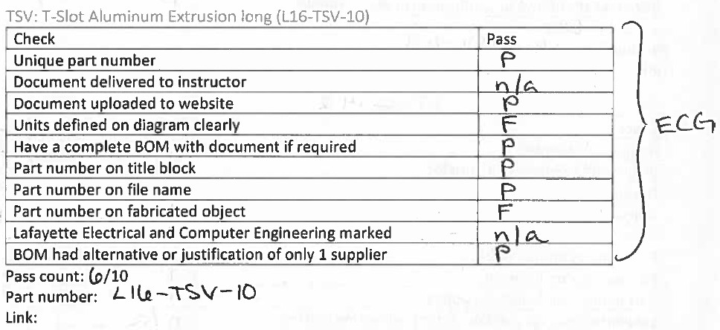

## TSV: T-Slot Aluminum Extrusion Short

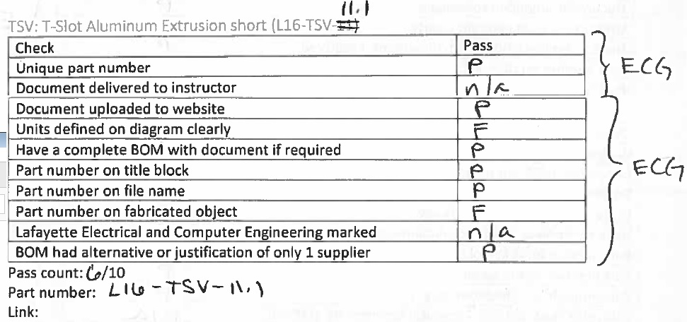

## TSV: Pack Top Negative End

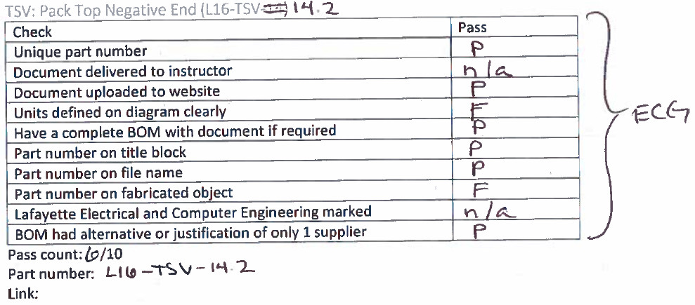

## TSV: Pack Top Positive End

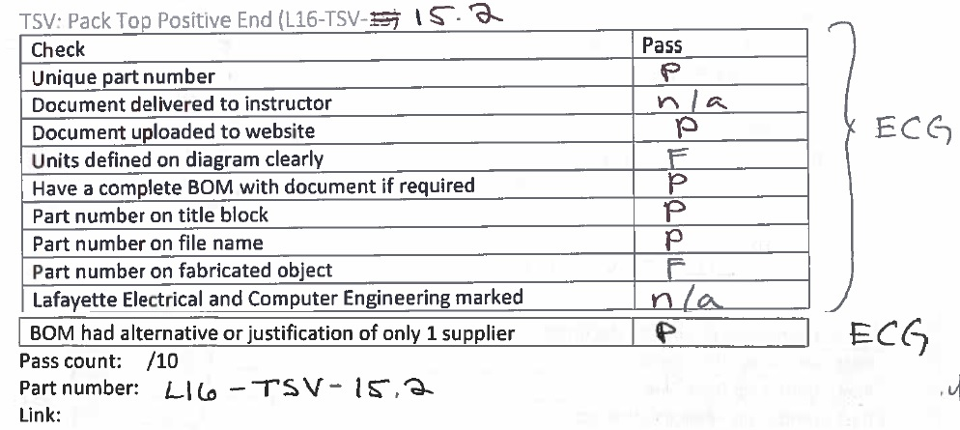

## TSV Front Exterior Side Panel

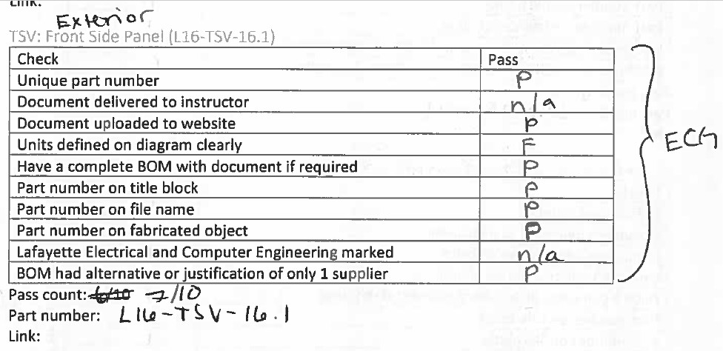

## TSV: Back Exterior Side Panel

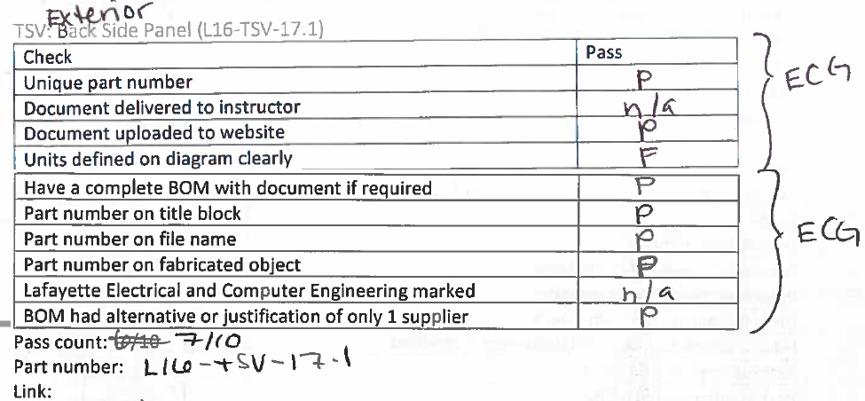

## TSV Internal Bottom Plate

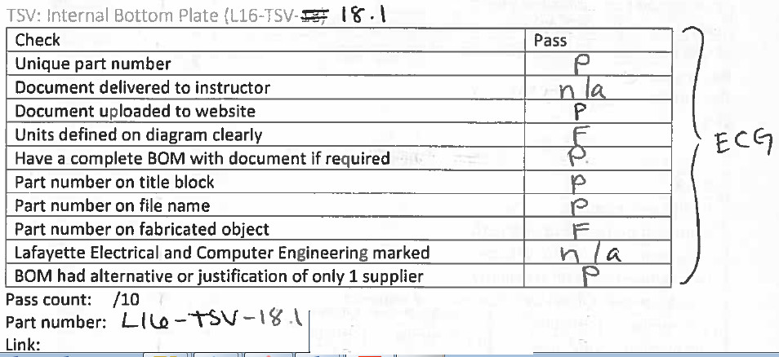

## TSV Left Side Panel (PacMAN & Fan)

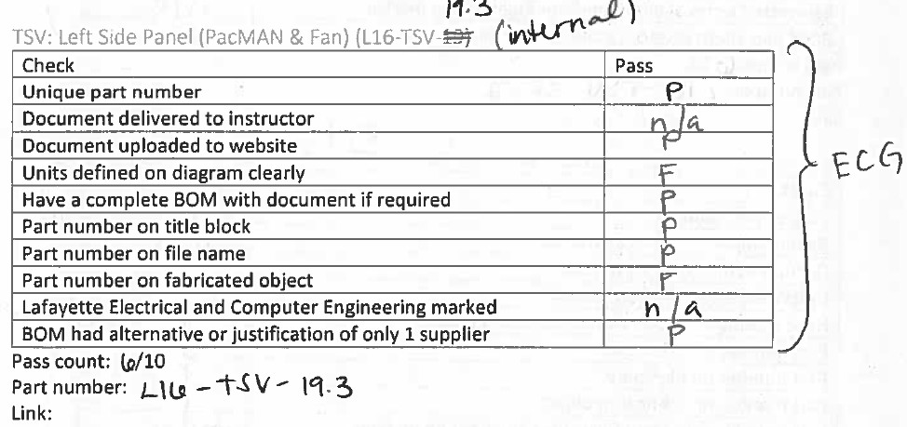

## TSV Connector Panel Negative Side

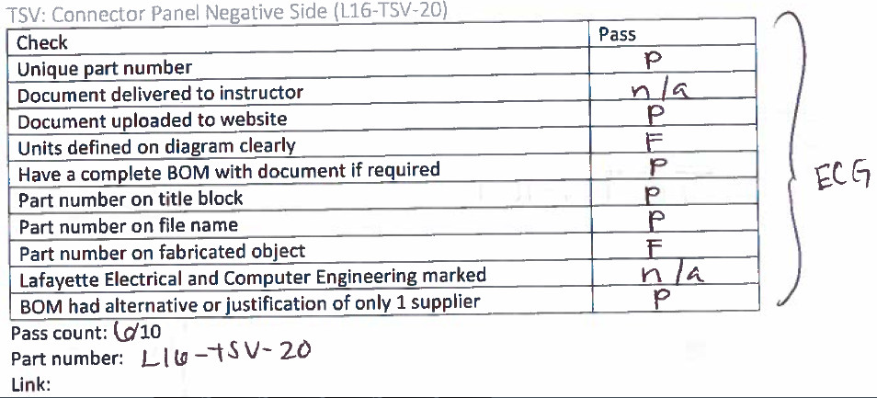

## TSV: Connector Panel Positive Side

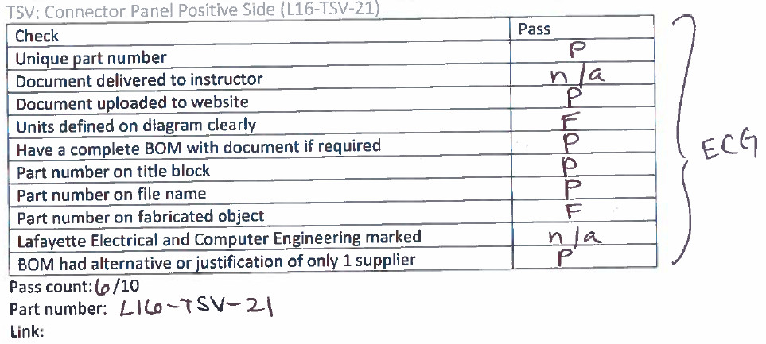

## TSV: Exterior Panel

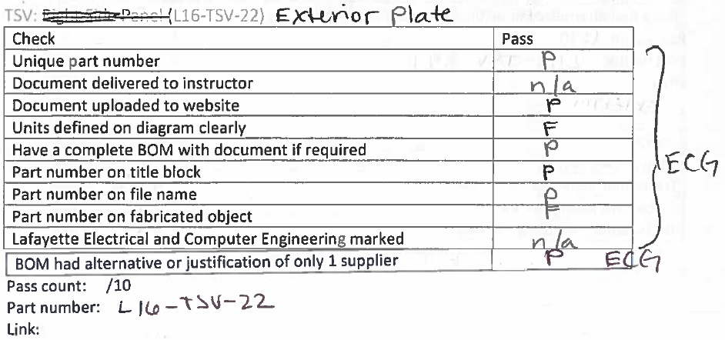

## TSV: LCD Cover Plate

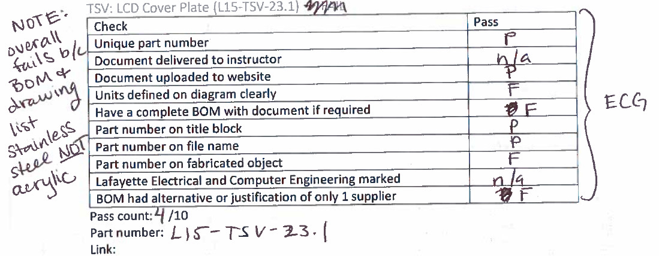

## TSV: Right Side Panel

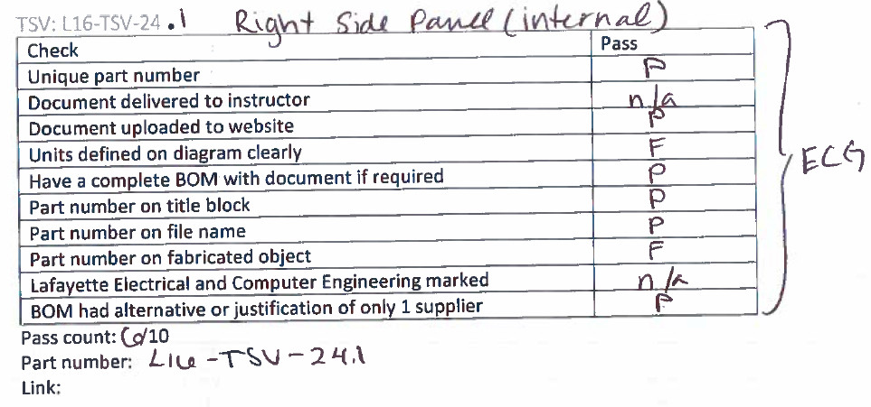

## TSV: HV to AIRS connector (L-shaped Conductor)

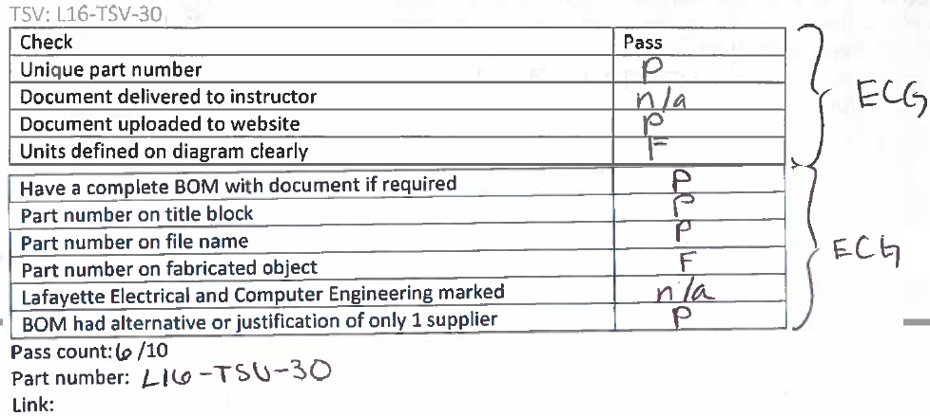

## TSV: AIRs Replacement Bar

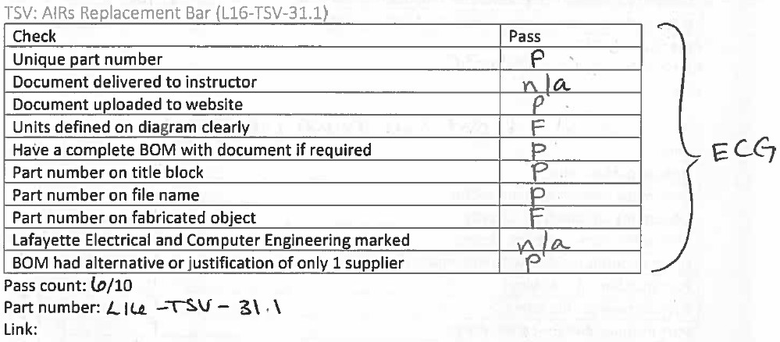

## TSV: Relay to fuse connector

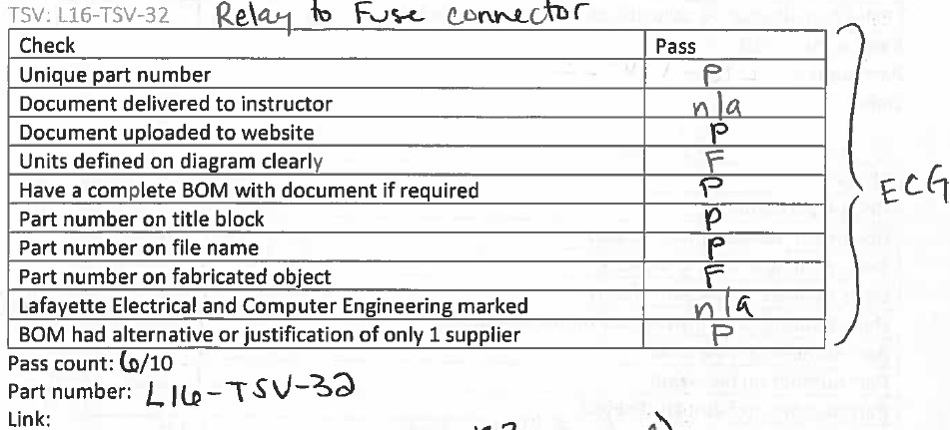

## TSV: Rounded fuse bus bar (shortened)

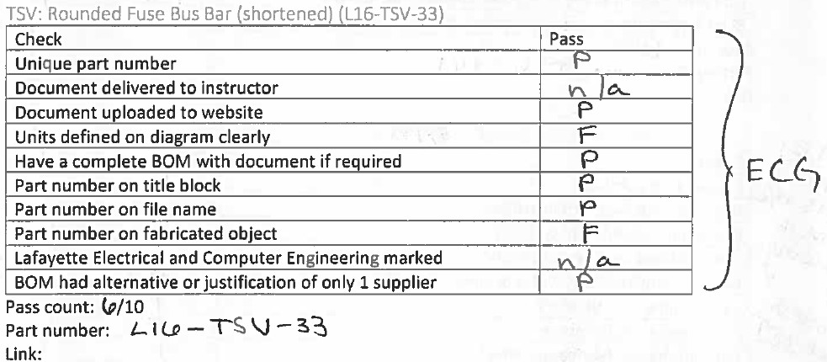

## TSV: Aluminum Jumper Slotted (Bus Bar)

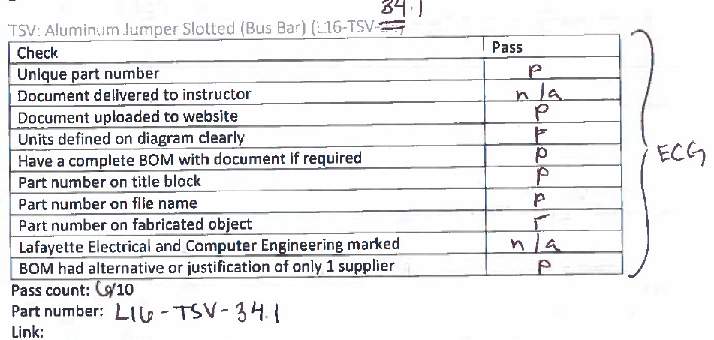

## TSV: Middle Aluminum Jumper Slotted (Bus Bar) (Extended)

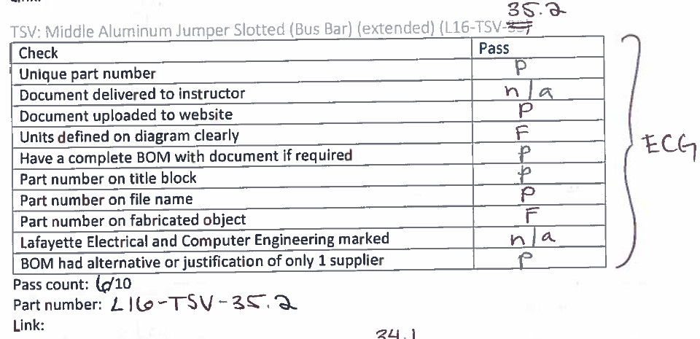

## TSV: Slotted Bus Bar

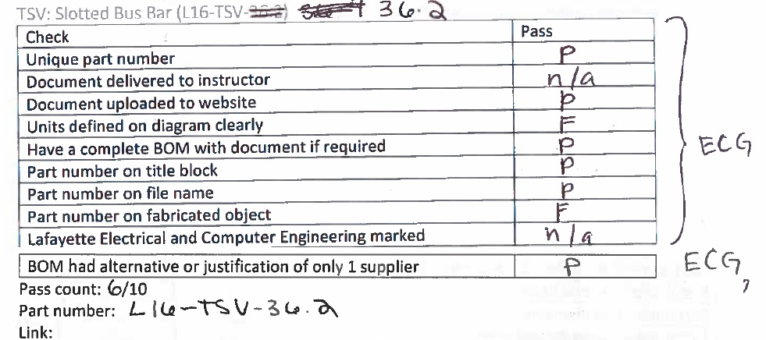

## TSV: LCD Bracket

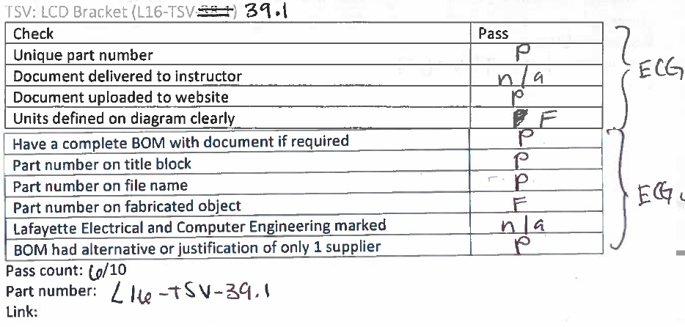

## TSV: AIRs Replacement Bar Mount

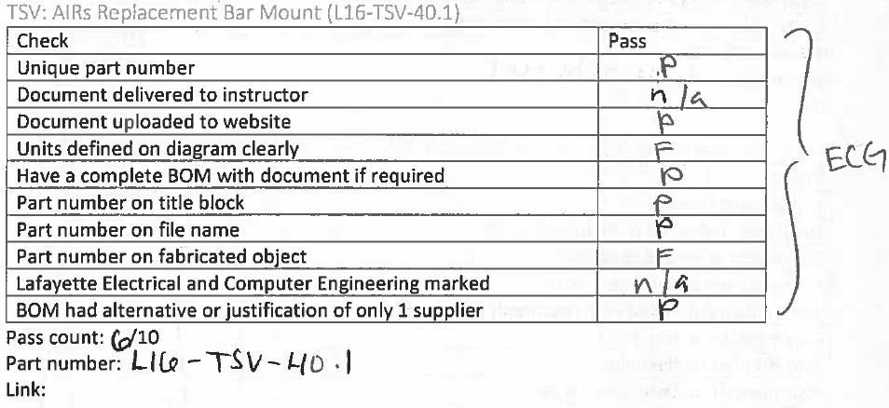

## TSV: AIRs Replacement Bar Mount

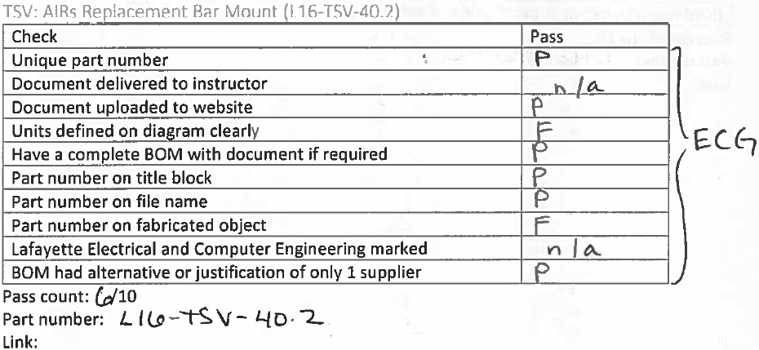

## TSV: AIRs Extender

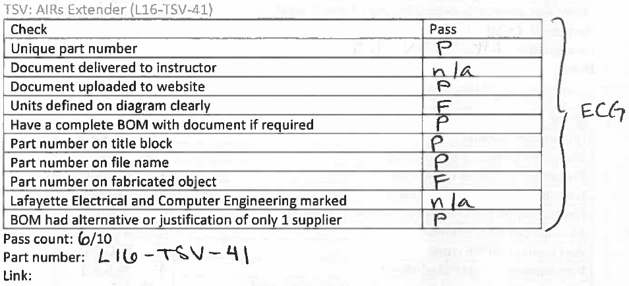

## TSV: Replacement Bar (Mounting)

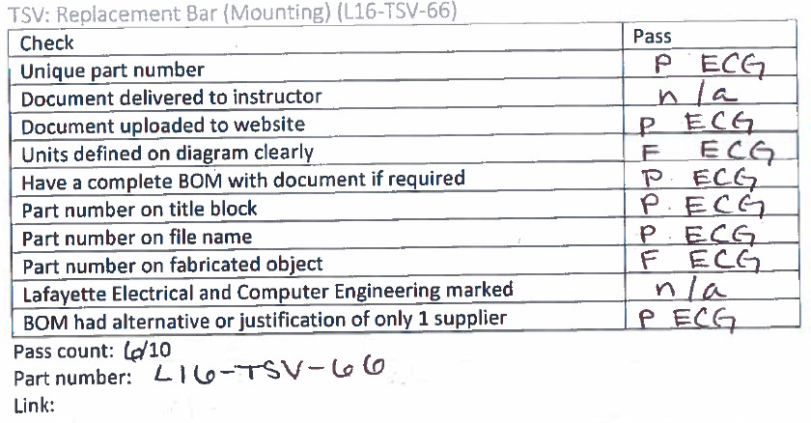

## TSV: Replacement Bar 2 (Mounting)

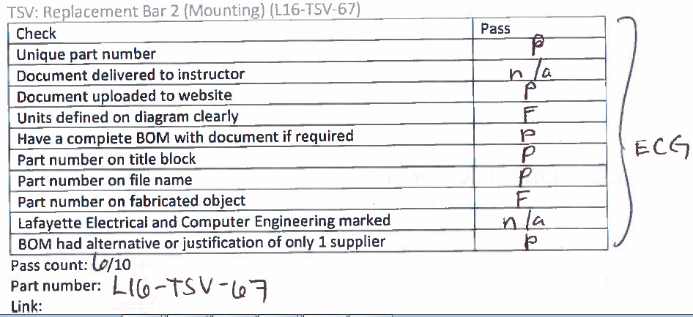

## TSV: Replacement Bar 3 (Mounting)

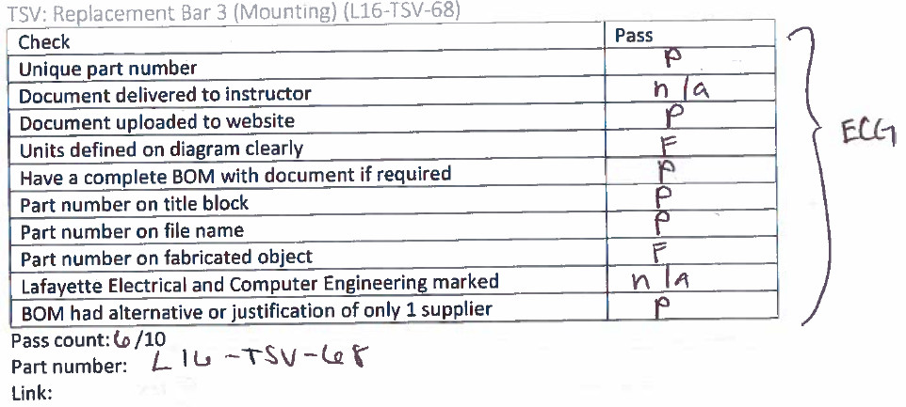

## TSV: Replacement Bar 4 (Mounting)

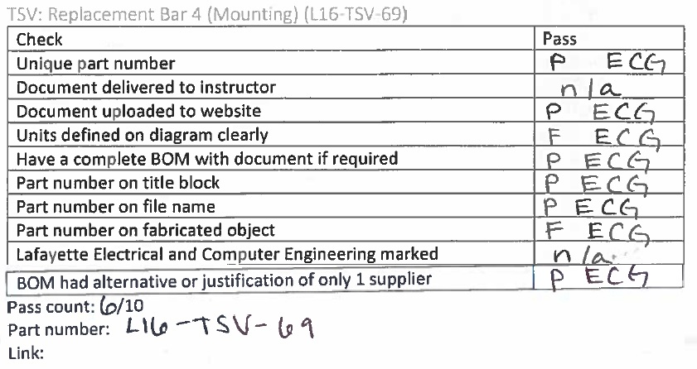

## TSI: Container

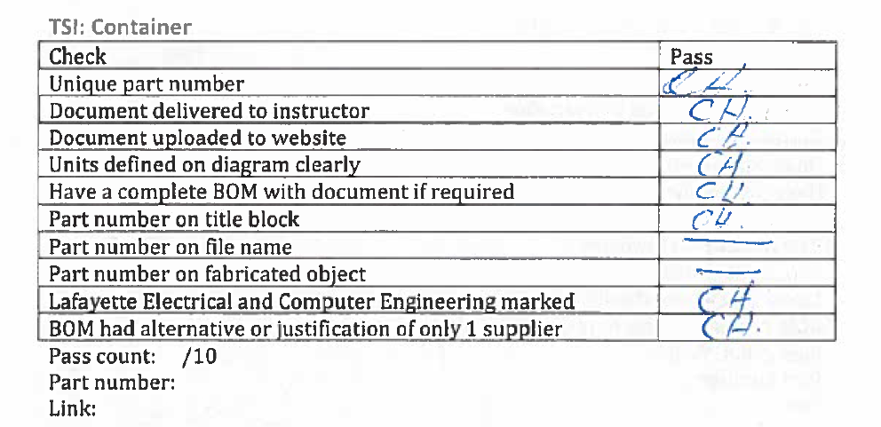

## TSI: Front Panel

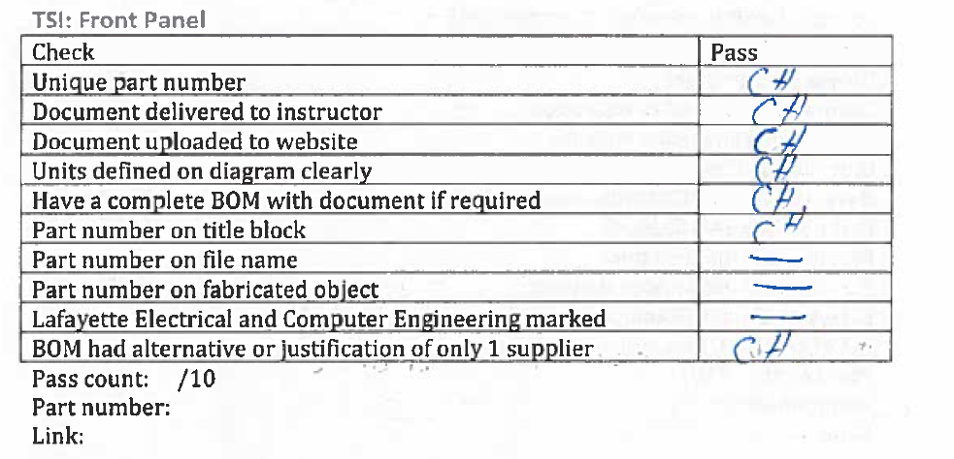

## TSI: Back Panel

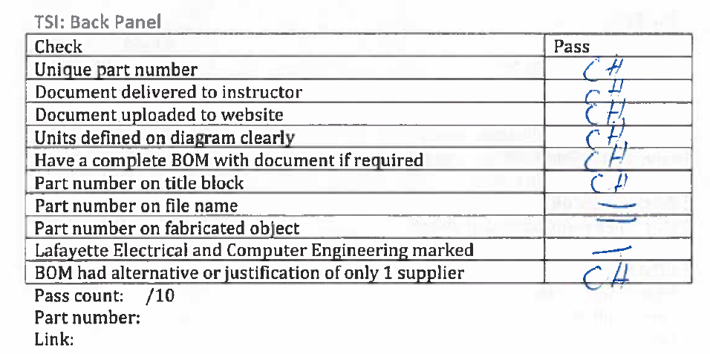

## TSI: Bus bar 1 (AIR to connector)

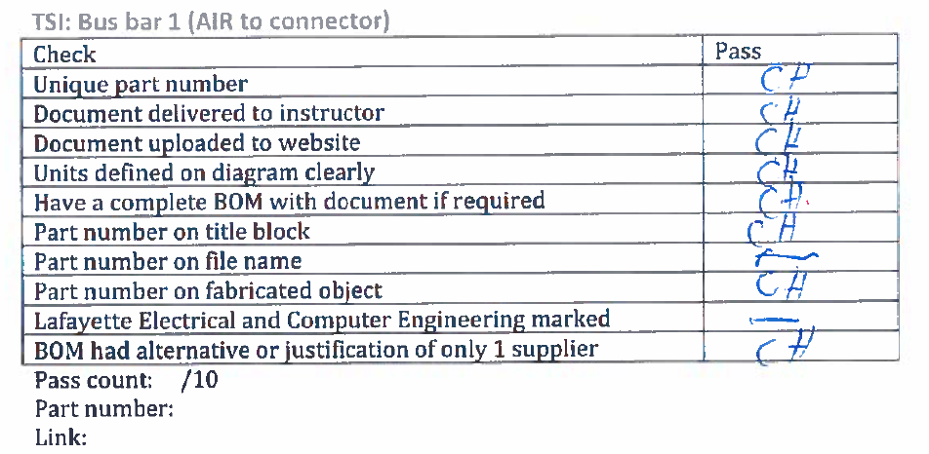

## TSI: Bus bar 2 (connector to connector)

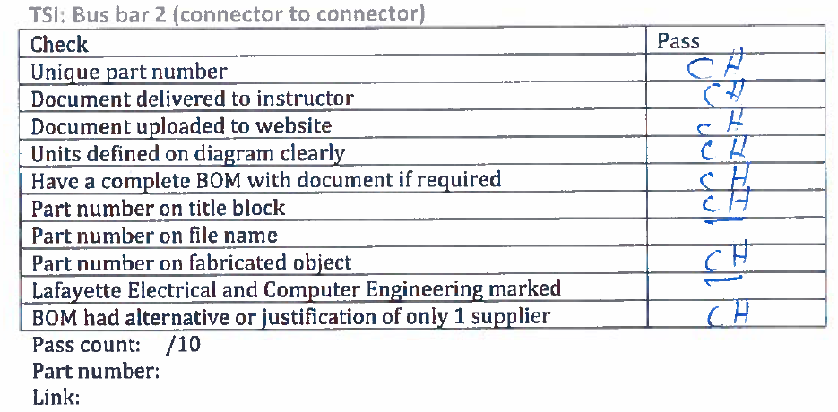

## TSI: PCB

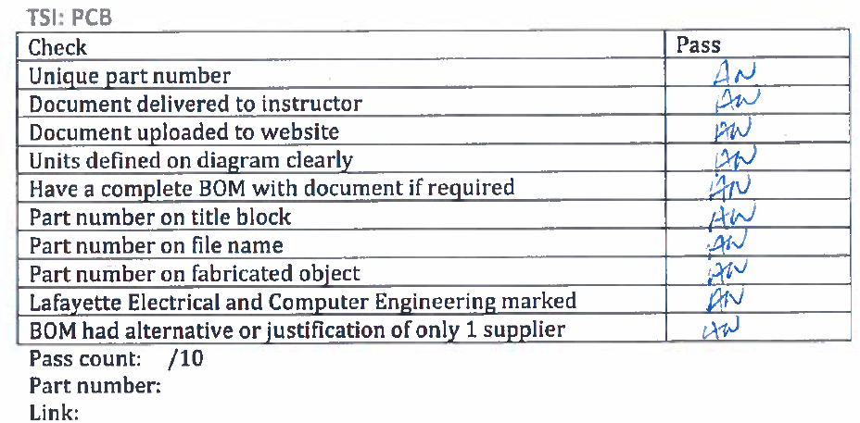

## TSI: Dyno panel

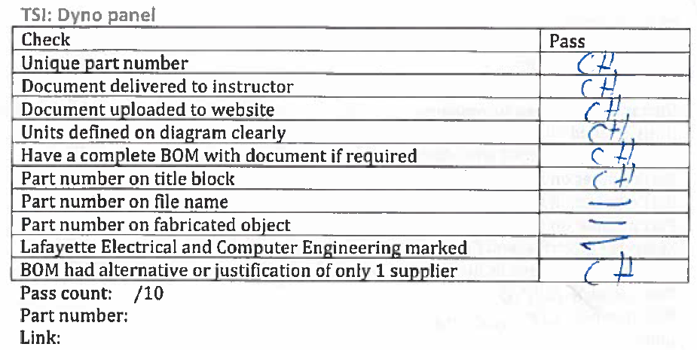

## GLV: Container

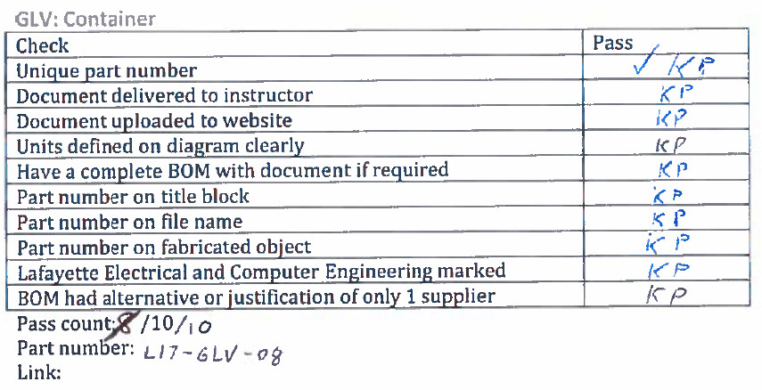

## GLV: Front panel

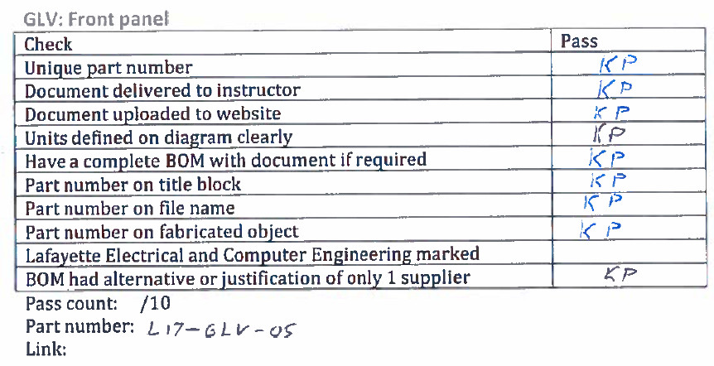

## GLV: Back panel

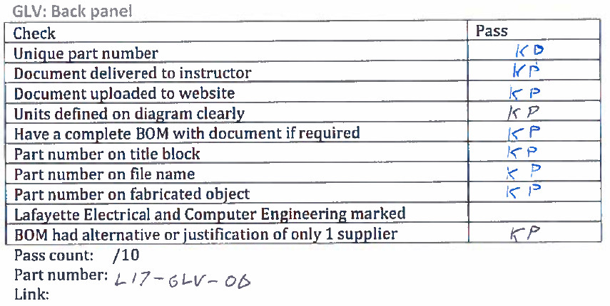

## GLV: PCB

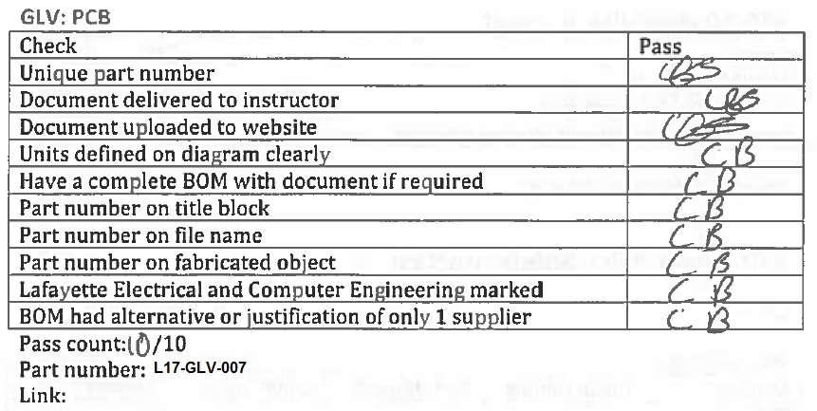

## GLV: Dyno panel

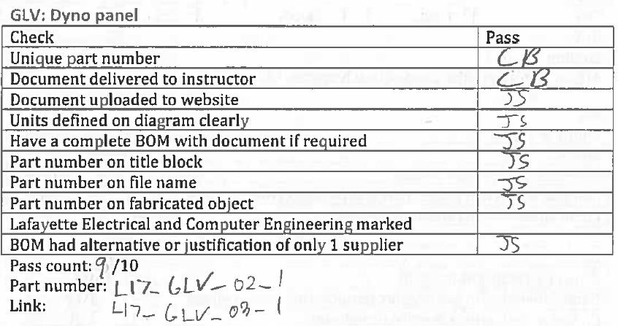

## Cooling: Assembly

|  |  |
| --- | --- |
| Check | Pass |
| Unique part number |  |
| Document delivered to instructor |  |
| Document uploaded to website |  |
| Units defined on diagram clearly |  |
| Have a complete BOM with document if required |  |
| Part number on title block |  |
| Part number on file name |  |
| Part number on fabricated object |  |
| Lafayette Electrical and Computer Engineering marked |  |
| BOM had alternative or justification of only 1 supplier |  |

Pass count: /10

Part number:

Link:

# ATP-10 checklist: Hazmat

|  |  |
| --- | --- |
| Check | Pass |
| All PCBs are RoHS |  |
| No NiCd/Pb-Acid batteries |  |
| Dispose pre 2002/96/EC WEEE Directive |  |

Attach link to hazmat documentation.

# ATP-11 checklist: Safety practice

## Wires

### Internal wiring

|  |  |  |  |  |
| --- | --- | --- | --- | --- |
| System | Clean cabling | No rats-nest | Color coded | Labeled |
| TSI |  |  |  |  |
| TSV |  |  |  |  |
| GLV |  |  |  |  |
| Cooling |  |  |  |  |

Attach pictures of the inside of each system to document.

### W1

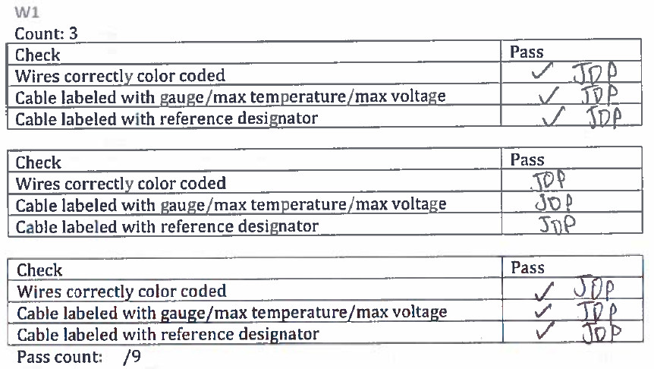

Attach image as evidence

### 

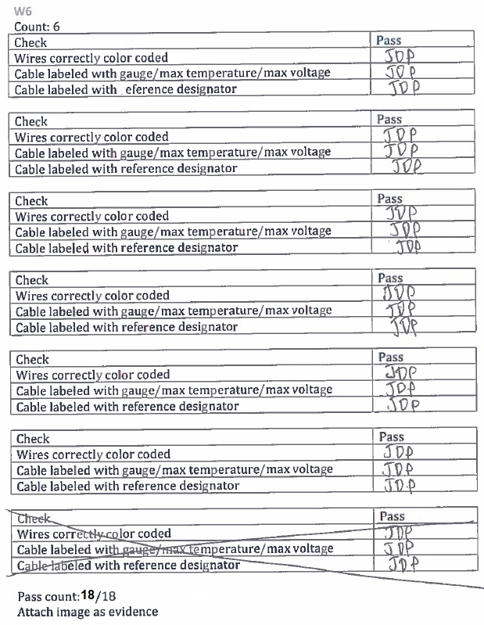

### W15

Count: 1

|  |  |
| --- | --- |
| Check | Pass |
| Wires correctly color coded |  |
| Cable labeled with gauge/max temperature/max voltage |  |
| Cable labeled with reference designator |  |

Pass count: /3

Attach image as evidence

### 

### W22

Count: 1

|  |  |
| --- | --- |
| Check | Pass |
| Wires correctly color coded |  |
| Cable labeled with gauge/max temperature/max voltage |  |
| Cable labeled with reference designator |  |

Pass count: /3

Attach image as evidence

### W24

Count: 1

|  |  |
| --- | --- |
| Check | Pass |
| Wires correctly color coded |  |
| Cable labeled with gauge/max temperature/max voltage |  |
| Cable labeled with reference designator |  |

Pass count: /3

Attach image as evidence

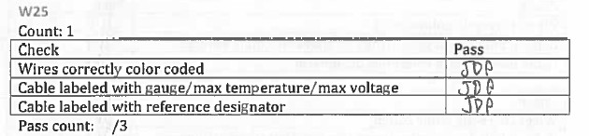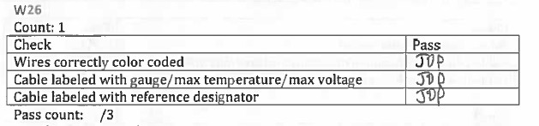

### 

## Indicators

### IMD fault light

|  |  |
| --- | --- |
| Check | Pass |
| Clear indicator of function |  |
| Red LED |  |
| Located in cockpit |  |
| Illuminates when IMD resistance is low |  |

Pass count: /4

Attach image of illuminated light

### Fault light

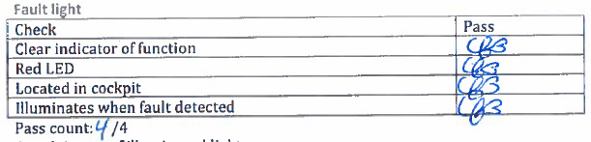

### AIRs Light

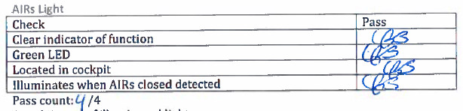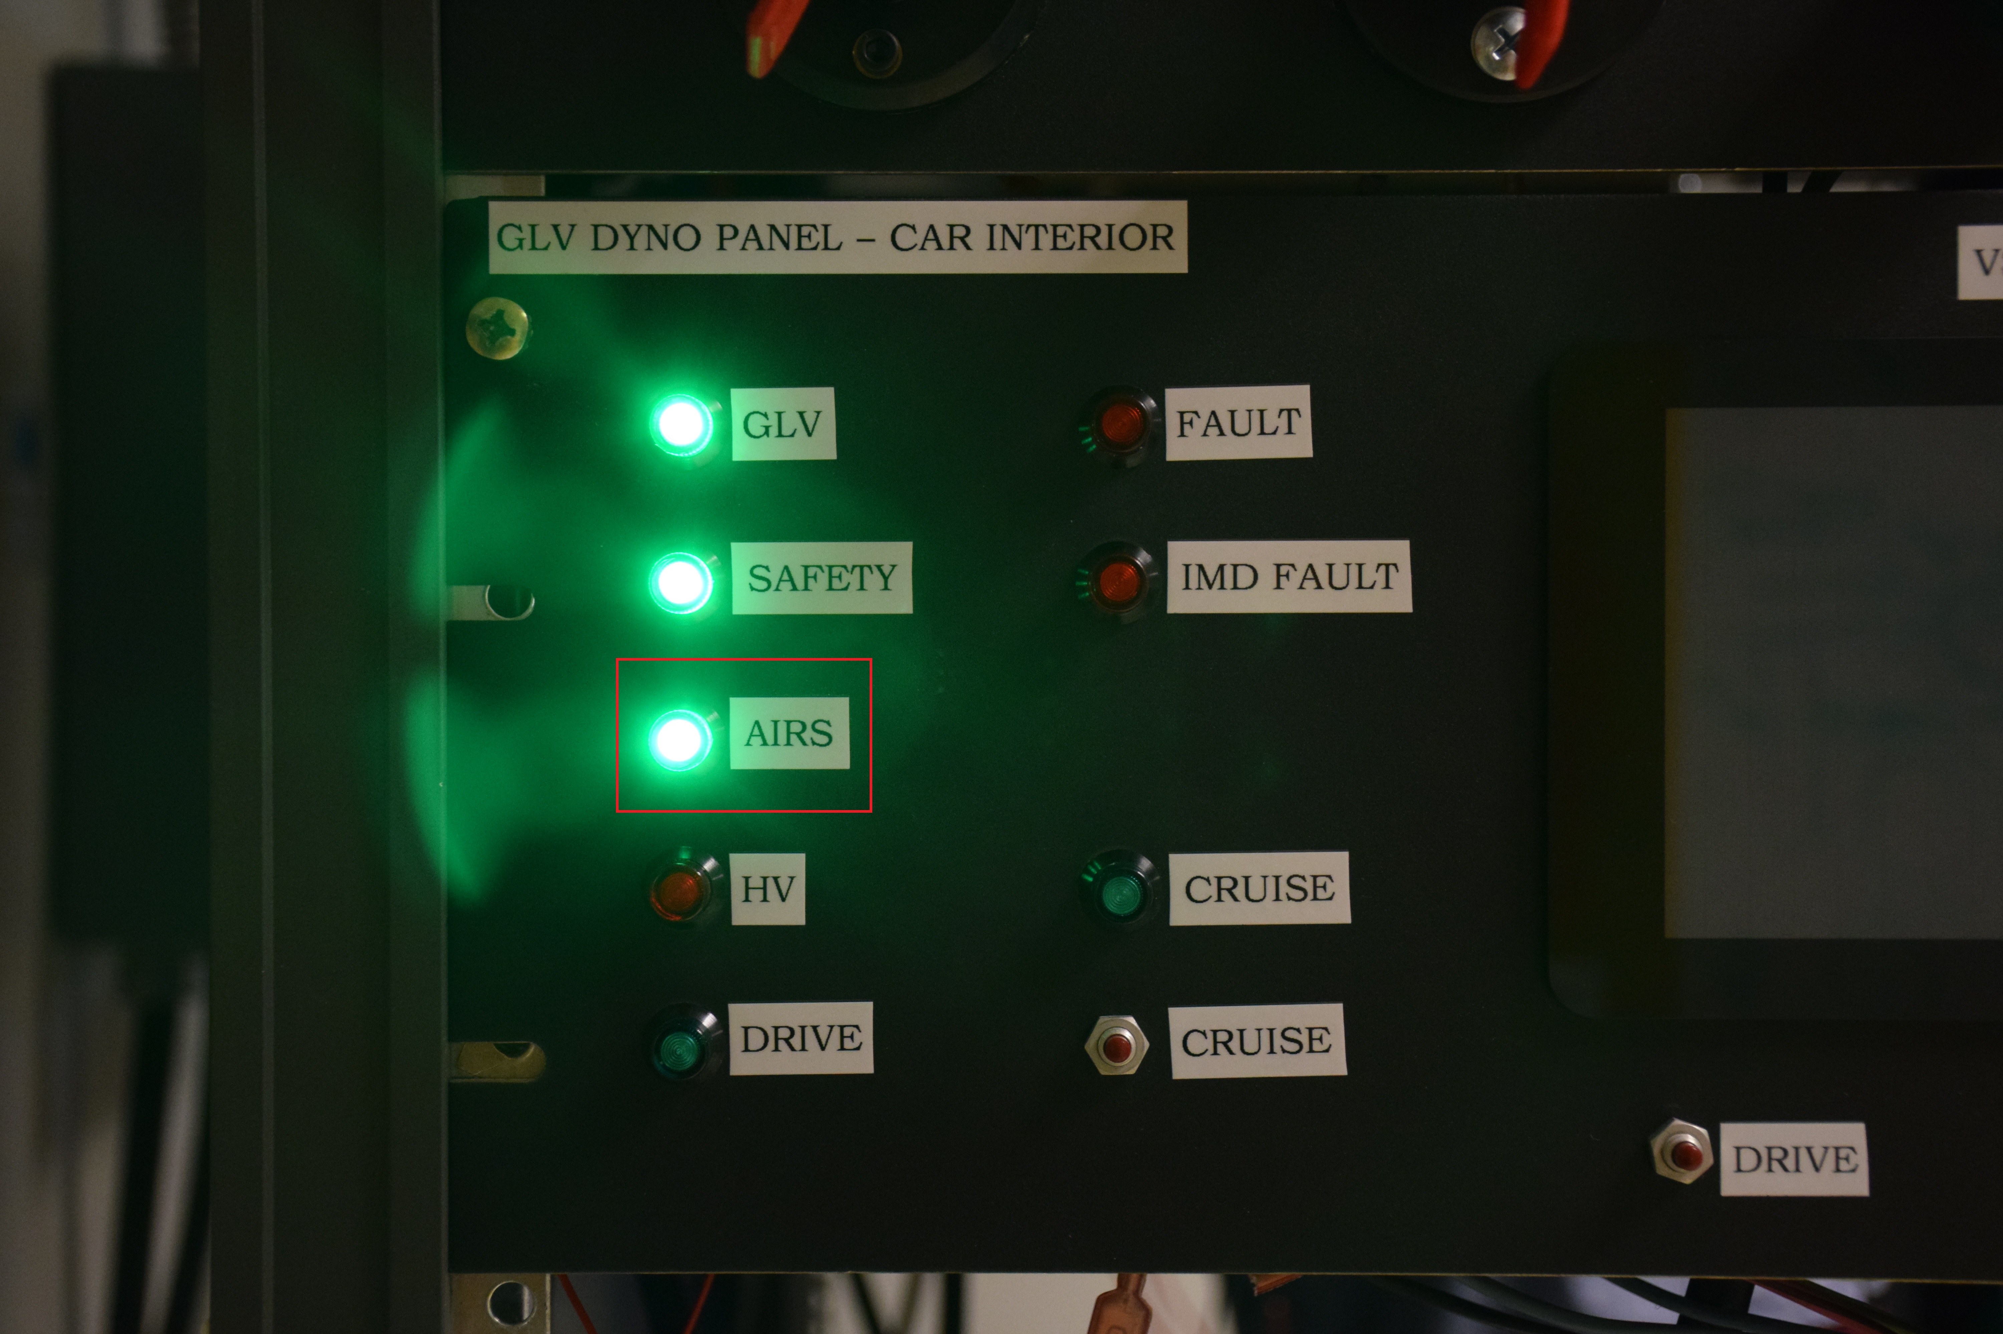

### Drive light

|  |  |
| --- | --- |
| Check | Pass |
| Clear indicator of function |  |
| Green LED |  |
| Located in cockpit |  |
| Illuminates when Drive mode entered |  |

Pass count: /4

Attach image of illuminated light

### Safety Light

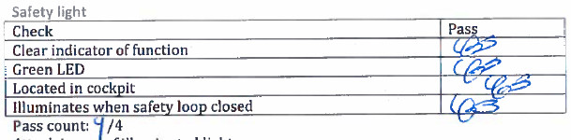

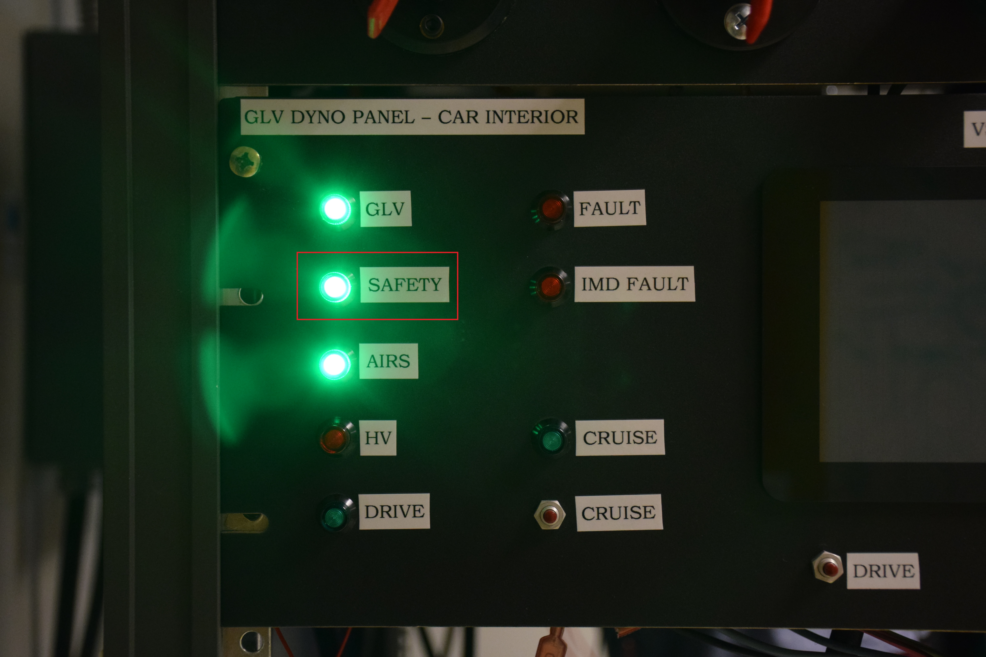

### Cruise light

|  |  |
| --- | --- |
| Check | Pass |
| Clear indicator of function |  |
| Green LED |  |
| Located in cockpit |  |
| Illuminates when cruise mode entered |  |

Pass count: /4

Attach image of illuminated light

### High Voltage Present light

|  |  |
| --- | --- |
| Check | Pass |
| Clear indicator of function |  |
| Red LED |  |
| Located in cockpit |  |
| Illuminates when HV outside of packs |  |

Pass count: /4

Attach image of illuminated light

### Grounded Low Voltage Present Light

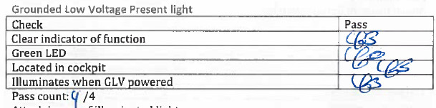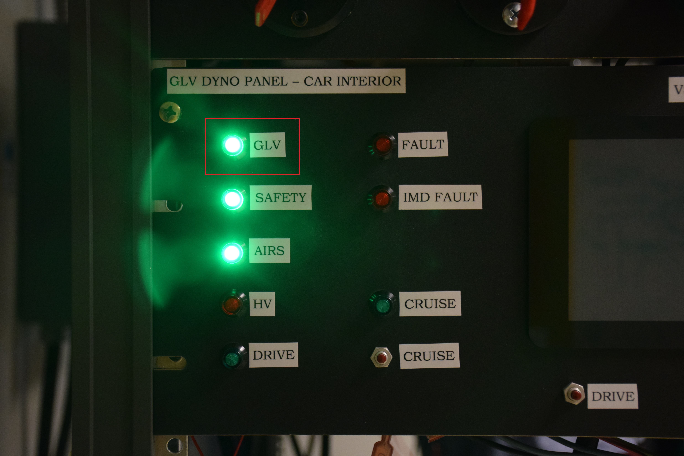

### Tractive System Energized Light

|  |  |
| --- | --- |
| Check | Pass |
| 2Hz-5Hz frequency when on |  |
| Amber strobe |  |
| Located on dyno specific panel (will be on car in future) |  |
| Illuminates when AIRs closed |  |

Pass count: /4

Attach image of illuminated light

### Tractive System Active Light

|  |  |
| --- | --- |
| Check | Pass |
| 2 lights present (LHS + RHS) |  |
| Red lights |  |
| Located on dyno specific panel (will be on car in future) |  |
| Illuminates when HV present outside of car |  |

Pass count: /4

Attach image of illuminated light

### Brake light

|  |  |
| --- | --- |
| Check | Pass |
| 1 light present |  |
| Red light |  |
| Located on dyno specific panel (will be on car in future) |  |
| Illuminates when brake pressed and GLV on |  |

Pass count: /4

Attach image of illuminated light

## Buttons and switches

### FWD/REV switch

|  |  |
| --- | --- |
| Check | Pass |
| Clearly labeled |  |
| Key switch 2 position |  |
| Key can be removed in either state |  |
| Mounted on TSI box |  |

Pass count: /4

Attach image of button/switch:

### Driver Reset

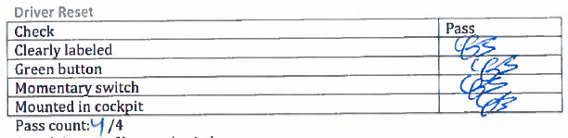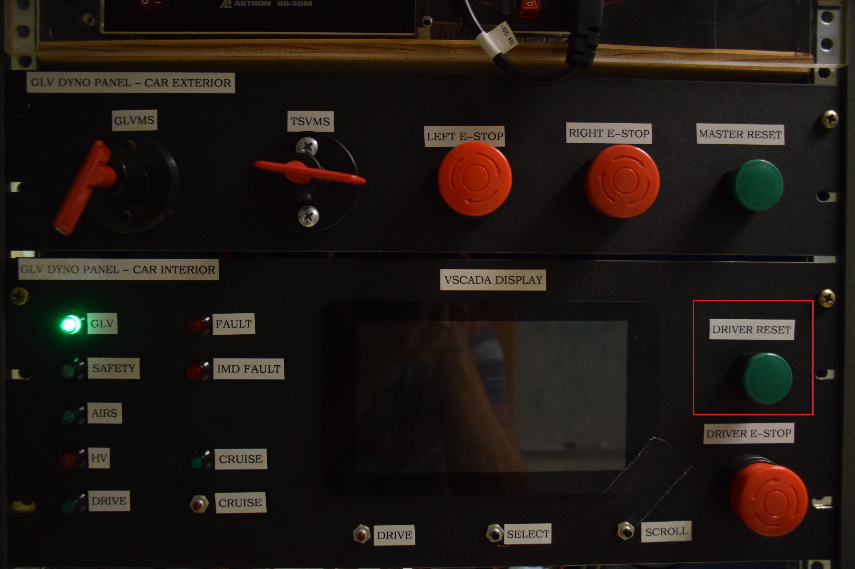

### Driver BRB

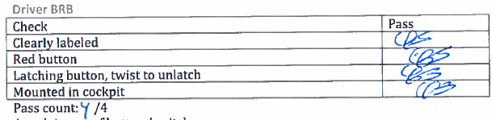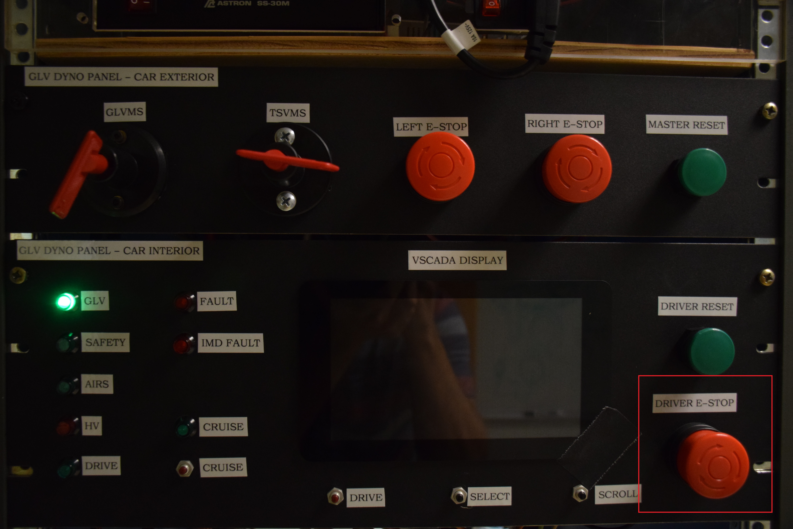

### Inertial switch

|  |  |
| --- | --- |
| Check | Pass |
| Clearly labeled |  |
| Inertial switch |  |
| Resettable by driver |  |
| Mounted in cockpit |  |

Pass count: /4

Attach image of button/switch:

### Drive Button

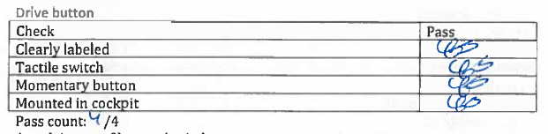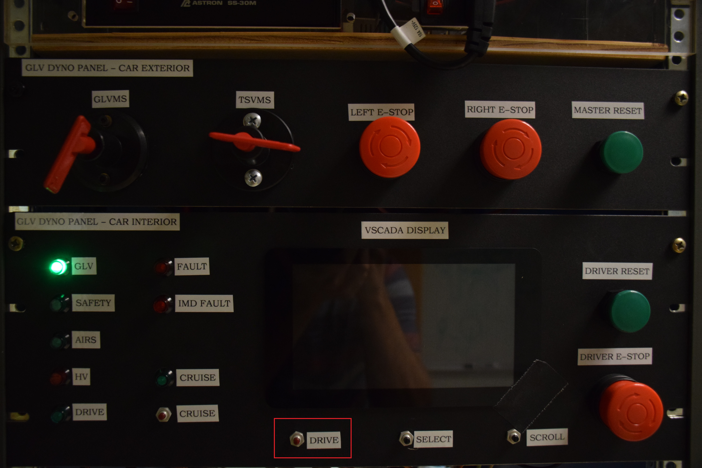

### Cruise button

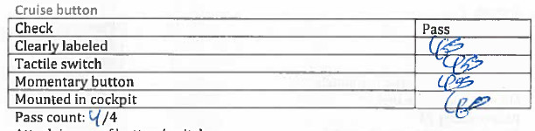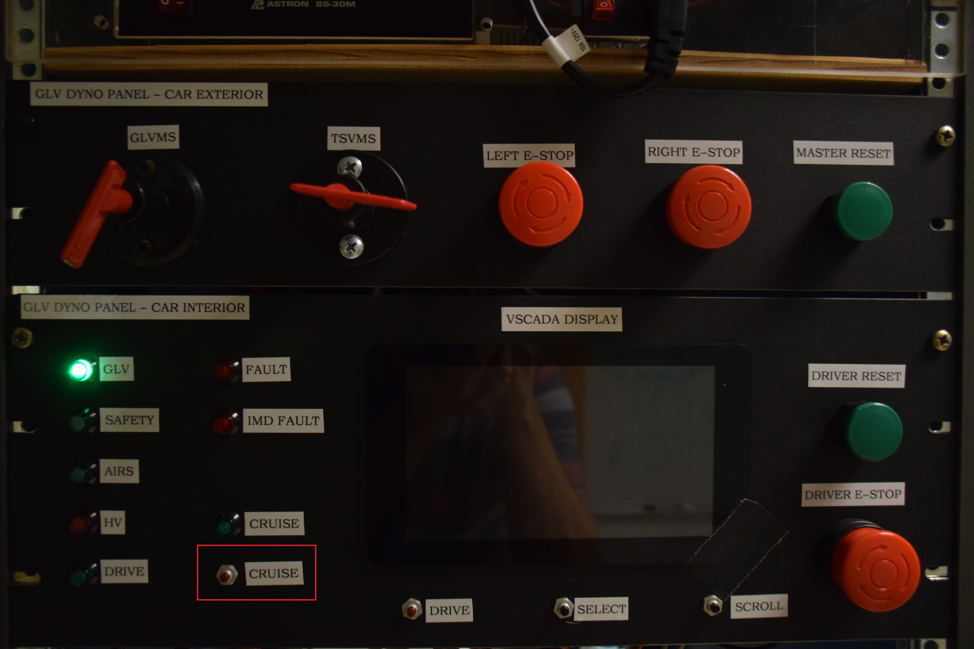

### Scroll button

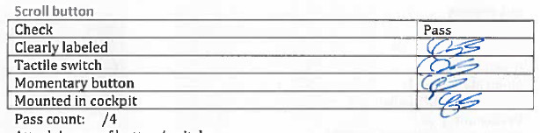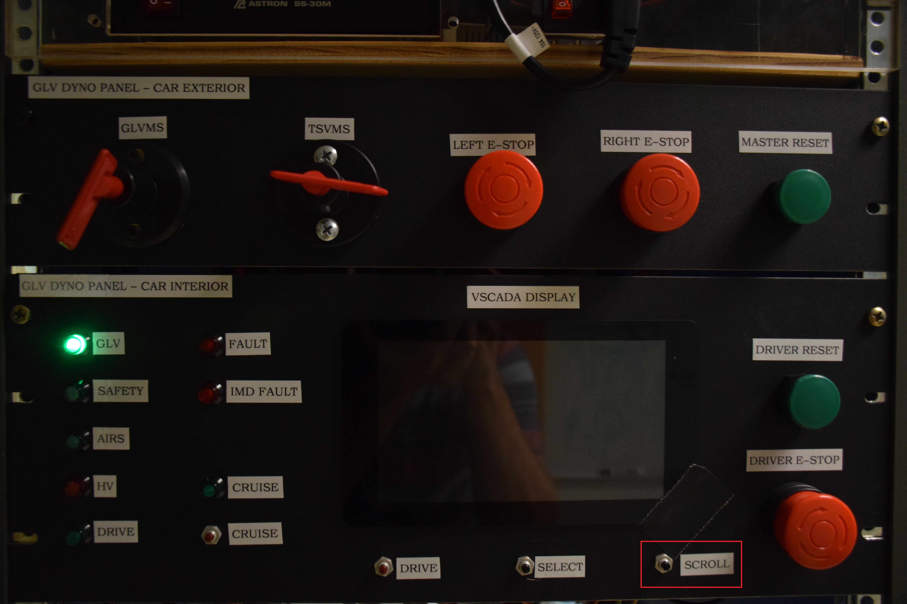

### Select Button

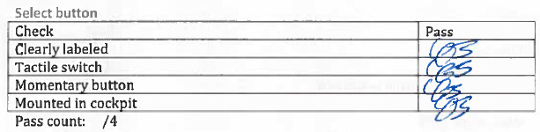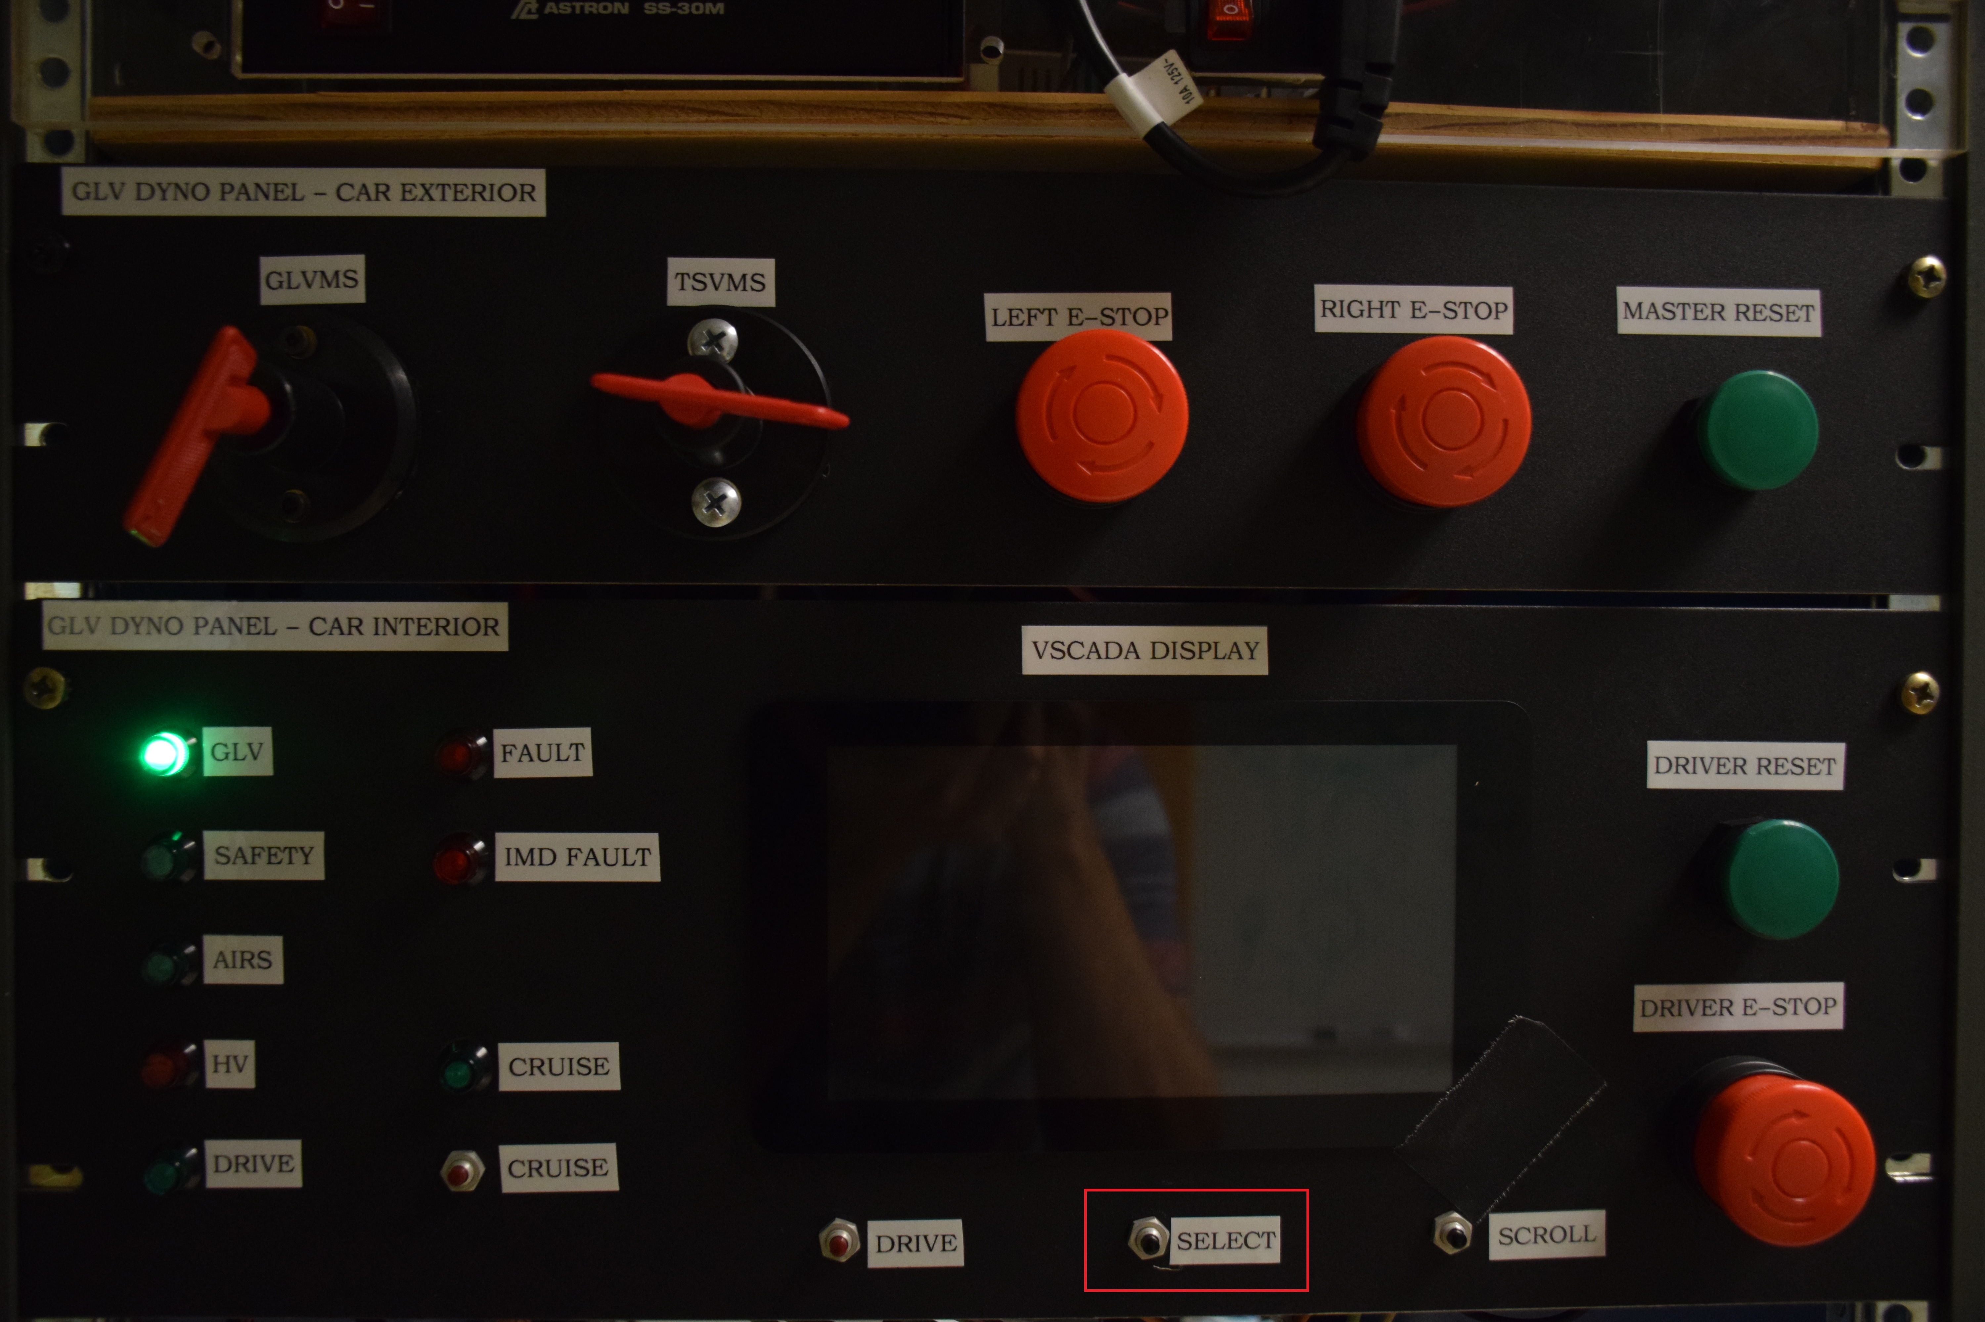

### GLV Master Switch

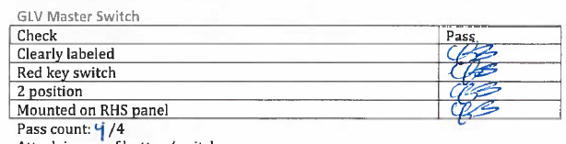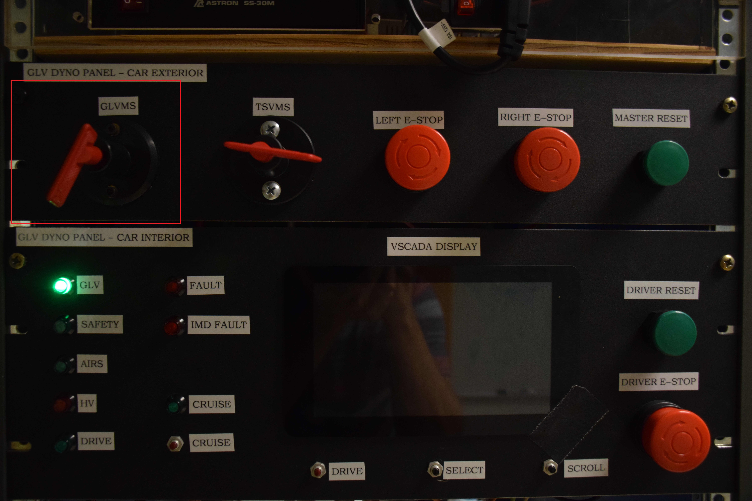

### TSV Master Switch

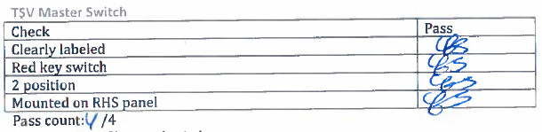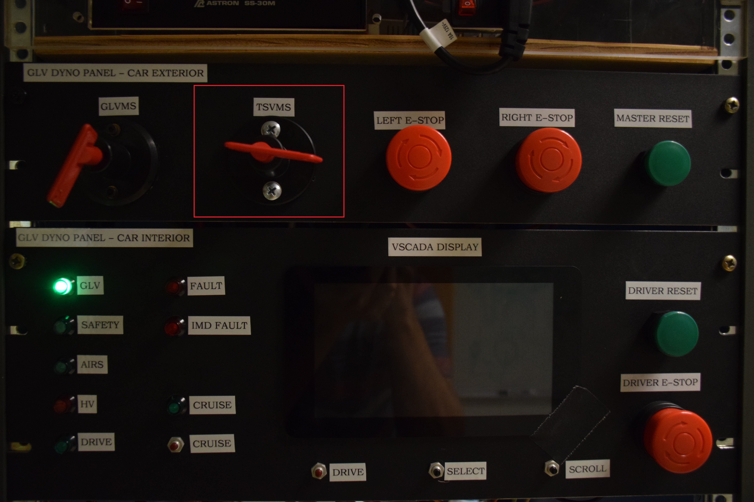

### RHSBRB

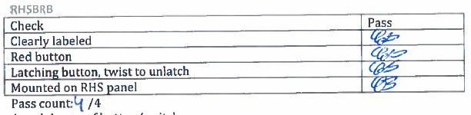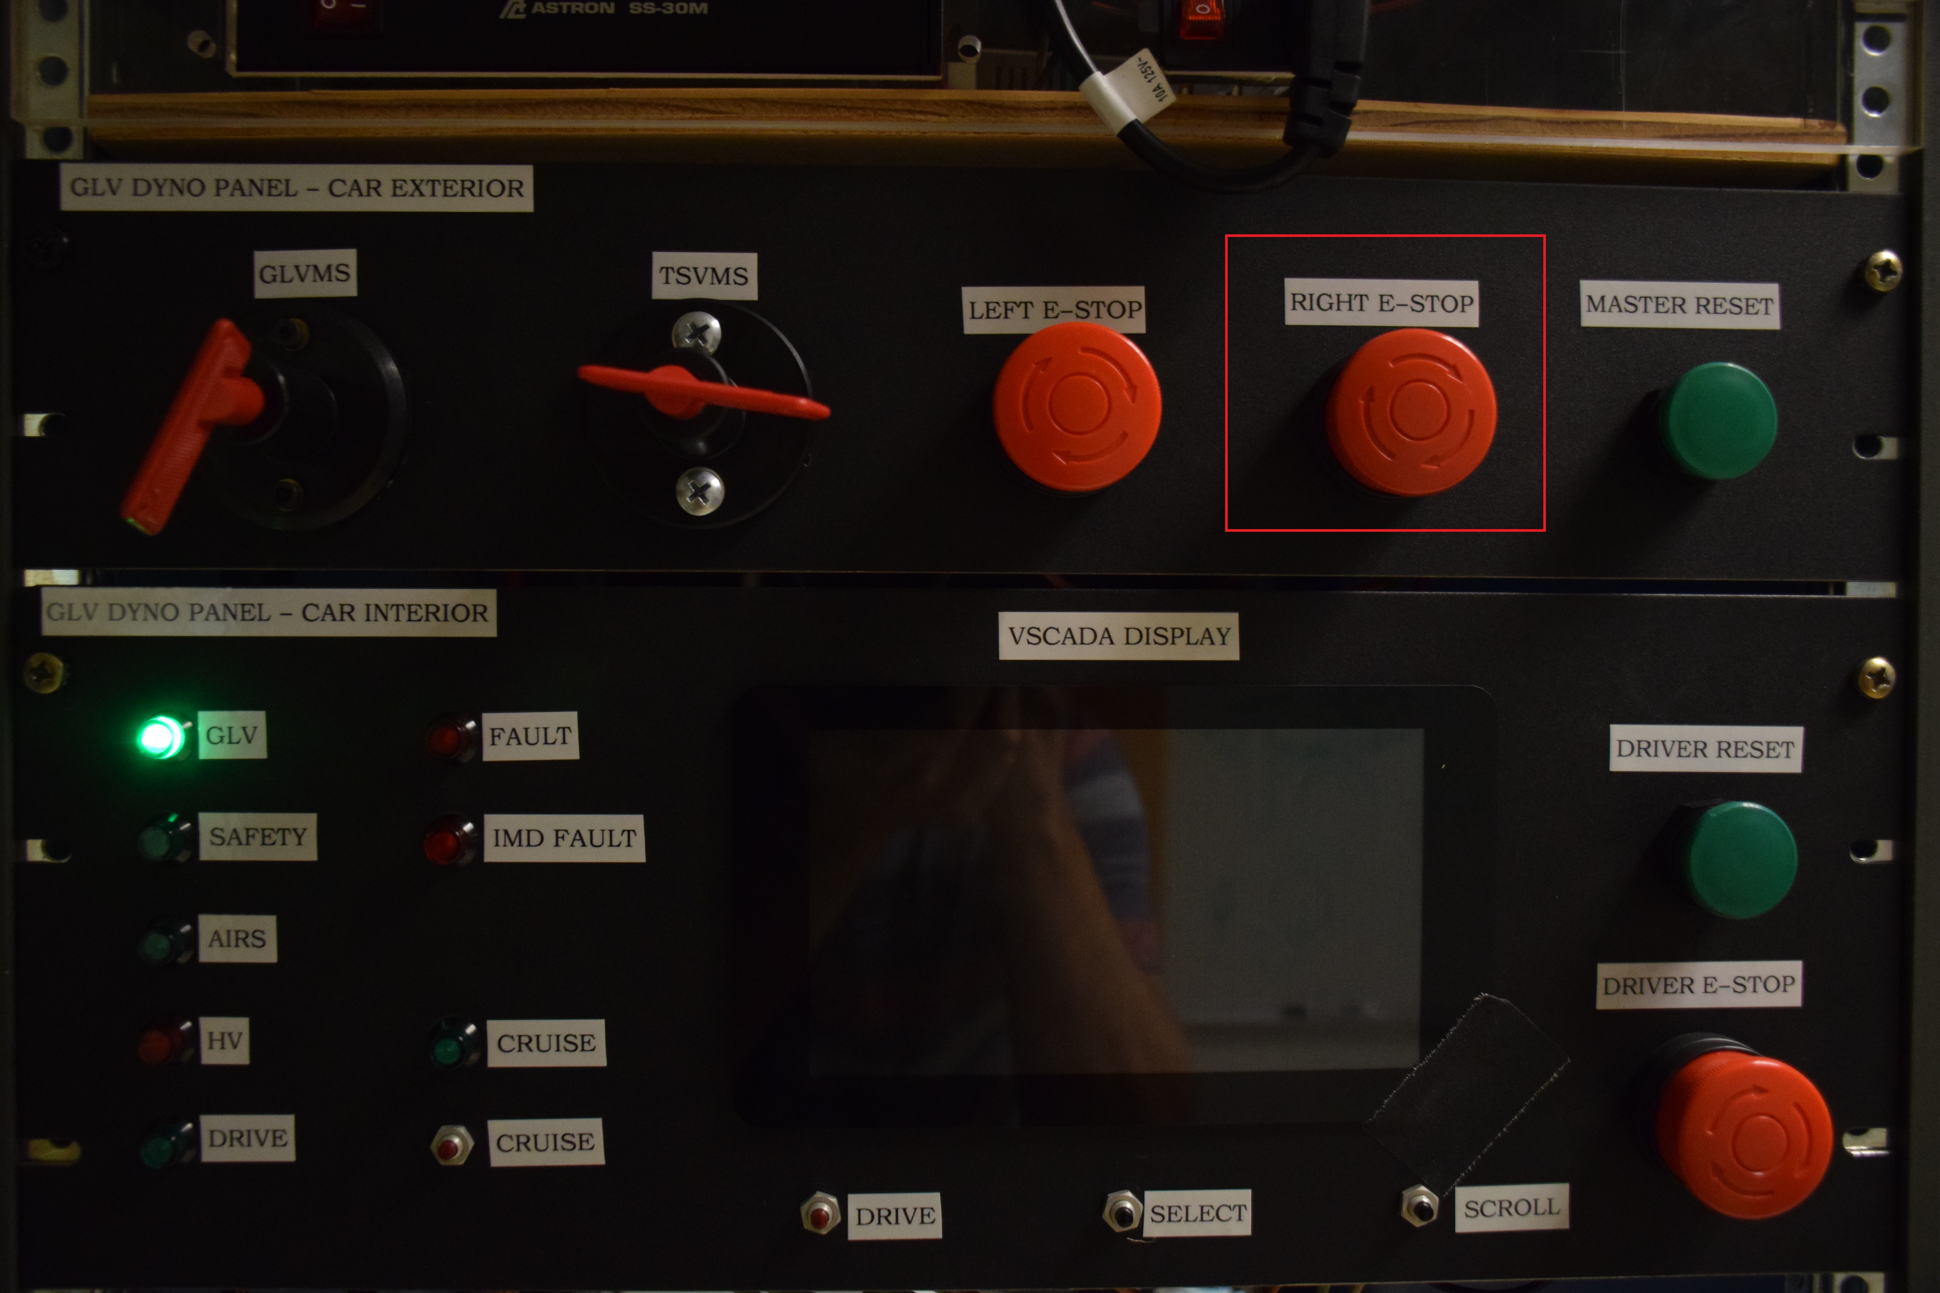

### RHS MReset

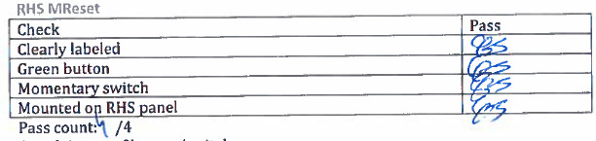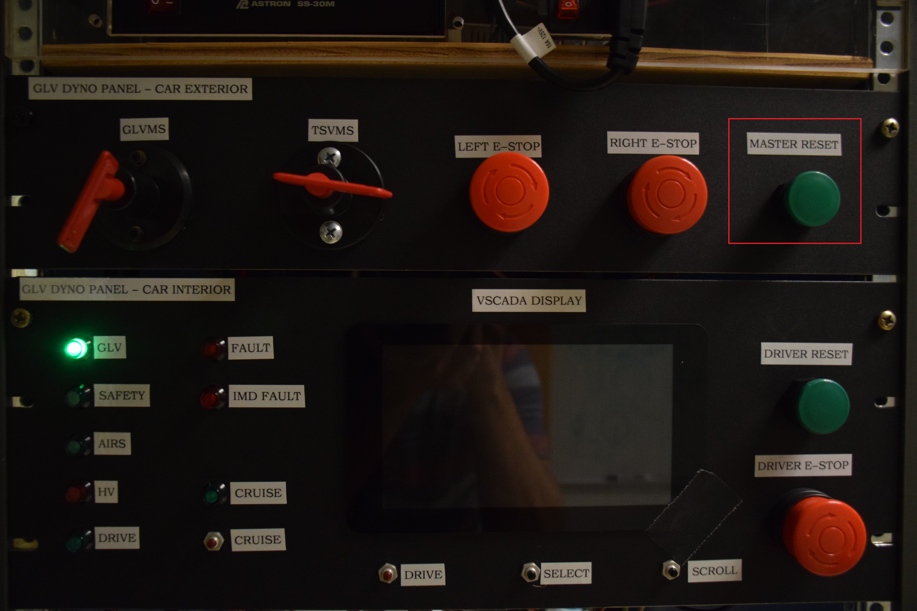

### LHSBRB

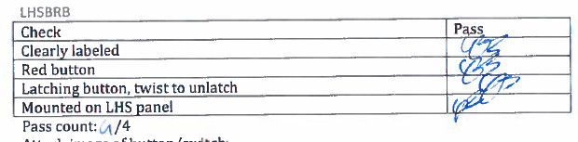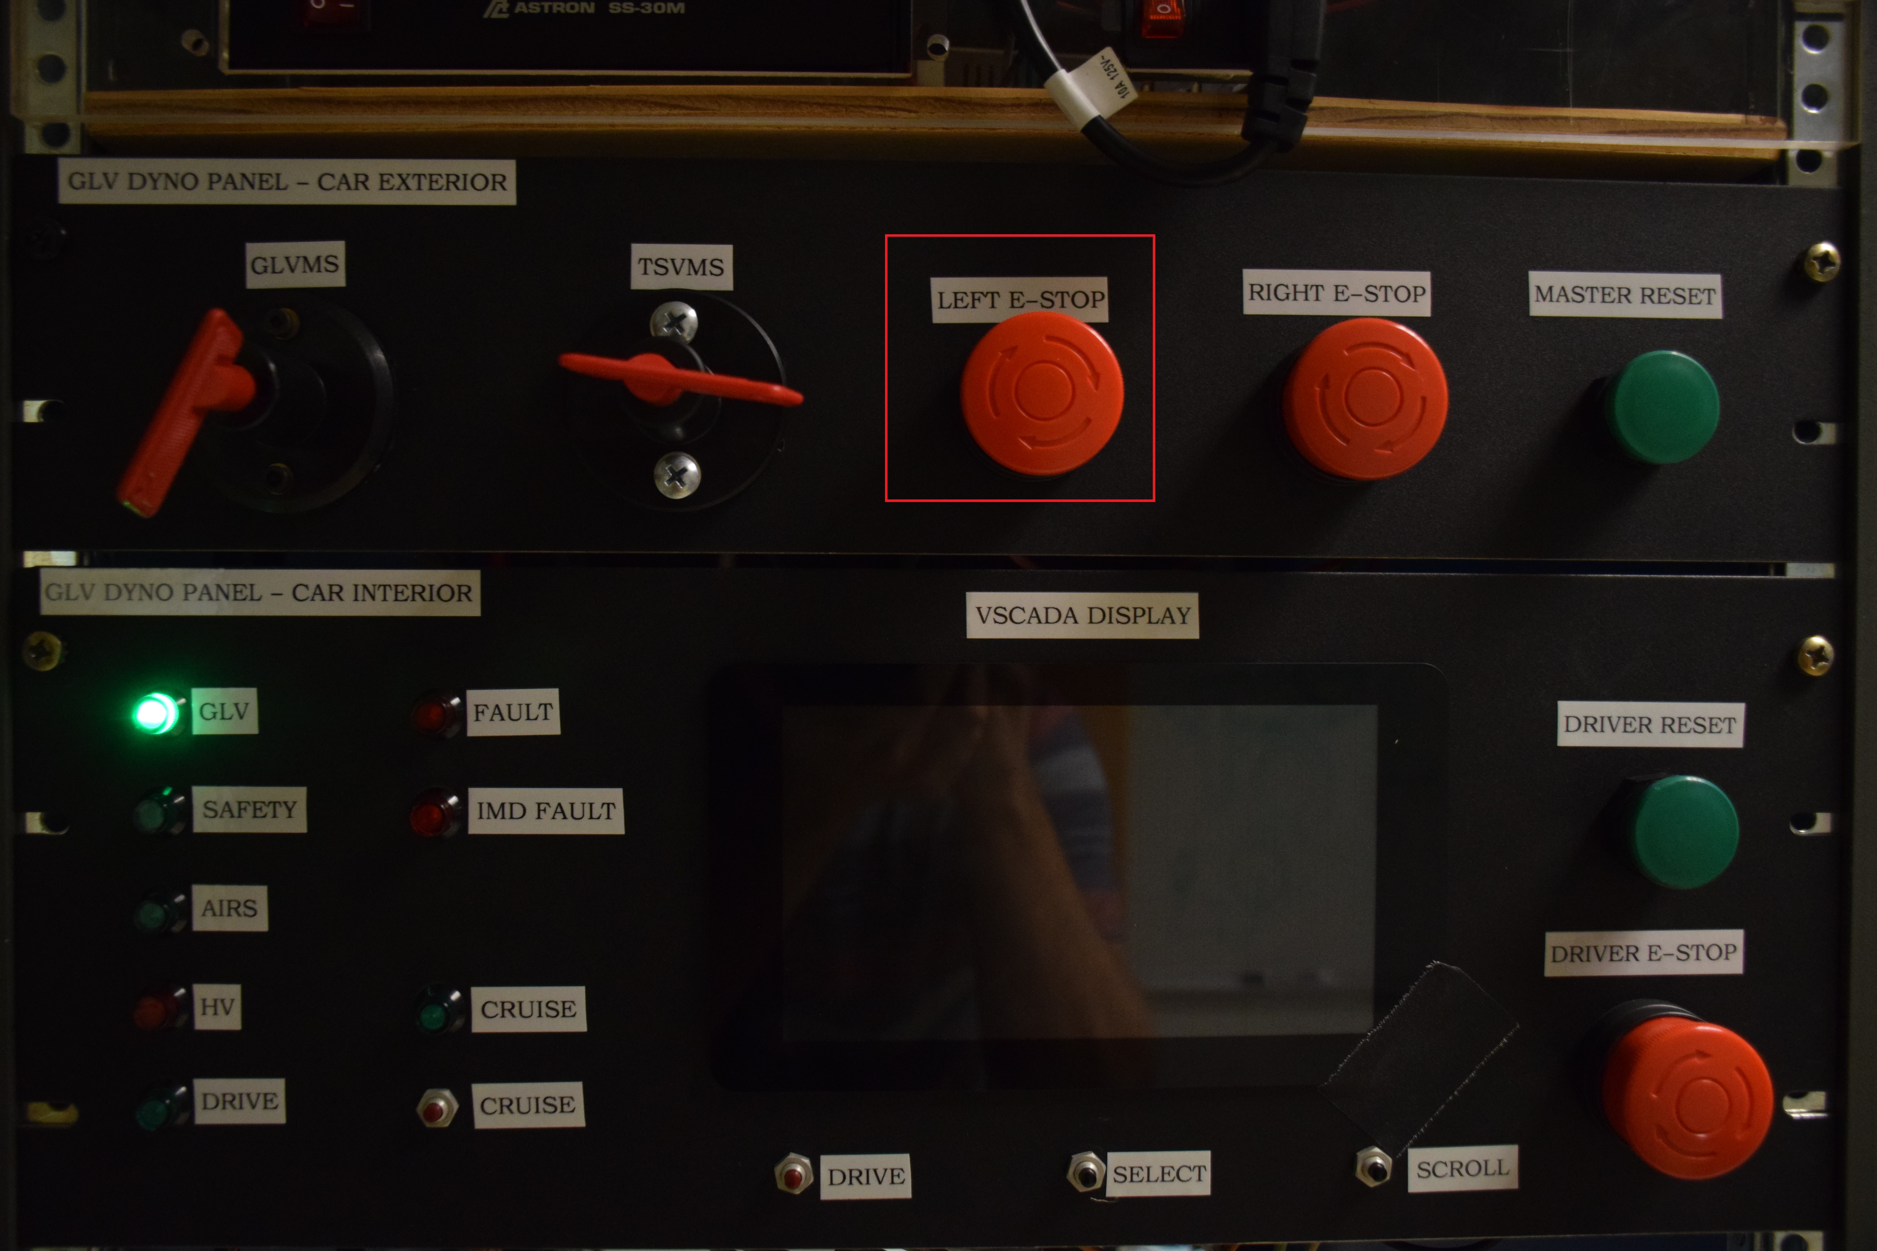

## PCBs

### AMS

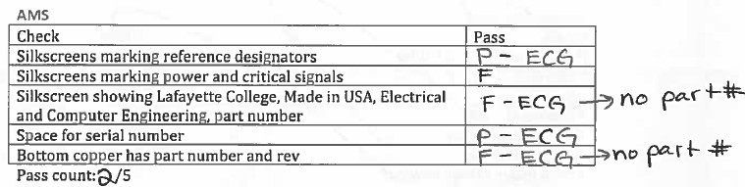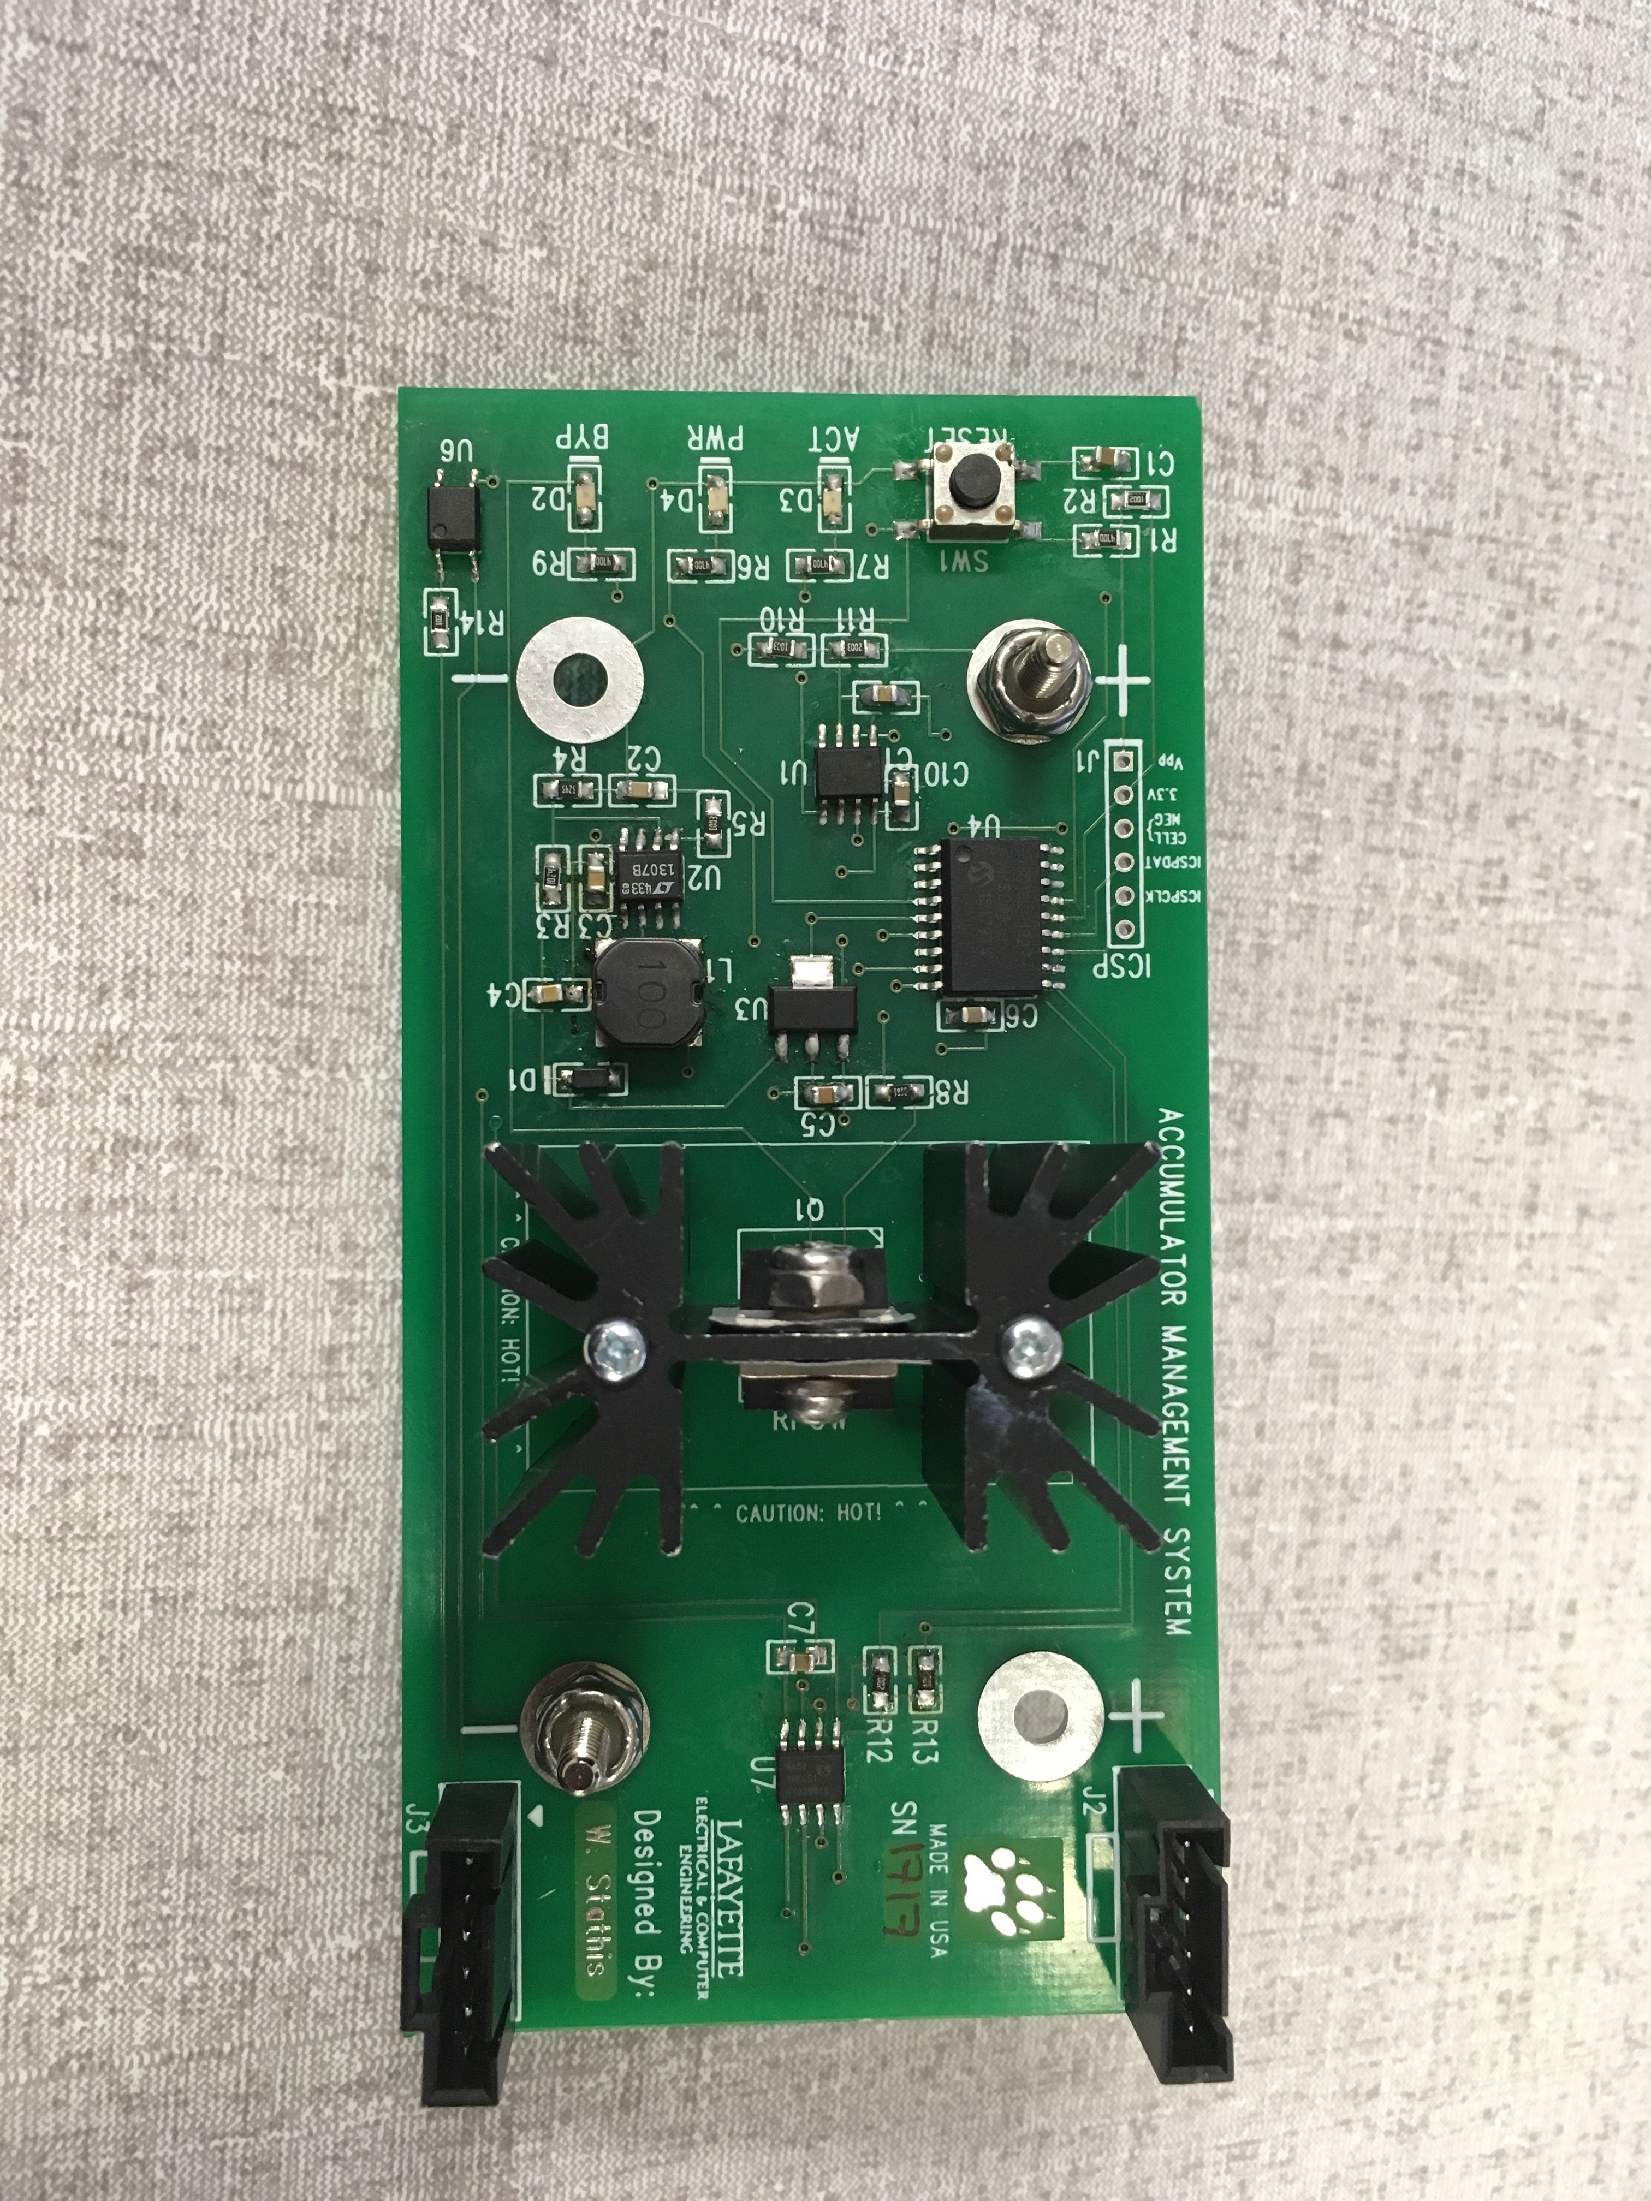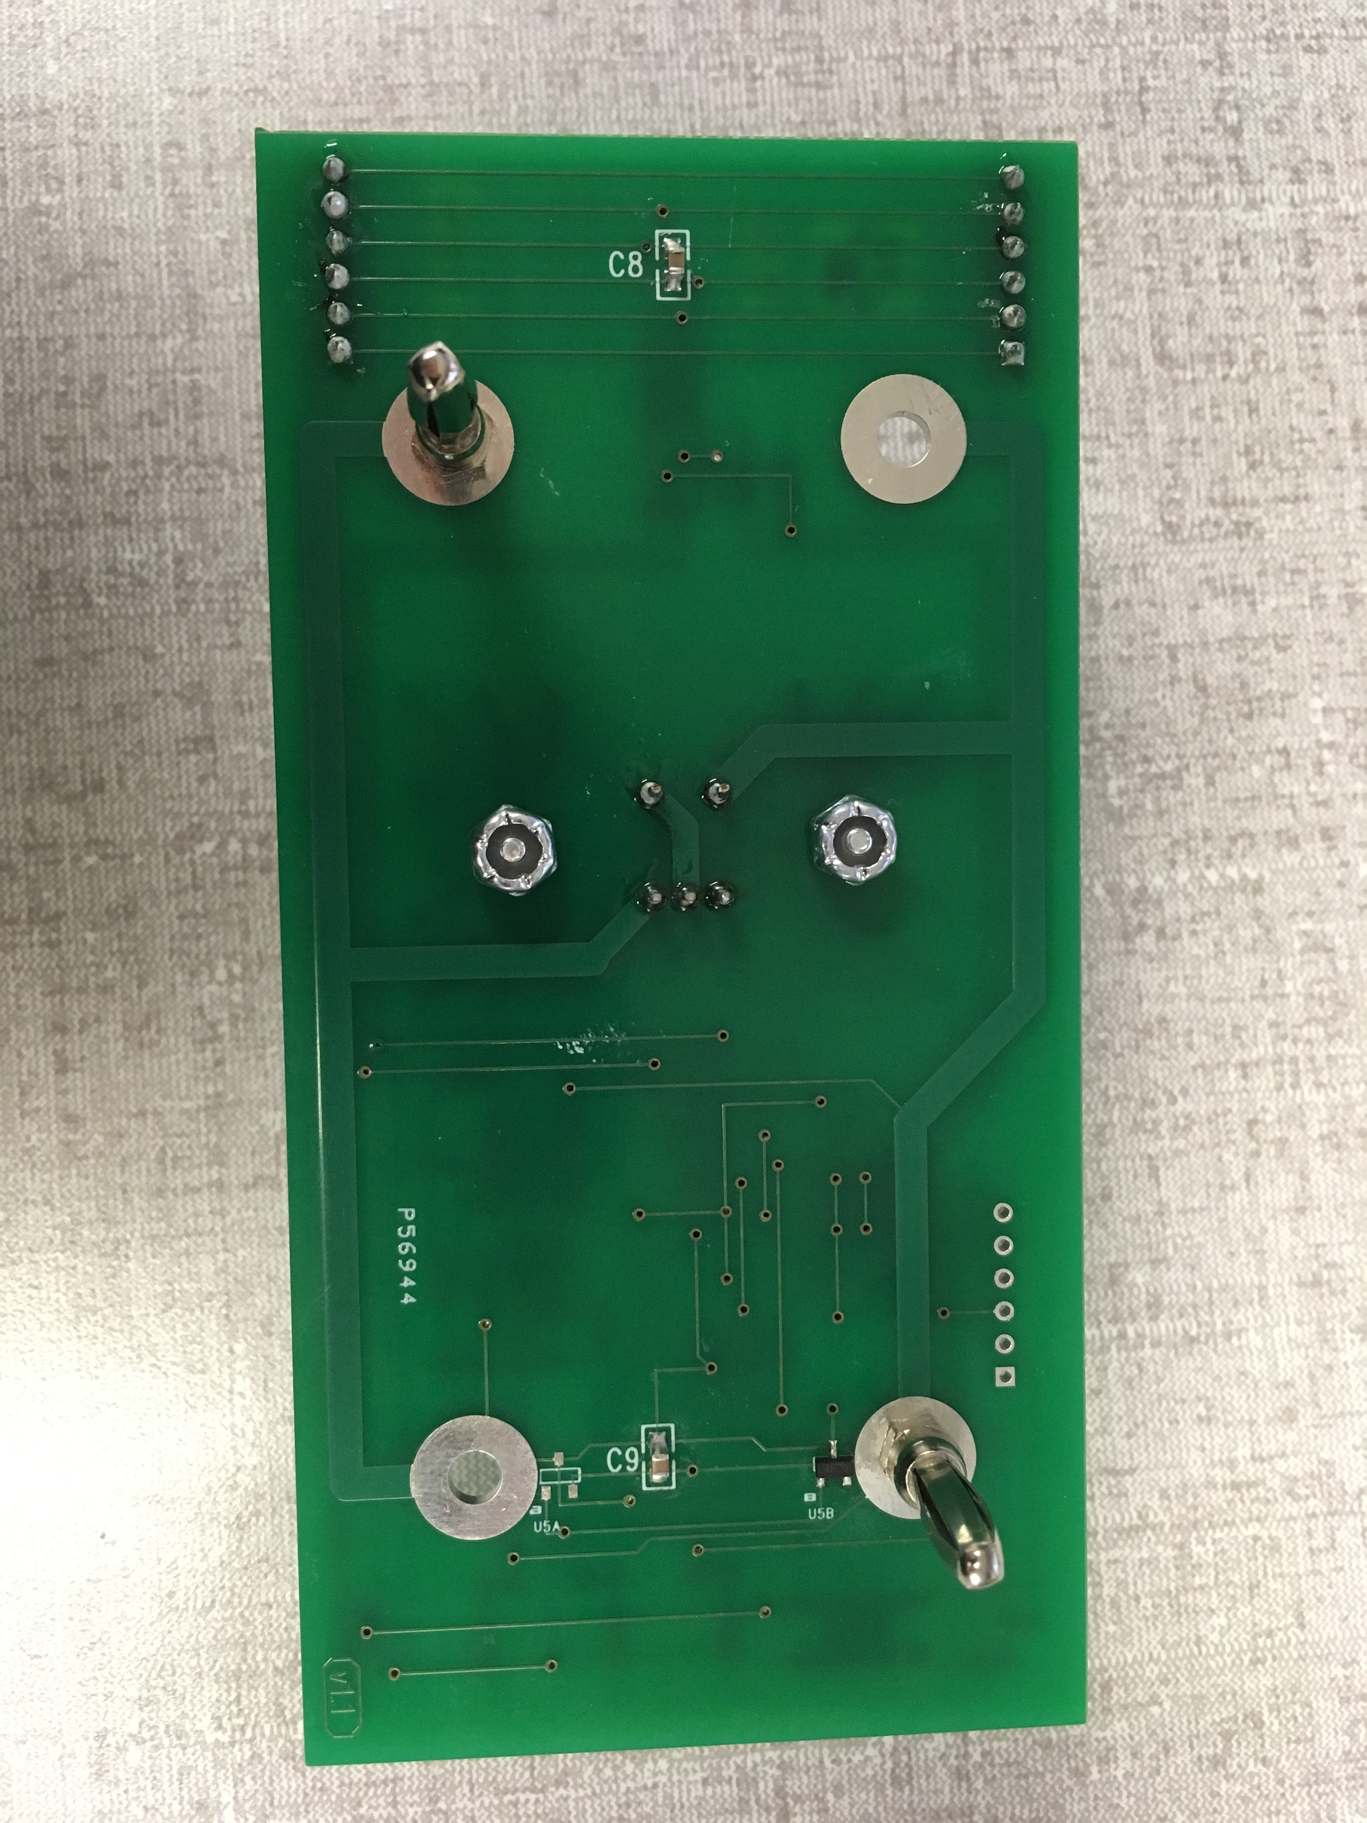

### Pacman

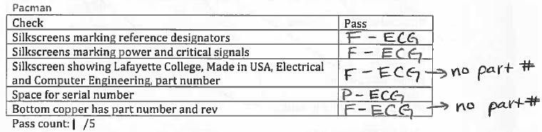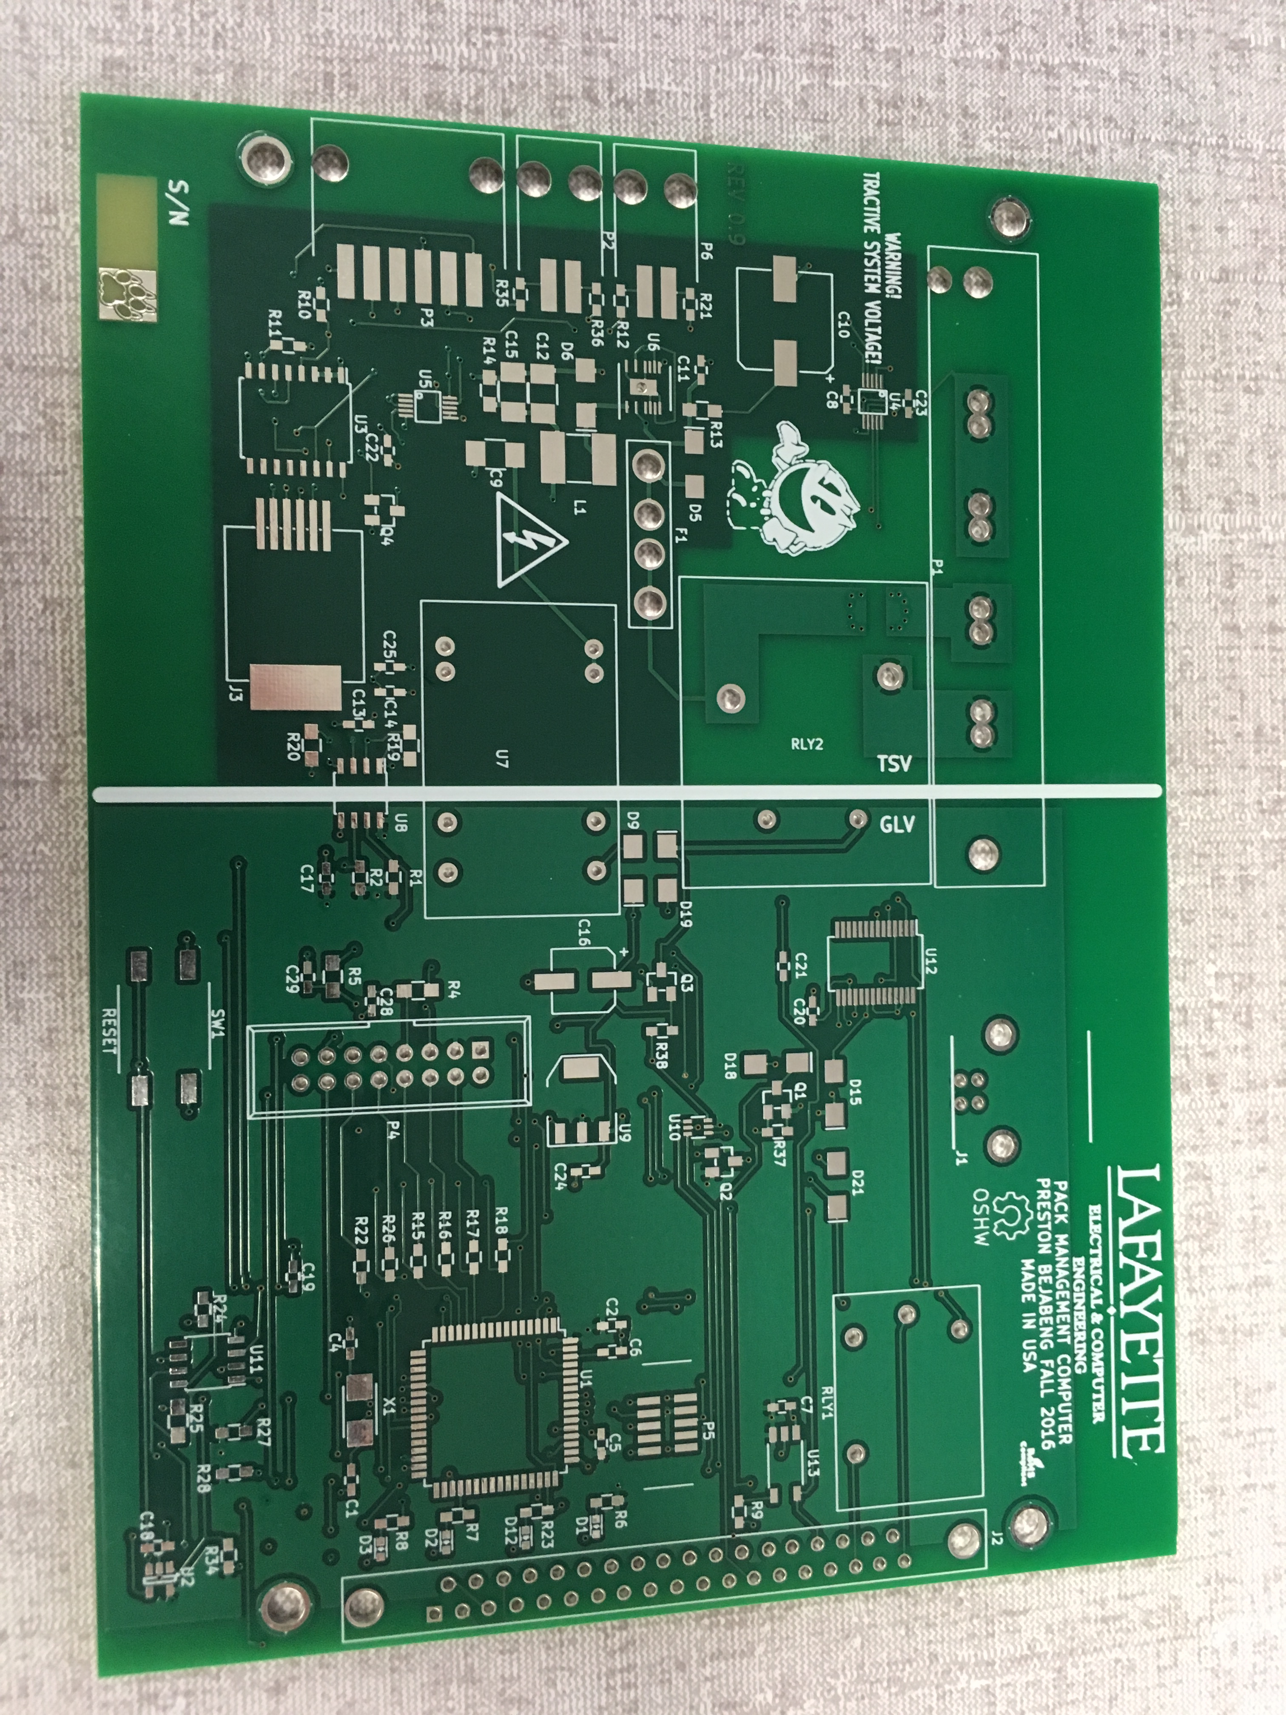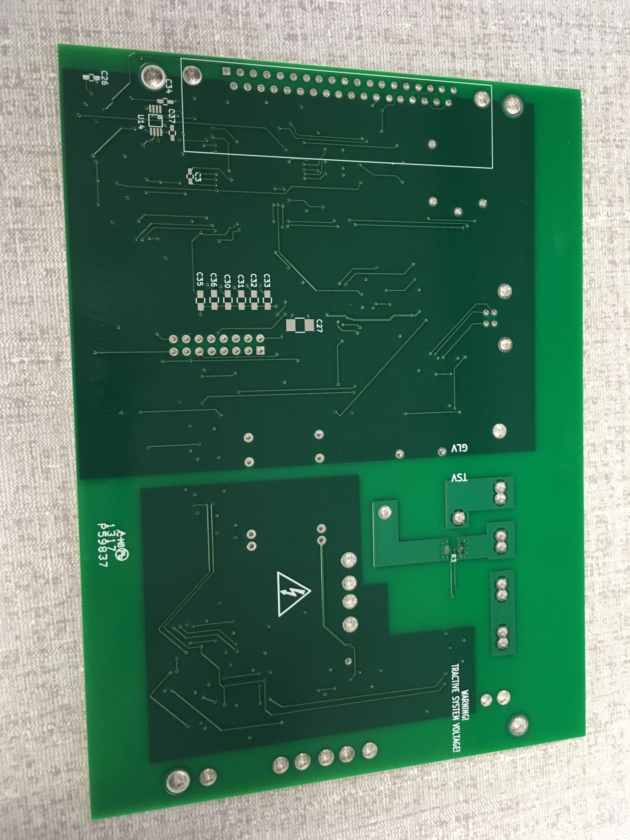

### TSV Control Panel PCB

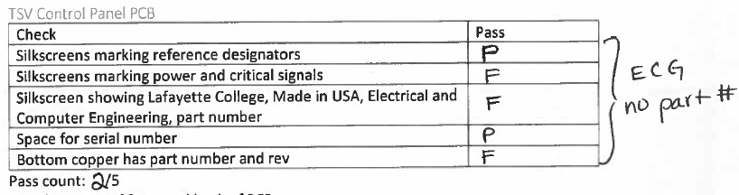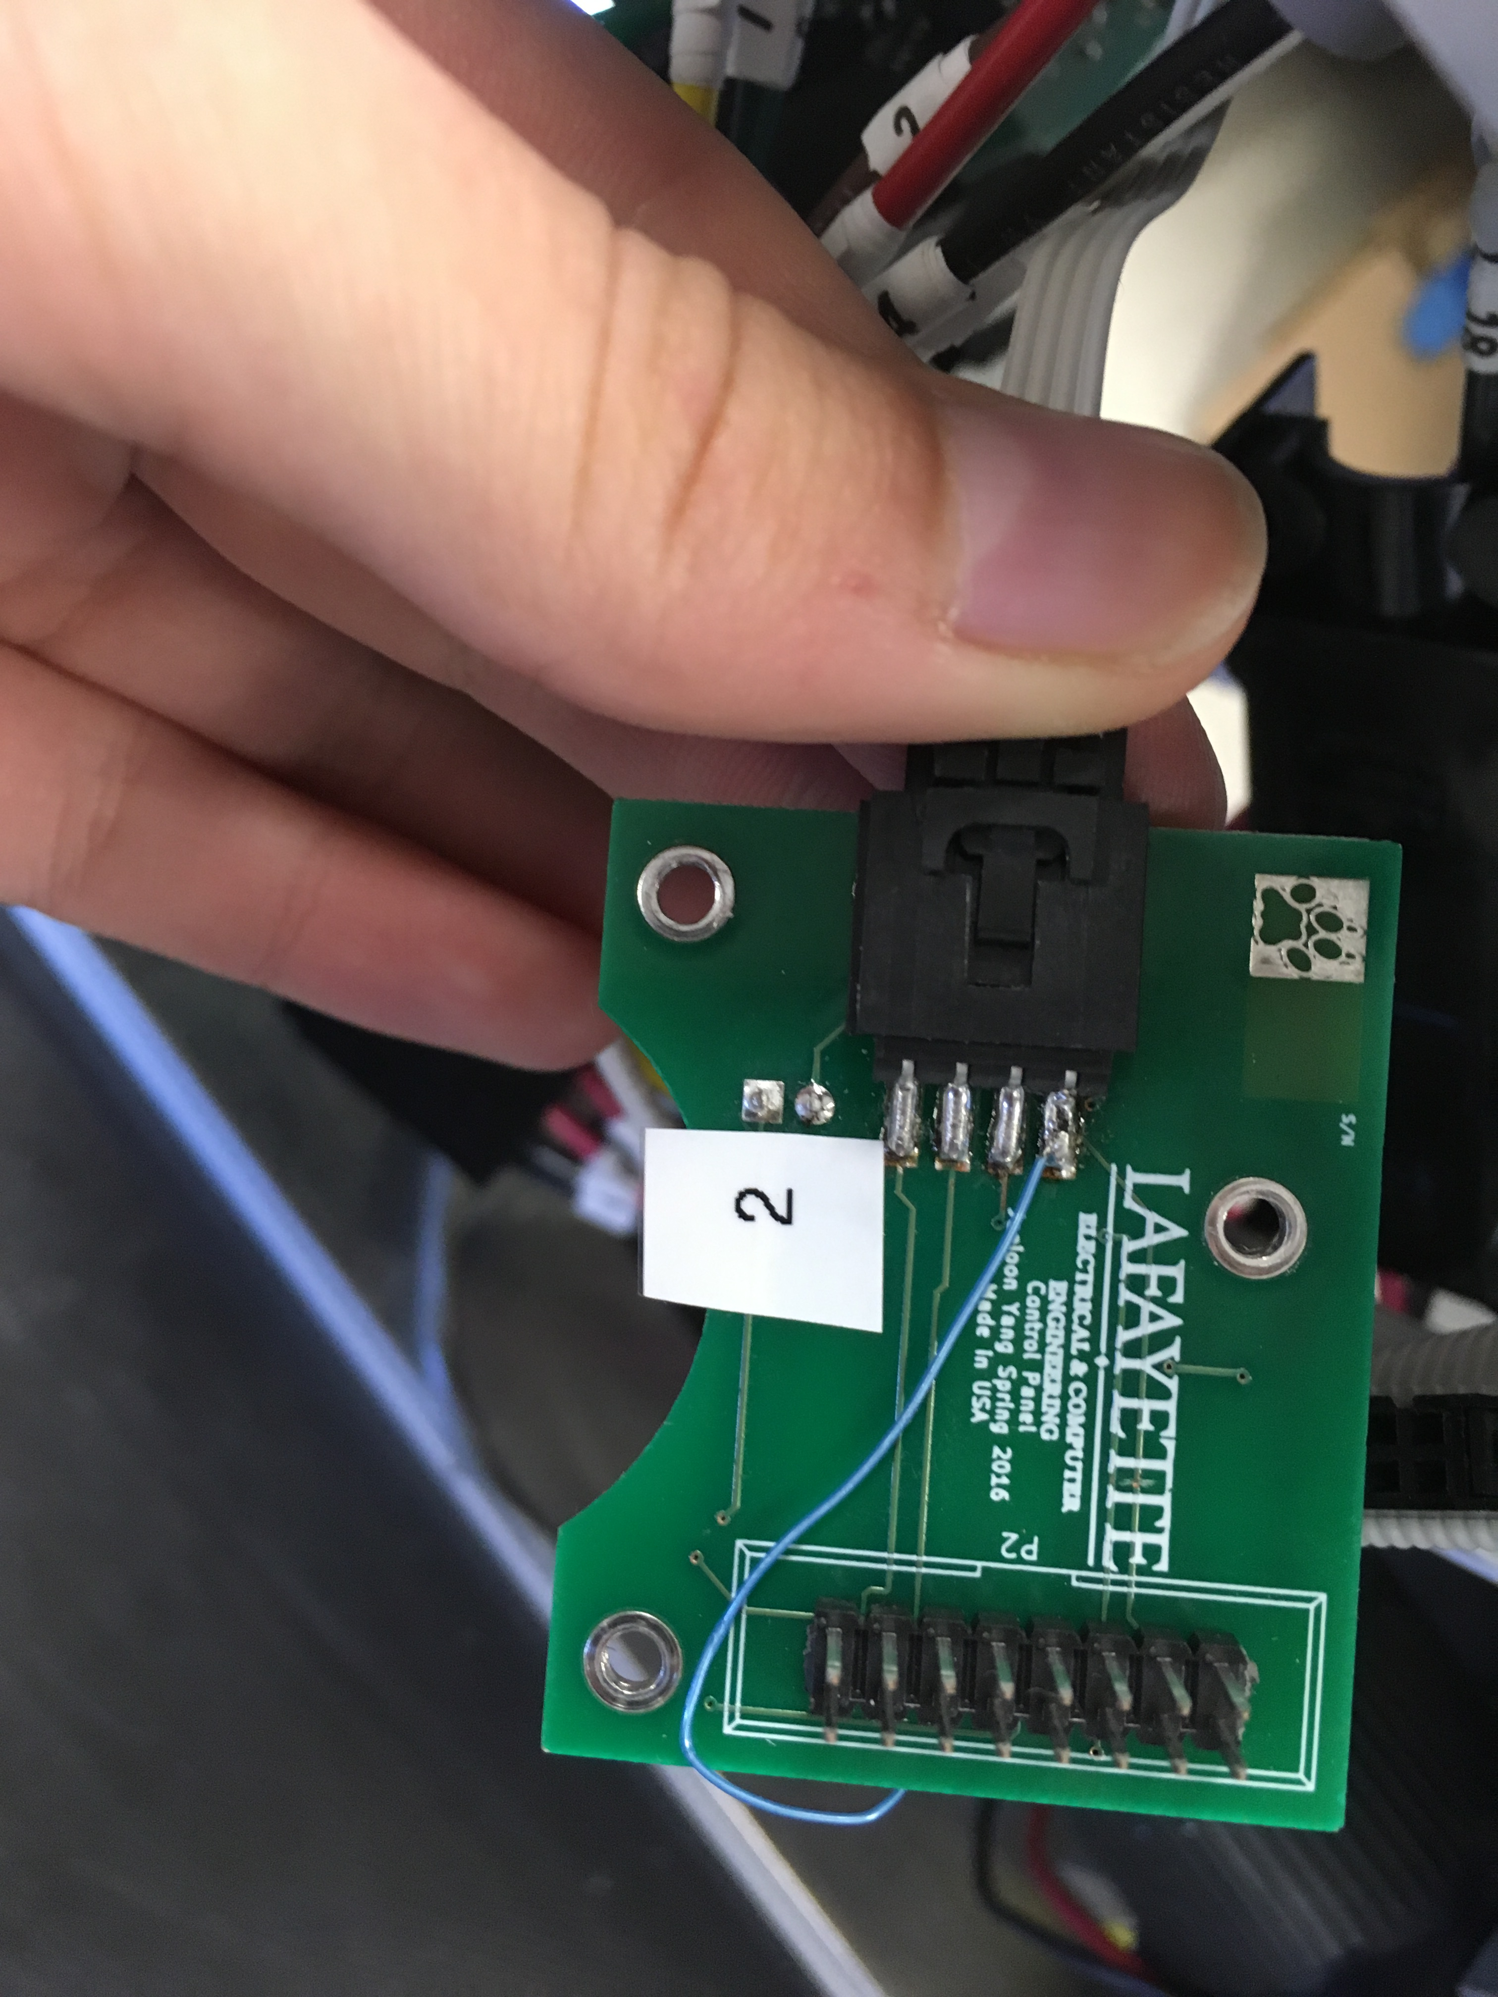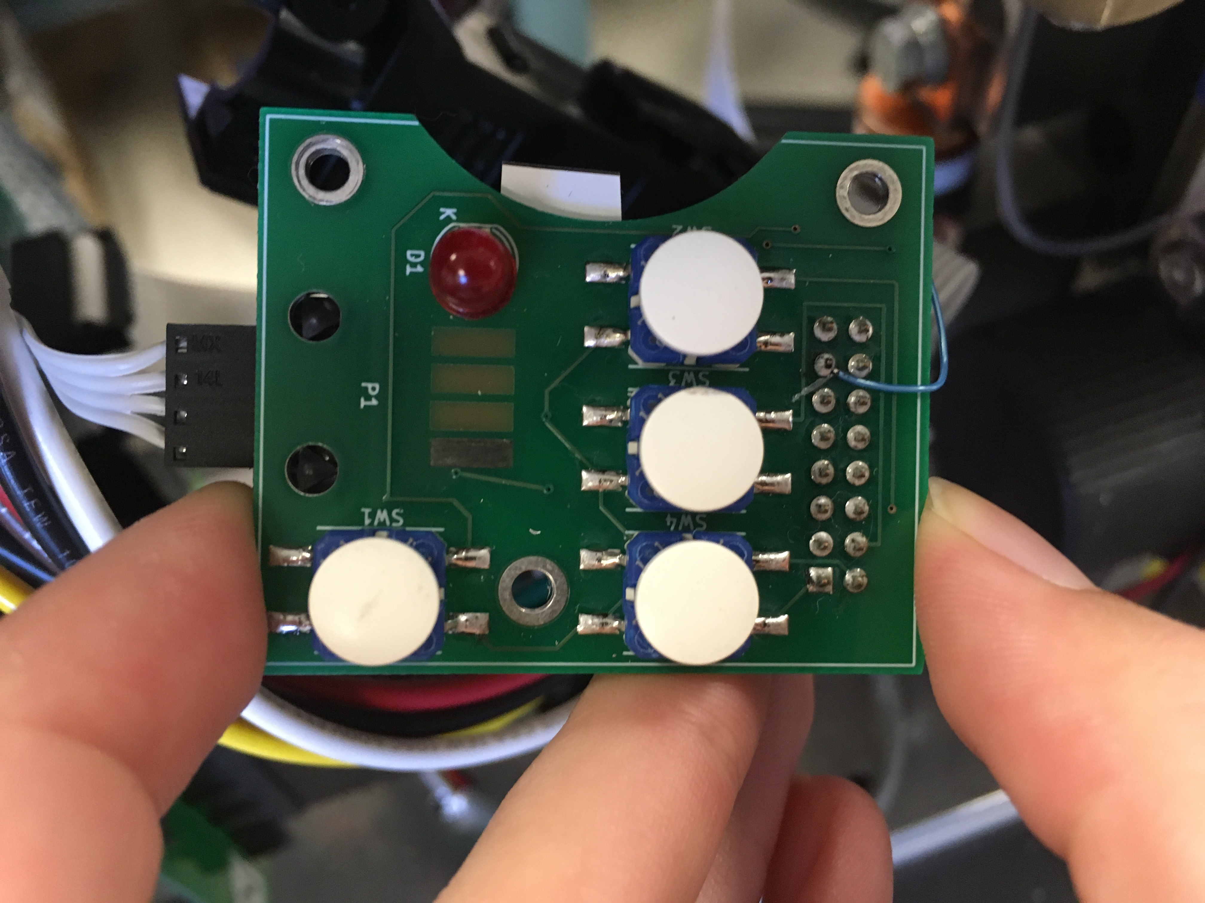

### TSI PCB

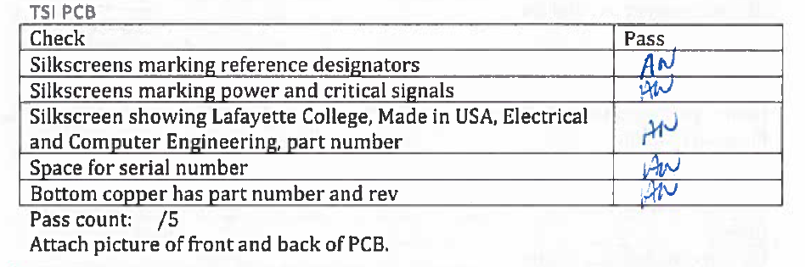

### GLV PCB

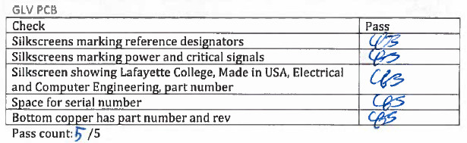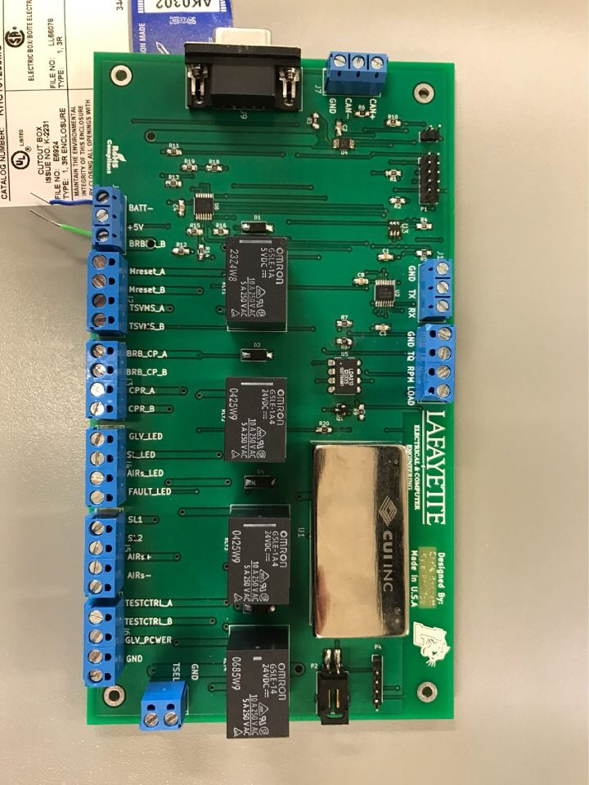

## Fuses

### Accumulator Fuse

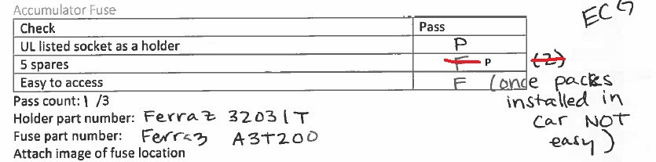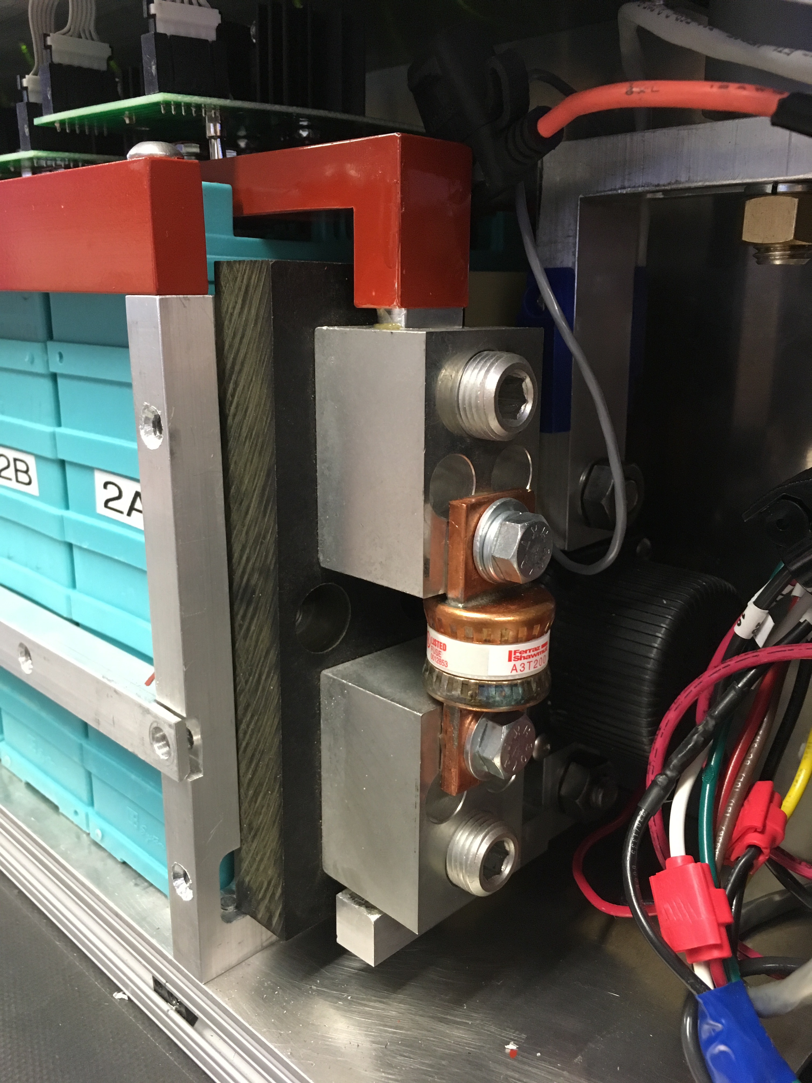

### Accumulator Blade Fuses

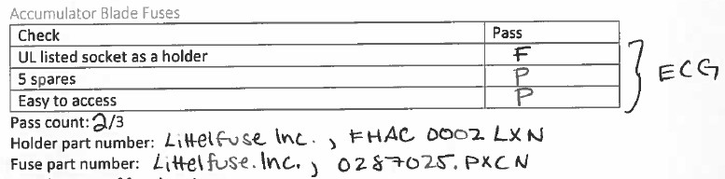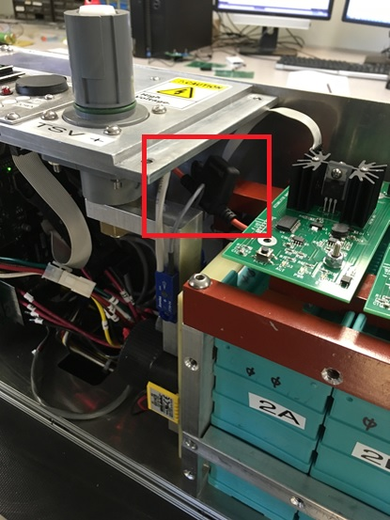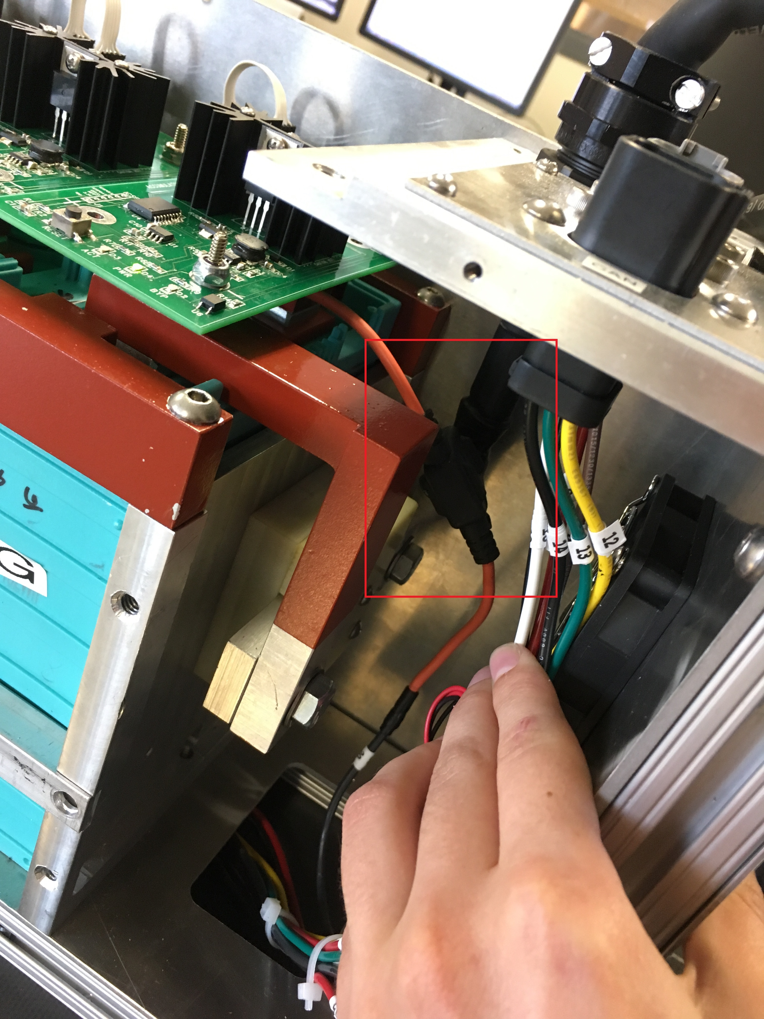

### Pacman Fuse

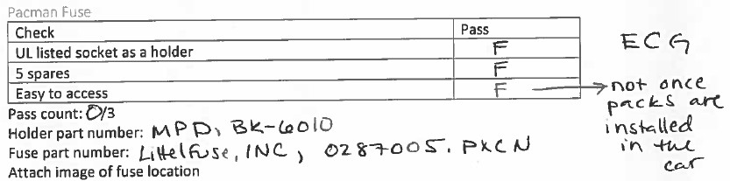

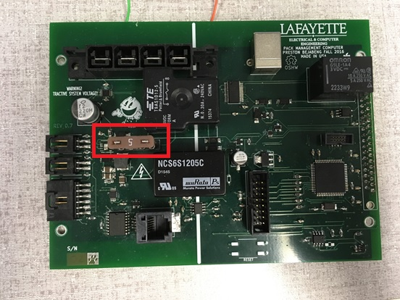

### TSI precharge relay fuse

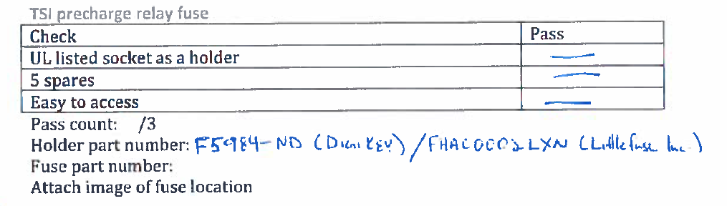

## Enclosures

### Pack

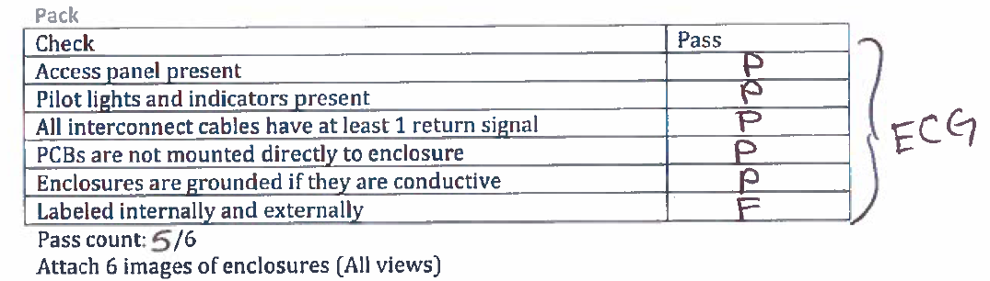

### TSI

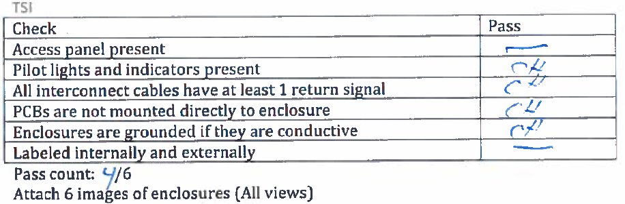

### GLV

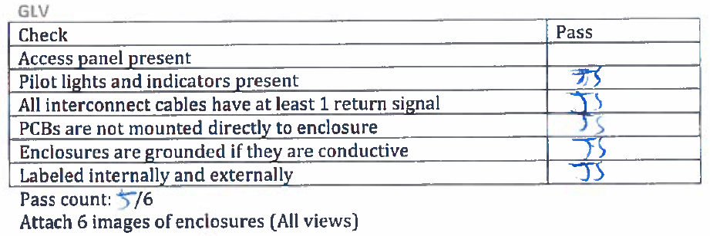

# ATP-12 checklist: Maintainability

## Software

### Pacman code

|  |  |
| --- | --- |
| Check | Pass |
| Version controlled |  |
| Can startup with no input from the user |  |
| Have an install script (.exe/make/RPM) |  |
| Configurable without requiring a recompile |  |
| Data stored in a well-supported format |  |
| Any files that grow should be automatically trimmed |  |
| A procedure for backing up data |  |
| Passwords should be avoided |  |
| If a port is needed it should enumerate automatically |  |

Pass count: /9

### AMS code

|  |  |
| --- | --- |
| Check | Pass |
| Version controlled |  |
| Can startup with no input from the user |  |
| Have an install script (.exe/make/RPM) |  |
| Configurable without requiring a recompile |  |
| Data stored in a well-supported format |  |
| Any files that grow should be automatically trimmed |  |
| A procedure for backing up data |  |
| Passwords should be avoided |  |
| If a port is needed it should enumerate automatically |  |

Pass count: /9

### VSCADA code

|  |  |
| --- | --- |
| Check | Pass |
| Version controlled |  |
| Can startup with no input from the user |  |
| Have an install script (.exe/make/RPM) |  |
| Configurable without requiring a recompile |  |
| Data stored in a well-supported format |  |
| Any files that grow should be automatically trimmed |  |
| A procedure for backing up data |  |
| Passwords should be avoided |  |
| If a port is needed it should enumerate automatically |  |

Pass count: /9

### Cell application code

|  |  |
| --- | --- |
| Check | Pass |
| Version controlled |  |
| Can startup with no input from the user |  |
| Have an install script (.exe/make/RPM) |  |
| Configurable without requiring a recompile |  |
| Data stored in a well-supported format |  |
| Any files that grow should be automatically trimmed |  |
| A procedure for backing up data |  |
| Passwords should be avoided |  |
| If a port is needed it should enumerate automatically |  |

Pass count: /9

### TSI code

|  |  |
| --- | --- |
| Check | Pass |
| Version controlled |  |
| Can startup with no input from the user |  |
| Have an install script (.exe/make/RPM) |  |
| Configurable without requiring a recompile |  |
| Data stored in a well-supported format |  |
| Any files that grow should be automatically trimmed |  |
| A procedure for backing up data |  |
| Passwords should be avoided |  |
| If a port is needed it should enumerate automatically |  |

Pass count: /9

### Remote software code

|  |  |
| --- | --- |
| Check | Pass |
| Version controlled |  |
| Can startup with no input from the user |  |
| Have an install script (.exe/make/RPM) |  |
| Configurable without requiring a recompile |  |
| Data stored in a well-supported format |  |
| Any files that grow should be automatically trimmed |  |
| A procedure for backing up data |  |
| Passwords should be avoided |  |
| If a port is needed it should enumerate automatically |  |

Pass count: /9

## Hardware

### Packs

|  |  |
| --- | --- |
| Check | Pass |
| Recommended list of spare hardware |  |
| Basic troubleshooting guidelines for a beginner |  |
| Advance troubleshooting for an expert |  |
| A beginner can diagnose a simple problem (loose connector) |  |
| An expert can diagnose a complex problem (TBA) |  |

Pass count: /5

Link to documentation:

### TSI

|  |  |
| --- | --- |
| Check | Pass |
| Recommended list of spare hardware |  |
| Basic troubleshooting guidelines for a beginner |  |
| Advance troubleshooting for an expert |  |
| A beginner can diagnose a simple problem (loose connector) |  |
| An expert can diagnose a complex problem (TBA) |  |

Pass count: /5

Link to documentation:

### GLV

|  |  |
| --- | --- |
| Check | Pass |
| Recommended list of spare hardware |  |
| Basic troubleshooting guidelines for a beginner |  |
| Advance troubleshooting for an expert |  |
| A beginner can diagnose a simple problem (loose connector) |  |
| An expert can diagnose a complex problem (TBA) |  |

Pass count: /5

Link to documentation:

### Cooling

|  |  |
| --- | --- |
| Check | Pass |
| Recommended list of spare hardware |  |
| Basic troubleshooting guidelines for a beginner |  |
| Advance troubleshooting for an expert |  |
| A beginner can diagnose a simple problem (loose connector) |  |
| An expert can diagnose a complex problem (TBA) |  |

Pass count: /5

Link to documentation:

# ATP-13 checklist: Demonstration

|  |  |
| --- | --- |
| Check | Pass |
| 1080p compressed video supplied |  |
| Video ~5min in length |  |
| Slideshow of final project |  |
| Demonstration of final project |  |
| Standalone self-contained display provided |  |

Pass count: /5

Attach link to video, slides and image of display.

# ATP-14 checklist: Disposal

|  |  |
| --- | --- |
| Check | Pass |
| All materials stored in the same room |  |
| Webpage updated to a final version |  |
| Old material removed from webpage |  |
| Test equipment returned |  |
| Trash cleaned in 400 and 401 |  |
| Items disposed in accordance with Hazmat procedures |  |
| Paper recycled |  |
| Webpage matches demonstration |  |

Pass count: /8

Attach link to disposal procedure. Attach image of clean lab at the end.

|  |  |  |  |
| --- | --- | --- | --- |
|  | | Formula-Hybrid 2016 Electrical Inspection | |
| **Note: Preliminary Electrical Inspection must be completed before mechanical inspection or performing any work on the vehicle.** | | | |
| **Team #** | **School:** | |
| **Date Started:** | **Vehicle Name:** | |
| **Time Started:** | **Team Leader(s):** | |
|  | **Faculty Advisor(s):** | |
| Rules and Safety Officer (RSO) |  | |
|  | **RSO Name:** | |
|  | **Cell Phone Number:** | |
|  | **Backup RSO:** | |
|  | **Backup RSO Cell Phone Number:** | |
|  |  | |
| Date and Time | Signoff By Inspector | |
|  | **Preliminary:** | |
|  | **Accum. Energy & Fuel Allocation:** | |
|  | **Safety & Charging (EV8 - Team Garage):** | |
|  | **Documentation: ESF & FMEA** | |
|  | **Full Electrical (Documentation):** | |
|  | **Full Electrical (Inspection):** | |
|  | **Full Electrical (Pouch Cells):** | |
|  | **Full Electrical (Demonstration):** | |
|  | **Rain Test:** | |
|  | **Approved to Compete (Chief Inspector):** | |

**Notes**

*FH-2016 Rev - CoverPage Page 1 of 16*

|  |  |  |  |
| --- | --- | --- | --- |
| Accumulator Data | | | |
| ACCUMULATOR DATA FOR BATTERIES | | | |
| **Chemistry:** | | | **Manufacturer: Part/Model number:** |
| Nominal Cell Voltage | | | Datasheet Value V. At 2C rate: [V@80%soc=](mailto:V@80%25soc) V [V@20%soc](mailto:V@20%25soc)= V Average = V |
| Nominal Cell AH | |  | AH at 2C Rate AH (2C is twice the cell capacity in Amps, or the current for a discharge time of 0.5h) |
|  |  |  | Nominal Cell Capacity Wh using [ ] Datasheet or [ ] Average V |
| Configuration | |  | P/S Code: In Series: In Parallel: Total Cells: |
| Total Rated Capacity: Wh FH Fuel Equivalency Capacity (Wh x 0.8): Wh (FH Rules Appendix A) | | | |
| Battery chemistry: Does cell contain metallic Li? Yes[ ] No [ ] | | | |
| Segment Energy Limit (EV3.3.3, Table 9): MJ Wh Number of Cells in Segment | | | |
| ACCUMULATOR DATA FOR CAPACITORS | | | |
| **Chemistry:** | | | **Manufacturer: Part/Model number:** |
| Capacity Per Unit | | | **[Cell] / [Module]** Capacity (F): Maximum Operating Voltage (V): |
| Configuration | |  | P/S Code: In Series: In Parallel: Total [Cells]/[Modules]: |
| Overall Capacity | |  | # Strings Farads per String: String Max Voltage (V) |
| FH Fuel Equiv. Rating | | | Rated Capacity: Wh See FH Rules Appendix A. |
| Segment Energy Limit (EV3.3.3, Table 9): MJ Wh Number of Cells in Segment | | | |

**Notes/Actions**

*FH-2016 Rev - Accumulator Data Page 2 of 16*

|  |  |  |  |
| --- | --- | --- | --- |
| Preliminary Electrical Inspection (required prior to Mechanical Inspection) | | | |
| **Complies** | | **Ref** | **Summary** |
| **Type** | **FH Inspector**  **Initials** |
| ***Verify the following information is contained within the vehicle's documentation/ESF:***  *[ESF paragraphs noted, as applicable]* | | | |
| Operating Voltage*: [ESF Section 1]* | | | |
| Pre |  | 1.2.1 | Maximum operating voltage is 300V |
| Pre |  | 1.2.2 | GLV voltage is less than 30 Vdc or 25 Vac |
| Safety Circuit*: [ESF Section 6.1]* | | | |
| Pre |  | 5.1.1 | TS shutdown circuit directly carries AIR coil current, including master, shutdown switches. |
| Pre |  | 5.1.2 | The shutdown circuit consists of at least 2 master switches, 3 shut-down buttons, the brake-over-travel-switch, the insulation monitoring device (IMD), all required interlocks and the accumulator management system (AMS). |
| Pre |  | 5.5.2  5.5.4 | Big Red Buttons must open the safety loop when pushed and must not act through logic or a microcontroller. Normally-  closed, push-pull or push-rotate are all acceptable BRBs. |
| Pre |  | 5.5.3 | Pressing any shutdown button must open the shutdown circuit, open the AIRs, kill the engine and fuel pumps (See Table  37 for Shutdown Priority Table). |
| Pre |  | 5.6.2  5.7.2  5.7.3 | Side mounted red buttons must shut down ALL electrical systems (with the exception of the engine starter). Control,  telemetry, and instrumentation MAY remain energized if the cockpit BRB is depressed. Refer to Table 16 |
| Pre |  | 5.3.1  5.3.2 | The GLVMS:  (a) disables power to ALL electrical circuits, including the alternator, lights, fuel pump(s), ignition and electrical controls. (b) All GLV (i.e battery, alternator) current must flow through this switch. |
| Pre |  | 5.4.1  5.4.2  5.4.3 | The TSMS:  (a) must be the last switch in the safety loop carrying the holding current to the AIRs.  (b) must be identified with a sticker of a red lightning bolt in a blue triangle (see Figure 34) |
| Pre |  | 5.5.6 | Electronic systems that contain internal energy storage (i.e. hold-up energy to allow an orderly shutdown of the system  upon loss of the GLV) must be prevented from back-feeding power onto the GLV. |
| Indicator Operation*: [ESF Sections 5.10, 6.6, 6.7]* | | | |
| Pre |  | 3.4.7  3.4.8 | **REMOVABLE ACCUMULATOR CONTAINERS ONLY:** Accumulator Voltage indicator is directly controlled by HV, not software or the AIR control signal |
| Pre |  | 4.10.1 | The car is equipped with a TSEL which must be lit and clearly visible any time the AIR coils are energized |
| Pre |  | 4.12.3 | TSVP must be directly controlled by voltage being present at the output of the accumulator (no Software control is  permitted). No TS voltage is present at the TSVP. If isolated DC/DC converter used, output of converter is ground referenced |
| TSMPs*: [ESF Section 1]* | | | |
| Pre |  | 4.4.5 | The ESF shows where the TSMPs are connected to the positive and negative motor controller or inverter supply lines. |
| Pre |  | 4.4.6 | Each TSMP is protected with an appropriately rated current limiting device (e.g., fuse or resistor). |
| Pre |  |  | Ensure Fuse Table is attached to the ESF. Complete review will happen during the documentation stage in full inspection |

*FH-2016 Rev - Preliminary Page 3 of 16*

|  |  |  |  |
| --- | --- | --- | --- |
| **Preliminary Electrical Inspection (required prior to Mechanical Inspection)** | | | |
| **Complies** | | **Ref** | **Summary** |
| **Type** | **FH Inspector**  **Initials** |
| ***Inspect the vehicle for the following:*** | | | |
| Ground Low Voltage*:* | | | |
| Pre |  | 1.2.3 | The GLV system is grounded to the chassis |
| Pre |  | 6.1.5 | GLV System is properly fused within close proximity to power sources (i.e. battery, alternator, etc). |
| Pre |  | 3.8.1 | GLV battery is securely attached to frame |
| Pre |  | 3.8.5 | One terminal of GLV battery securely fastened to frame using adequate size/length wire and robustly connected? |
| Pre |  | 3.8.3 | Non-grounded GLV battery terminal is insulated |
| Vehicle Grounding*:* | | | |
| Pre |  | 4.3.1 | Except for components of the GLV system, all metal parts accessible when the vehicle is configured for driving, maintenance, or charging have a resistance below 300 milliohm (measured at 1 amp) to the GLV system ground. |
| Pre |  | 4.3.2 | All accessible parts of the vehicle containing conductive material (including coated metal parts or carbon-fiber parts) which might contact a damaged wire or electrical part, have a resistance below 100 ohm to the GLV system ground. If no convenient conductive point is available for testing, then an area of coating may be removed to create one. |
| Pre |  | 4.3.3 | Conductors used for grounding shall be stranded and 16 AWG minimum. |
| Tractive System Wiring*:* | | | |
| Pre |  | T4.5.1 | There is no HV or TS wiring in the driver's compartment (Whether contained within conduit or not) |
| Pre |  | 4.5.1 | All parts of the TS circuity are protected by electrically insulating material. When the TS enclosures are in place, no  conductive part of the TS circuitry can be touched with a 6 x 100 mm probe. |
| TSMPs*:* | | | |
| Pre |  | 4.4.1  4.4.4 | Two 4 mm, shrouded, banana-jack TSMPs are installed in an easily accessible well marked location. Access must not  require the removal of body panels. |
| Pre |  | 4.4.2 | The TSMPs are protected by a non-conductive housing that can be opened without tools. |
| Pre |  | 4.4.3 | The TSMP must be protected from being touched with the bare hand / fingers, even when the housing is opened. |
| Pre |  | 4.4.8  4.4.9 | A shrouded, 4mm, banana-jack GLV ground terminal is available near the TSMP. |
| Indicators and Safety Labels*:* | | | |
| Pre |  | 4.6.1 | A High Voltage sticker is applied to every container if TS voltage is > 30 Vdc |
| Pre |  | 4.10.1  4.10.4 | The TSEL is mounted under the highest point of the main roll hoop and helmet must not contact the TSEL |
| Pre |  | 4.10.7 | There are no other lights mounted in proximity to the TSEL. |
| Pre |  | 3.4.7 | **REMOVABLE ACCUMULATOR CONTAINERS ONLY:** There is a prominent indicator for voltage > 30V (LED or analog) when  AIRs are closed |
| Safety Components*:* | | | |
| Pre |  | 5.2.1 | There is both a Grounded Low Voltage Master Switch (GLVMS) and a Tractive System Master Switch (TSMS). |
| Pre |  | 5.2.2 | The GLVMS and TSMS are located on the right side of the vehicle, in proximity to the Main Hoop, at the driver’s shoulder  height and is easily actuated from outside the car. |
| Pre |  | 5.2.4 | The GLVMS and TSMS are direct acting, i.e. it cannot act through a relay or logic. |
| Pre |  | 5.2.3 | Both master switches must be of the rotary type, with a red, removable key. |
| Pre |  | 5.2.5 | The master switches are not mounted onto removable body work, etc. |
| Pre |  | 5.2.6 | The function of both switches is clearly marked with “GLV” and “TSV”. |
| Pre |  | 5.5.1 | Three shut-down buttons are installed on the vehicle (left, right and cockpit). |
| Pre |  | 5.6.1 | One big red button is located on each side of the vehicle behind the driver’s compartment at approximately the level of  the driver’s head. The minimum allowed diameter of the shutdown buttons on both sides of the car is 40 mm. |
| Pre |  | 5.7.1  5.7.5 | The cockpit-mounted master switch must be easily accessible by the driver in any steering wheel position. The minimum  allowed diameter of the shutdown button in the cockpit is 24 mm. |
| Pre |  | 5.5.5 | The shutdown buttons are not to be mounted onto removable body work,etc. |

*FH-2016 Rev - Preliminary Page 4 of 16*

|  |  |  |  |
| --- | --- | --- | --- |
| **Preliminary Electrical Inspection (required prior to Mechanical Inspection)** | | | |
| **Complies** | | **Ref** | **Summary** |
| **Type** | **FH Inspector**  **Initials** |
| ***The following is the Preliminary Demonstration. The team should be able to perform the following actions upon request. Ability to complete these actions constitutes passing the applicable rules.*** | | | |
| Pre |  | A6.4.2 | Team should demonstrate their jack stand procedure. (Quick jack is not allowed for powered testing) |
| Pre |  | A6.4.2  4.7.5 | RSO should explain and team should demonstrate their Lock-Out/Tag Out procedure |
| Pre |  | 4.8.2 | With meter attached to TSMPs, team should energize car. There should be a second action to put the car into “Ready-To-  Drive” mode (Full demonstration of this requirement will happen during Full Inspection) |
| Pre |  | 4.11 | “Ready-To-Drive” Sound occurs |
| Pre |  | 4.10 | TSEL is activated when AIR coils are energized:  -Brightness  -Color  -Flash Rate  -Position |
| Pre |  | 4.12 | TSVP light  -Location  -Color  -TSVP is activated when accumulator voltage is greater than 32VDC or 1/3 max tractive system bus voltage (whichever is higher) |
| Pre |  | 5.2.7 | Ensure both master switches are parallel to the fore-aft axis of the vehicle |
| Pre |  | 5.1.3  5.5.2  5.5.3  5.7.4 | Check operation of Big Red Buttons (repeat for each button)  ***-*** Voltage should be <30V in less than 5 seconds. Time Measured  ***-*** Voltage meter or indicator on accumulator indicates HV until output is <30V  -Cockpit button is resettable |

***Note: Preliminary Inspection Demonstration may be repeated during Full Inspection if there is any question of safety***

***circuit operation***

|  |  |  |  |
| --- | --- | --- | --- |
| ***The following is for REFERENCE ONLY with regards to demonstration requirements.*** | | | |
|  |  | A6.4.2 | Jack Stand Procedure (Quick Jack is not permitted for powered testing) |
|  | A6.4.2  4.7.5 | RSO can explain and team should demonstrate their Lock-Out/Tag-Out Procedure |
| *Ready to Drive Sound* | | | |
|  |  | 4.11.1 | The car must make a characteristic sound, for a minimum of 1 second and a maximum of 3 seconds, when it is ready to  drive. |
|  | 4.11.2 | The sound emitting device must produce a tone between 2500-3500Hz at 68dB(A) at 2Ft, or be a Mallory Sonalert  SC648AJR or equivalent. |
| *Indicators:* | | | |
|  |  | 4.10.5 | The TSEL is clearly visible from all horizontal directions even in bright sunlight. |
|  | 4.10.2  4.10.3 | The TSEL is amber and flashes continuously with a frequency of 2-5 Hz. |
|  | 4.10.6 | The TSEL must be visible from a person standing up to 3m away from the TSAL itself. The person's minimum eye height is  1.6m. |
|  | 4.12 | Two TSVP lights are present. Each TSVP must be each side of the roll bar near the shutdown buttons and easily seen from  the side of the vehicle |
|  | 4.12.1 | TSVP must be red and comply with DOT FMVSS 108 for trailer clearence lamps |
|  | 4.12.2 | TSVP must be lit and visible any time the voltage outside of the accumulator container exceeds 32VDC or 1/3 maximum  tractive bus voltage (whichever is higher) |

*FH-2016 Rev - Preliminary Page 5 of 16*

|  |  |  |  |
| --- | --- | --- | --- |
| **Preliminary Electrical Inspection (required prior to Mechanical Inspection)** | | | |
| **Complies** | | **Ref** | **Summary** |
| **Type** | **FH Inspector**  **Initials** |
| *Safety Circuit:* | | | |
|  |  | 5.2.7 | The “ON” position of both master switches is parallel to the fore-aft axis of the vehicle |
|  | 5.5.2  5.5.3 | Side mounted red buttons must shut down all electrical systems. Buttons must be push pull or push-rotate where pushing  the button opens the shutdown circuit. |
|  | 5.1.3 | If the shutdown circuit is opened/interrupted the tractive system must be shut down by opening all accumulator isolation relays. The voltage in the tractive system must drop to under 30 VDC or 25 VAC RMS in less than five seconds. |
|  | 5.1.3 | Voltage decay to under 30 VDC or 25 VAC in less than 5 seconds. Time measured |
|  | 5.7.4 | The cockpit-mounted shutdown button must be driver resettable. If the driver disables the system by pressing the cockpit  shutdown button, the driver must then be able to restore system. Restoring the system must include pulling the button back out, taking the "additional action" to re-activate motor control and make the vehicle ready to drive sound. |

**Notes/Actions**

*FH-2016 Rev - Preliminary Page 6 of 16*

|  |  |  |  |
| --- | --- | --- | --- |
| Full Inspection: Documentation/ESF | | | |
| **Complies** | | **Ref** | **Summary** |
| **Type** | **FH Inspector**  **Initials** |
| ***Verify the following information is contained within the vehicle's documentation/ESF:***  *[ESF paragraphs noted, as applicable]* | | | |
| *Fusing:* | | | |
| Doc |  | 6.1.1 | All electrical systems must be properly fused |
| Doc |  | 6.1.2 | All conductors must be fused with a fuse rating <= current rating of conductor. Note: to know whether a vehicle  passes this item, you do not need to consider the current that actually flows. |
| Doc |  | 6.1.3 | All fuses and holders must be rated for the highest voltage in the system they protect |
| Doc |  | 6.1.4 | Interrupt rating of fuses must be greater than short circuit current. |
| Doc |  | 6.1.6 | Branch circuits must be fused if the branch wire is too small to be protected by the main fuse |
| Doc |  | 3.6.5 | Series fuses must have lower rating than isolation relays (AIRs) |
| Doc |  | 6.1.7 | Parallel cells in a battery or cap bank individually fused or certification from mfr. attached. |
| Doc |  | 6.1.8 | Parallel strings in a battery or capacitor bank individually fused; full-current conductors sized for sum of ratings or  separately fused. |
| Doc |  | 6.1.9  6.1.10 | Are any fusible links OR internal cell protection used for paralleling? If so attach documentation of 6.1.7 a,b,c. |
| Doc |  | 6.1.11 | Attach fusing table. All pertinent fuse information is in ESF |
| *Motors: [ESF Section 4.1]* | | | |
| Doc |  | A.2.1.1 | Motor is electric |
|  |  | 4.2.3 | Does the vehicle have outboard wheel motors Yes [ ] No [ ]. If Yes: |
| Doc |  | Are the wheel motors interlocked for damage scenarios. |
| *Isolation and Insulation:* | | | |
| Doc |  | 1.2.4  1.2.5 | The Tractive System is galvanically isolated from the GLV system and chassis and other conductive parts of the car. |
| Doc |  | 3.7.5 | GLV connections to the AMS are galvanically isolated. |
| Doc |  | 4.5.4 | All controls, indicators and data acquisition connections or similar must be galvanically isolated from the TS. |
| Doc |  | 3.7.6 | External connections (i.e. laptop) to tractive system components are galvanically isolated with connection to frame  ground. Documented in ESF |
| Doc |  | 2.3.1 | Accelerator/Motor Controller Inputs are galvanically isolated from TS |
| Doc |  | 1.2.6 | The tractive system motor(s) is connected to the accumulator through a motor controller. |
| Doc |  | 1.3.1 | Electrical insulating materials are UL (or equivalent) listed. |
| Doc |  | 4.5.10 | Conduit is UL Listed for conduit. Not UL Recognized, and not sleeving. (NMPT-B is allowable only in limited  situations) |
| Doc |  | 1.3.1  1.3.2 | Insulating material temperature rating is appropriate for location AND greater than 90C. Isolation between GLV and  TS is rated for 150C |
| Doc |  | 4.5.5 | Appropriately insulation materials have been used for the intended vehicle location. None are below 90C. No  electrical tape or coatings are used alone for insulation. |
| Doc |  | 4.5.6 | All wires, terminals, and conductors used in the HV are appropriate for the application and thus marked: (1) sized  appropriately for the continuous current rating of the fuse protecting them and marked with the current or wire gauge, (2) temperature rated for their environment (at least 90C) (3) insulation voltage rating. The lowest  insulation voltage is V. Part numbers or standards designations printed on parts are documented in  the Electrical design report, if needed. |
| Doc |  | 4.1.1 | The electrical design report contains PCB TS-GLV isolation information, including photographs if necessary. |
| Doc |  | 4.1.7  4.1.8 | On each **team designed PCB**, TS and GLV circuits are on separate, clearly-marked areas of the board. Spacing  complies with the FH rules. Samples or photos are provided in Electrical design report. All mixed HV-GLVS PCBs are accessible for inspection. |

*FH-2016 Rev - Documentation Page 7 of 16*

|  |  |  |  |
| --- | --- | --- | --- |
| **Full Inspection: Documentation/ESF** | | | |
| **Complies** | | **Ref** | **Summary** |
| **Type** | **FH Inspector**  **Initials** |
| *IMD: [ESF section 6.2, 6.3]* | | | |
| Doc |  | 5.9.1  5.9.2 | IMD installed is a Bender A-ISOMETER ® iso-F1 IR155-3203 or -3204 or approved equivalent |
| Doc |  | 5.9.3 | The response value of the IMD is set tono less than 500 ohm / volt maximum tractive system operation voltage. |
| Doc |  | 5.9.4 | An insulation fault or IMD failure causes shut down of all electrical systems (with the exception of the engine  starter, control, instrumentation and telemetry) and the internal combustion system. Action cannot be controlled via logic or microcontroller. |
| Doc |  | 5.9.8 | IMD ground connection must be wired according to MFG instructions so the ground detector is functional |
| *AMS: [ESF section 5.8]* | | | |
| Doc |  | 3.7.1 | Accumulator is monitored when both active and charging. |
| Doc |  | 3.7.2 | AMS measures sufficient cell voltages (1 cell for lithium, 6 cells for PbA & NiMH) |
| Doc |  | 3.7.3  3.7.7 | AMS measures sufficient and representative cell temperatures per Table 12. |
| Doc |  | 3.7.4 | AMS voltage sense wires are appropriately protected by fuses or resistors |
| Doc |  | 3.7.9 | Is AMS team designed? If so, does it comply with all the requirements of EV3.6.9? (Consult rule book) |
| *Accumulator and Accumulator Container: [ESF Sections 5]* | | | |
| Doc |  | 3.1.1 | Acceptable technologies: Lithium Ion Batteries, NiMH Batteries, Lead Acid Batteries, Rechargeable Batteries not  listed below, Capacitors, Ultracaps, Supercaps  Technologies NOT permitted: Molten Salt Batteries, Thermal Batteries, Fuel Cells, Atomic Batteries, Mechanical  Flywheel Batteries |
| Doc |  | 3.1.2 | Have manufacturer's data sheets showing accumulator rating been submitted? |
| Doc |  | App F | MSDS Sheets for Accumulator |
| Doc |  | 3.4.3 | Segment isolation meets requirements (<120V and 6MJ)? Note that this is rated energy, not FH capacity. No tools  required to isolate the segments |
| Doc |  | 3.5.2 | Mounting system is designed to withstand 20g horizontal and 10g vertical (Min 4 Bolts for tube cars, see 3.5.2 for  monocoque) |
| Doc |  | 3.5.5 | Container material is fire-resistant |
| Doc |  | 3.5.7 | Segments are separated with insulating barrier. For all Lithium based cells, must also be fire-resistant |
| Doc |  | 3.4.2 | Each accumulator container contains at least one fuse? |
| Doc |  | 3.6.1 | At least two isolation relays must be installed in every accumulator container |
| Doc |  | 3.6.2 | Relays must open both poles of accumulator |
| Doc |  | 3.6.4 | Isolation relays are of "normally open" type. |
| Doc |  | 3.6.6 | Relays containing mercury are not permitted |
| Doc |  | 4.7.1 | An HVD is provided to quickly disconnect the accumulator, independently of the AIR. |
| Doc |  | 3.4.10 | There are no unnecessary GLV circuits in the accumulator container. AMS and AIR circuitry is acceptable. Must  explain in ESF. |
| *Pre-Charge/Discharge: [ESF sections 5.11]* | | | |
| Doc |  | 4.9.1 | The vehicle has a means of precharging the intermediate circuit to at least 90% of the current accumulator voltage  before closing the last AIR. |
| Doc |  | 4.9.2 | A pre-charge sequence using time is acceptable (describe method). |
| Doc |  | 4.9.3 | If a discharge circuit is needed for EV5.1.3, the team has shown the calculations demonstrating that it is designed to  handle the maximum discharge current for at least 15 seconds. |
| Doc |  | 4.9.4 | The discharge circuit is wired so it is always active whenever the shutdown circuit is open. The discharge circuit is  fail-safe. |
| Doc |  | 4.9.6 | Pre-Charge circuitry always on discharge circuits, or components that dissipate significant power must rated for  maximum expected operating temperature and documented in ESF |

*FH-2016 Rev - Documentation Page 8 of 16*

|  |  |  |  |
| --- | --- | --- | --- |
| **Full Inspection: Documentation/ESF** | | | |
| **Complies** | | **Ref** | **Summary** |
| **Type** | **FH Inspector**  **Initials** |
| *GLV/Torque Control: [ESF Sections 7]* | | | |
| Doc |  | 3.8.4 | Is GLV battery team-built lithium? If so, is protection described in ESF? Battery must have OV/UV/SC and Over  Temp protection (Review) |
| Doc |  | 2.2.1 | All analog torque control signals must have continuous error checking which can detect open circuit, short to ground and short to sensor power and will shut down the torque production when a fault is detected |
| 2.3.2 | Accelerator/Motor Controller bonded to GLV Ground (i.e. negative/common tied to ground) |
| … | Digital pedal position encoders must incorporate error checking |
| … | All digital communications directly controlling torque production must have a timeout such that is a valid command  is not received, torque production in shut down |
| *General:* | | | |
| Doc |  | 4.1.1 | Electrical device layout is documented *accurately* in the ESF |
| Doc |  | 9.1 | FMEA is present and complete |
| Doc |  | 4.1.1 | Electrical design report is complete, understandable, and correct. (Use back for comments). |

**Notes/Actions**

*FH-2016 Rev - Documentation Page 9 of 16*

|  |  |  |  |
| --- | --- | --- | --- |
| Full Electrical: Inspection | | | |
| **Complies** | | **Ref** | **Summary** |
| **Type** | **FH Inspector**  **Initials** |
| ***Inspect the vehicle for the following:***  *Note: Those items with an * require special attention to ensure safety of tractive system.* | | | |
| *TS Wiring:* | | | |
| Insp* |  | 4.5.2 | Nonconductive covers prevent inadvertent contact with any TS circuitry. Covers are secure and rigid. No body  panels function as the sole TS circuitry insulation. |
| Insp* |  | 4.5.7 | All TS wiring technique is to professional standards and with adequate strain relief and protection from loosening  due to vibration, etc. Conductors and terminals have not been modified from their original size and shape and are appropriate for the use. |
| Insp* |  | 4.5.15 | All HV circuitry uses current paths through conventional conductor materials, such as copper or aluminum. No structural components or fasteners are used as primary conductors. No clamped connections in stressed, statically indeterminate stack-ups include materials subject to creep or plastic deformation. |
| Insp* |  | 4.5.17 | TS wiring must be mechanically shielded against damage from rotating or moving parts |
| Insp |  | 4.2.1 | All TS parts, cables, and wiring are contained within the frame, and protected from crash or roll-over per rule 4.2.1 |
| Insp |  | 4.2.2 | If subject to potential side or rear impact, TS parts must be protected per T3.3. |
| Insp |  | 4.2.4 | No TS components project below the lower surface of the frame or monocoque, visible from the side or front. |
| Insp* |  | 4.5.8  4.5.9 | All TS wiring running outside of electrical enclosures is shielded, double insulated cable or enclosed in separate,  orange, nonconductive conduit. Tractive System wiring greater than 25mm^2 may be run outside of conduit if shielded and properly terminated. |
| Insp |  | 4.5.13 | If shielded double insulated cable used, location of cabling is within the frame of the vehicle. Cabling outside the frame but within the surface envelope of the vehicle must be in conduit or connected to wheel motors |
| Insp* |  | 4.5.16 | If shielded double insulated cable used, all shields are properly terminated on both ends and connected to chassis. |
| Insp |  | 4.5.10 | Conduit is UL Listed for conduit. Not UL Recognized, and not sleeving. (NMPT-B is allowable only in limited  situations) |
| Insp |  | 4.5.12 | TSV Conduit or cable is securely anchored at least at each end so that it can withstand a force of 200N without  straining the cable, and must be located out of the way of possible snagging or damage. |
| Insp |  | 4.5.12 | Fittings/connectors must be appropriate for the conduit/cable used for the TSV. See EV4.5 for special exceptions for  wheel motors |
| Insp |  | 4.5.3 | TS components and their containers are protected from rain or splash moisture. |
| *TS/GLV Separation* | | | |
| Insp |  | 4.1.2 | There is no connection between the frame or other conductive surface and the TS circuits. |
| Insp |  | 4.1.3 | There are no GLV circuits in the HV conduit or connector (except interlock connections). |
| Insp |  | 4.1.5 | Within each enclosure, TS and GLV circuits are separated by UL recognized 150° C insulating barriers or maintain  spacing (See Table 15). |
| Insp |  | 4.1.6 | TS and GLV spacing is clearly evident. Parts and wires are positively secured to maintain spacing. |
| Insp |  | 4.1.9  4.1.10 | Bare perforated boards with both TS and GLV are inspectable and meet spacing requirements. Plated perforated  board or generic conductor patterns may not be used. |
| *HVD* | | | |
| Insp |  | 4.7.3 | The HVD is clearly marked "HVD". |
| Insp |  | 4.7.4 | Positive means of securing HVD in disconnected state exists (lockable switch, removable plug if it can't accidently  connect). Procedure exist in ESF for the HVD |
| *Firewall:* | | | |
| Insp |  | T4.5.1 | Firewalls separate driver's compartment from accumulators and lithium GLV batteries |
| Insp |  | 4.3 | Firewalls comply with EV4.3 grounding requirements (<300mOhm if metallic, <100 ohm carbon fiber) |
| Insp |  | T4.5.1 | Firewalls separate the driver compartment from all HV components. |
| Insp |  | 4.2.5 | There is insulating material between tractive system terminals and firewall if within 2" |

*FH-2016 Rev - Inspection Page 10 of 16*

|  |  |  |  |
| --- | --- | --- | --- |
| *Accumulator and Accumulator Container* | | | |
| Insp |  | 3.2.1 | Accumulator is segmented and enclosed? |
|  |  | 3.2.2 | Are there spare accumulators? Yes [ ] No [ ] If Yes then: |
| Insp |  | Are spare accumulators identical to vehicle units and presented for inspection? |
|  |  | 3.2.3 | Are accumulator contents accessible? Yes [ ] No [ ] if No then: |
| Insp |  | Are adequate photos provided? |
| Insp |  | 3.4.1 | Is cell to container (if conductive) insulation adequate? |
| Insp |  | 3.4.1 | External conductive container surfaces are grounded? |
| Insp |  | 3.4.1 | If conductive penetration of container are present, they are located outside of and cannot penetrate insulative  barrier |
| Insp |  | 3.4.4  3.4.5 | SMD Connect (if needed) is a switch or a removable plug and has positive means to ensure SMD remains in  disconnected state  Note: Use of Tools to isolate segments in NOT acceptable |
| Insp |  | 3.4.3 | Segment isolation means meets requirements (<120V and 6MJ energy)? Note that this is rated energy, not FH  capacity. |
| Insp |  | 3.4.6 | There are no soldered connections to cells in the high current path |
| Insp |  | 3.4.9 | Minimum Spacing/Creep Distance for conductive materials, including cell to cell connections in accumulator meets  Table 10 |
| Insp |  | 3.5.1 | Container is rugged and rigidly-mounted. |
| Insp |  | 3.5.3 | Containers are within surface envelope (See IC1.5.1 for envelope) |
| Insp |  | 3.5.4 | Materials are mechanically robust |
| Insp |  | 3.5.6 | Cells are appropriately secured using mechanical fasteners |
| Insp |  | 3.5.7 | Segments are separated with insulating barrier. For Lithium based cells, must also be fire resistant |
| Insp |  | 3.5.8 | Holes only for wiring, ventilation, cooling or fasteners. See EV4.5 |
| Insp |  | 3.4.9 | Container must adequately enclose accumulator |
| Insp |  | 3.5.10 | An accumulator that can vent explosive gas must have a ventilation system, or.. |
| Insp |  | 3.5.11 | Sealed accumulators must have pressure release valves |
| Insp |  | 3.6.1 | At least two isolation relays must be installed in every accumulator container |
| Insp |  | 3.6.3 | When open, no TS Voltage may be present outside container, including to AMS. |
| Insp |  | 4.1.4 | There are no unnecessary GLV circuits in the accumulator container. AMS and AIR circuitry is acceptable. Must  explain in ESF. |
| Insp |  | 3.5.9 | Accumulator is marked "High Voltage" sticker. See 3.5.9 for sticker guidelines |
| *Ground Low Voltage:* | | | |
| Insp |  | 3.8.2 | Wet cell GLV batteries in driver's compartment must have container and barrier |
| Insp |  | 4.6.3 | All external, uninsulated, heat sinks are grounded to the GLV system ground. |
| *General:* | | | |
| Insp |  | 4.6.1 | Every housing or enclosure containing parts of the TS (except motor housings) is labeled with a "High Voltage"  sticker. |
| Insp |  | 4.6.2 | All electrically conductive or potentially conductive TS housing materials have a low-resistance (under 300 milliohm)  connection to GLV system ground. |
| Insp |  | 4.5.14 | Wheel Motors ONLY: at least one wire of the interlock system must accompany each conduit or cable to wheel  motor |
| Insp |  | 3.7.10 | AMS Test Port accessible with jumper/connector for normal operation installed?(Molex or 4 Shrouded Banana)? |
| Insp |  | 1.3.3 | Vinyl electrical tape and rubber-like paints and coatings are not used for insulating materials. |
| Insp |  | 6.1.5 | Fuses must be physically located at the end of the wiring closest to an uncontrolled energy source |
| Insp |  | 6.1 | Physically inspect key TS fuses |
| Insp |  | 6.1 | Physically inspect key GLV fuses |

**Notes/Actions**

*FH-2016 Rev - Inspection Page 11 of 16*

|  |  |  |  |
| --- | --- | --- | --- |
| Full Electrical: Pouch Cells **(Not applicable)** | | | |
| **Complies** | | **Ref** | **Summary** |
| **Type** | **FH Inspector**  **Initials** |
| **Note: Accumulators utilizing pouch type lithium ion cells are subject to the following rules.**  **Do NOT complete this section if prismatic or cylindrical cells are used.** | | | |
| Doc |  | 3.9 | Are pouch type lithium cells used? Yes [ ] No [ ] |
| Insp |  | 3.9.1 | Cells in a stack are arranged face-to-face (Edge-To-Edge is NOT allowed) |
| Doc |  | 3.9.2 | Did team request variance from 3.8.2 from rules committee? Yes [ ] No [ ]. If No, then review documentation for compliance to 3.8.2 below: |
|  |  | - | Mechanical restraining system of the pouch cell must  -Be capable of applying >=10 psi without yielding for all temps <=150°C  -Allow the stack to expand 8%-12% in volume before reaching 10 psi  -Use fire retardant and creep immune materials  -Not impinge on the cell separator internal to the cell  -Be electrically insulated from the cells (if made of conductive materials)  -Documented in the ESF |
| Insp |  | 3.9.3 | A fire resistant soft elastic filler material is present between every cell. Material is evenly distributed through the  stack and applying even pressure to each cell surface |
| Insp |  | 3.9.4 | Cell tabs are mechanically restrained and cannot move relative to the cell |
| Insp |  | 3.9.4 | Cell tabs are connected above the level of the tab insulator (metallic parts of the battery assembly may not bridge  the insulation gap provided by the tab insulator) |
| Insp |  | 3.9.4 | Cell Tabs are insulated to prevent accidentally short circuit of adjacent cells |
| Insp |  | 3.9.5 | Cells held in position using a repeated frame (or equivalent). Frame does not change shape of the cell, inpinge on the  cell separator, or allow the edge of the cell to move in relation to the rest of the cell |
| Insp |  | 3.9.6 | Entire stack is firmly anchored in the accumulator enclosure and clean of shavings or filings from manufacture |

|  |  |  |  |
| --- | --- | --- | --- |
| **Full Electrical: Virtual Accumulator** | | | |
| **Complies** | | **Ref** | **Summary** |
| **Type** | **FH Inspector**  **Initials** |
| **Note: Vehicles with multiple interconnected accumulator containers may be considered as a single "Virtual Accumulator Container" if the** | | | |
| Doc |  | 3.3 | Does the vehicle has multiple interconnected containers and does team desire for the vehicle for the accumulators to be considered as a "Virtual Accumulator Container? Yes [ ] No [ ]. If yes, continue with the following inspection |
| Insp |  | 3.3.5 | All accumulators are NOT removable |
| Insp |  | 3.3.1  3.3.2 | The interconnecting conduit that contain high current tractive wiring is red (or painted red) flexible metallic liquid  tight steel electrical conduit (NEC type LFMC). Conduit containing GLV, AMS wiring, etc may be red or orange non- metallic conduit |
| Insp |  | 3.3.1 | The interconnecting conduit is securely fastened at each end with fitting rated for metallic LFMC and are properly  grounded to the GLV ground (<300mOhm) |
| Insp |  | 3.3.3 | The interconnecting conduit is supported every 150mm (~6 in) |
| Insp |  | 3.3.4 | Separate interconnecting conduit are used for the following:  (a) Individual Tractive System Conductors (one conductor per "high-current" TSV conductor) (b) GLV level wiring  (c) AMS wiring (i.e. sense wires that are at TS potential) |
| Insp |  | 3.3.7 | If an interconnecting conduit is the lowest point in the virtual accumulator housing, it has a 3-5mm drain hole in its  lowest point |
| Insp |  | 3.3.8 | Accumulator segmentation is satisfied at the individual accumulator level AND at the virtual accumulator level |

**Notes/Actions**

*FH-2016 Rev - Specials Page 12 of 16*

|  |  |  |  |
| --- | --- | --- | --- |
| Final Demonstration **(See attached procedure that covers these rules)** | | | |
| **Complies** | | **Ref** | **Summary** |
| **Type** | **FH Inspector**  **Initials** |
| ***The team should be able to perform any of the following actions upon request.***  ***Ability to complete these actions constitutes passing the applicable rules.*** | | | |
| Demo  Step 1 |  | A.6.4.2 | Team should demonstrate their jack stand procedure. (Quick jack is not allowed for powered testing) |
| Demo  Step 2 |  | 4.7.5 | With meter attached to TSMPs, team should energize car. There should be a second action to put the car into  “Ready-To-Drive” mode (Full demonstration of this requirement will happen during Full Inspection) |
| Demo  Step 3 |  | 2.1.1 | Ensure torque control is actuated by a right foot pedal. |
| Demo  Step 4 |  | N/A | Ask team to slightly depress the pedal to show drive wheel will rotate. |
| Demo  Step 5 |  | 2.1.2 | Ask team to release pedal to demonstrate pedal returns to original position. Ensure presence of positive stop. |
| Demo  Step 6 |  | 2.2 | Ask team to slightly depress the pedal to rotate drive wheel. Interrupt torque command signal. Torque production  should stop within 1 sec . Power down the vehicle |
| Demo  Step 7 |  | N/A | Perform the steps 8-13 to demonstrate safety circuit operation. ***Note: Each time the car is energized, ensure two***  ***actions must be taken to achieve “Ready to Drive”*** |
| Demo  Step 8 |  | 5.1.6  5.8 | Energize the vehicle. Slightly depress the right foot pedal to rotate wheels. Open the Brake Over Travel Switch. AIRs  should open and wheels should spin freely. Ensure the driver cannot reset the brake over travel switch with foot or hand |
| Demo  Step 9 |  | 1.2.7 | Reset Brake Over Travel Switch and energize the vehicle. Open the GLV Master Switch. AIRs should open. |
| Demo  Step 10 |  | 5.4.1 | Close GLV Switch and energize the vehicle. Open the TSMS. Air should open |
| Demo  Step 11 |  | 4.8 | Close the TSMS and energize the vehicle. Ask the team to open the Big Red Button in the cockpit. AIRs should open.  Close the Big Red Button in the cockpit. AIRs should NOT close. Perform second action to achieve “Ready to Drive.”  AIRs should close. |
| Demo  Step 12 |  | 4.9 | Open any big red button during the pre-charge stage. Ensure the Pre-charge is disabled. |
| Demo  Step 13 |  | 3.7 | With car de-energized, attach AMS test connector. Energize the vehicle. Induce an AMS fault using the  potentiometer based on the ESF. AIRs should open. Remove fault. Ask team to reset AMS. Ensure driver cannot reset AMS. |
| Demo  Step 14 |  | N/A | Remove meter from TSMP and the AMS test connector. Connect IMD test box |
| Demo  Step 15 |  | 5.9 | Induce fault to high pole of TS (level based on TS Voltage). Ensure shutdown occurs within 30 seconds. Fault light in cockpit should illuminate. Remove fault. Ensure the TS system does not re-energize (i.e. latches off due to fault) |
| Demo  Step 16 |  | 5.9 | Induce fault to low side of TS (level based on TS Voltage). Ensure shutdown occurs within 30 seconds. Fault light in cockpit should illuminate. Remove fault. Ensure the TS system does not re-energize (i.e. latches off due to fault) |
| Demo  Step 17 |  | 5.9.5 | Ensure driver cannot reset IMD |
| Demo  Step 18 |  | 4.7 | Remove the HVD in under 10 seconds (Ensure no panels could interfere with the HVD removal). Replace HVD |
| Demo  Step 19 |  | 5.5.3 | **HYBRIDS ONLY (to be performd in a designated area):** With the vehicle on the jack stands, enable the IC engine. Press one of the side mounted BRBs. Ensure the IC engine turns off (Inspector optionally may also use a DMM to ensure fuel pump is disabed if it is easily accessible. Repeat for the other side mounted button and the cockpit BRB. |

*FH-2016 Rev - Demonstration Page 13 of 16*

|  |  |  |  |
| --- | --- | --- | --- |
| ***The following is for REFERENCE ONLY with regards to demonstration requirements.*** | | | |
| *Torque Control:* | | | |
| Demo |  | 2.1.1 | Torque control sensor actuated by a right foot pedal |
| Demo | 2.1.2 | Foot pedal returns to original position when not actuated and has positive stops to protect sensor |
| Demo | 2.2.1 | All plausibility detections schemes must detect and shutdown torque production within 1 second of the errors first  occurrence or loss of communication. |
| Demo | 2.2.2 | Teams must be prepared to demonstrate error detection at Electrical Tech Inspection. Unplugging a connector is an  acceptable method of demonstration |
| *Safety Circuit/Shutdown* | | | |
| Demo |  | 5.8.1 | The brake over-travel switch shuts down the tractive system, the IC engine and the fuel pumps |
| Demo | 5.8.2 | The brake over-travel switch is not driver-resettable |
| Demo | 5.1.6 | Check that motor spins freely when TS is deactivated. |
| Demo | 1.2.7 | The GLV system must be energized in order to activate the tractive system. If the GLV system shut down, the  tractive system must de-activate immediately. |
| Demo | 4.7.6  4.7.6  4.7.7 | The team can remove the HVD in under 10 seconds, from the ready-to-drive condition, without the use of tools |
| Demo | 4.8.1 | The driver can make the car ready to drive without assistance. For AMS, IMD, or other inaccessible shutdown circuit  opens, the drives alone cannot make the car ready-to-drive. |
| Demo | 4.8.1 | The driver must be able to re-activate or reset the tractive system from within the cockpit without the assistance of  any other person except for situations in which the AMS or IMD have shut down |
| Demo | 4.8.2 | At least one action in addition to enabling the shutdown circuits is required to set the car to ready-to-drive mode. A  start button shall not be such that it can inadvertently be left in the “on” position. |
| Demo | 4.9.1 | The precharge is disabled by an opened shutdown circuit. |
| Demo | 4.9.5 | Pre-Charge circuit must operate regardless of the sequence of operation used to energize the vehicle (i.e. restarting  after automatic shut down of safety circuit |
| Demo | 5.1.7  5.1.8 | Shutdown circuit operates to state diagram in Figure 31 |
| *AMS* | | | |
| Demo |  | 3.7.8 | AMS disables all electrical systems, disables IC drive system, and opens AIRs until manually reset by other than  driver. |
| Demo | 3.7.10 | Does AMS trip at level documented in ESF? |
| *IMD* | | | |
| Demo |  | 5.1.5 | The driver must not be able to re-activate the tractive system from within the car in case of an AMS or IMD fault.  Wireless reset shutdown circuit is not permitted |
| Demo | 5.9.5 | TS remains inactive until manually reset by other than the driver (IMD Fault). Driver must not be able to reset an  IMD fault from within the car. |
| Demo | 5.9.6  5.9.7 | A red indicator light in the cockpit indicates IMD status. It is visible in bright sunlight, and marked "IMD" or "GFD". |
|  | 7.1 | The IMD test is passed if the IMD shuts down the tractive system within 30 seconds at a fault resistance of 250 ohm/volt (50% below the response value) - Note: Proper wiring proven through successful testing of the IMD |
| Demo |  | IMD test. Shuts down HV? Latches off? Labeled cockpit light? |
| Demo | 7.2 | The insulation resistance between the tractive system and control system ground will be measured during Electrical  Tech Inspection. The available measurement voltages are 250 V and 500 V. All cars with a maximum nominal operation voltage below 500 V will be measured with the next available voltage level. For example, a 175 V system will be measured with 250 V; a 300 V system will be measured with 500 V etc. |
| Demo |  | The measured insulation resistance is >= 500 ohm/volt related to the maximum nominal tractive system operation voltage |

**Notes/Actions**

*FH-2016 Rev - Demonstration Page 14 of 16*

|  |  |  |  |
| --- | --- | --- | --- |
| **EV8 -** High Voltage Procedures and Tools | | | |
| **This form is completed in the team's garage.** | | | |
| **Complies** | | **Ref** | **Summary** |
| **Type** | **FH Inspector**  **Initials** |
| **Charging Systems** | | | |
| S&C |  | 8.1.1 | Team knows the location of the designated charging area |
| S&C |  | EV3.4.3 | Are the accumulator energy and voltage levels below the segmentation limit? Yes [ ] No [ ]. Complete Table on  Page EV3. |
| S&C |  | 8.1.2 | Vehicle has maintenance plugs |
| S&C |  | 8.1.3  8.1.4 | Team has appropriate insulated tools for working on the accumulator. Visible "High Voltage" sign displayed when working on the accumulator |
| S&C |  | 8.2.5 | Has a label prepared complying with EV8.2.4: Team name and Safety Officer phone number(s). |
| S&C |  | 8.2.6 | No exposed connections during charging |
| S&C |  | 8.2.9 | Review Charging Process with Inspector |
| S&C |  | 8.2.11 | High voltage wiring to/from an off board charger is UL listed.  All flexible cables comply with NEC Article 400; double insulated. |
| S&C |  | 8.2.12 | Charger is UL listed (or waiver approved by FHRC) |
| S&C |  | 8.2.14 | Charging port is only energized when the tractive system is energized and TSEL is flashing. Charging system is disconnected if safety circuit is opened |
| **Accumulator Hand Cart** | | | |
| S&C |  | 8.3.1 | Team has accumulator hand cart? Yes [ ] No [ ]. If Yes, then: |
| S&C |  | 8.3.2 | Cart has dead man's switch |
| S&C |  | 8.3.3 | Brake capable of full stop when loaded with accumulator |
| S&C |  | 8.3.4 | Hand cart rated for accumulator load |
| **Required Tools** | | | |
| S&C |  | 8.4 | **Tools required:** |
| S&C |  |  | a. Insulated screw drivers |
| S&C |  |  | b. Multimeter with protected probe tips |
| S&C |  |  | c. Insulated wrenches, if screwed or bolted connections are used in the tractive system |
| S&C |  |  | d. Face shield which meets ANSI Z87.1-2003 |
| S&C |  |  | e. HV insulating gloves which are within test date and protective outer glove |
| S&C |  |  | f. 2 HV insulating blankets of sufficient size to cover accumulator |
| S&C |  |  | g. Safety glasses with side shields for all team members which meet ANSI Z87.1-2003 |
| S&C |  | Appendix F | Fire Extinguishers |
| S&C |  | Appendix F | Chemical Spill Absorbent & MSDS for Accumulator |
| S&C |  | Appendix F | Describe team response to an accumulator fire and to an electrolyte spill |

**Notes/Actions**

*FH-2016 Rev - EV8 Page 15 of 16*

## Inspectors Reference

|  |  |
| --- | --- |
| **wire** | **Max fuse** |
| 24 | 5 |
| 22 | 7 |
| 20 | 10 |
| 18 | 14 |
| 16 | 20 |
| 14 | 28 |
| 12 | 40 |
| 10 | 55 |
| 8 | 80 |
| 6 | 105 |
| 4 | 140 |
| 3 | 165 |
| 2 | 190 |
| 1 | 220 |
| 1/0 | 260 |
| 2/0 | 300 |

|  |  |  |  |
| --- | --- | --- | --- |
| **Enclosure segregation:** | | | |
| Barrier rated for electrical insulation,  150 C or higher  OR | | | |
| **Spacing of** | | **Voltage between** | |
| 1 cm | 0.4 inch | 0 | 100 |
| 2 cm | 0.75 inch | 100 | 200 |
| 3 cm | 1.2 inch | 200 |  |

|  |  |  |  |
| --- | --- | --- | --- |
| **Circuit boards** | | | |
| **Voltage** | **Over**  **Surface** | **Thru Air** | **Under**  **Coating** |
|  |  | **(Cut in**  **board)** |  |
| **0-50** | 1.6 mm  (1/16”) | 1.6 mm  (1/16”) | 1 mm |
| **50-150** | 6.4 mm  (1/4”) | 3.2 mm  (1/8”) | 2 mm |
| **150-300** | 9.5 mm  (3/8”) | 6.4 mm  (1/4”) | 3 mm |
| **300-400** | 12.7 mm  (1/2”) | 9.5 mm  (3/8”) | 4 mm |

**6.10.5 Any time a vehicle is energized and capable of electric motion (See section 3.1.5) the drive wheels must be supported clear of the ground or removed, complying with the requirements of Section 6.10.6.**

**6.10.7 Safety glasses must be worn at all times while working on a vehicle, and by anyone within 10 ft. (3 meters) of a vehicle that is being worked on.**

**4.11 Energized electrical work is any work to be performed where energized high voltage will be exposed and present and the vehicle will be energized for testing. Teams must receive approval from an electrical safety inspectors prior to any energized electrical work being performed.**

**Inspectors will review the work to be done with the team and upon approval place a “Danger High Voltage” work sign outside the pit.**

**During the energized electrical work the number of people in the pit area may be limited by the electrical inspectors. Failure to follow this rule will result in disqualification from the event in progress.**

**Charging must be attended by someone knowledgeable, no other work on car (elec or mech) Medical emergency procedure (direct ambulance crew contact during hours they are on site)**

**If an emergency crew is within sight, make contact. Otherwise Dial 911** 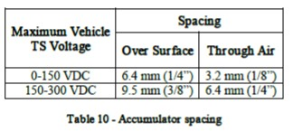

*FH-2016 Rev - Inspectors Reference Page 16 of 16*

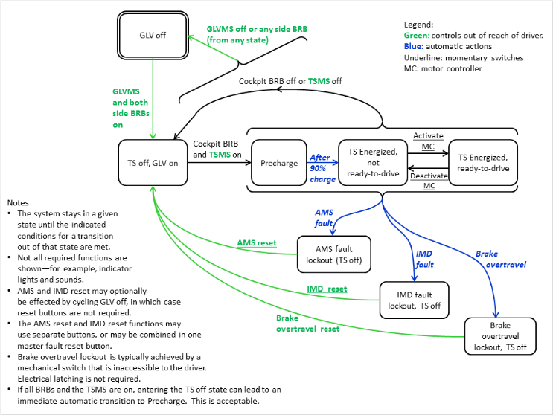

Figure - FSM for TSI

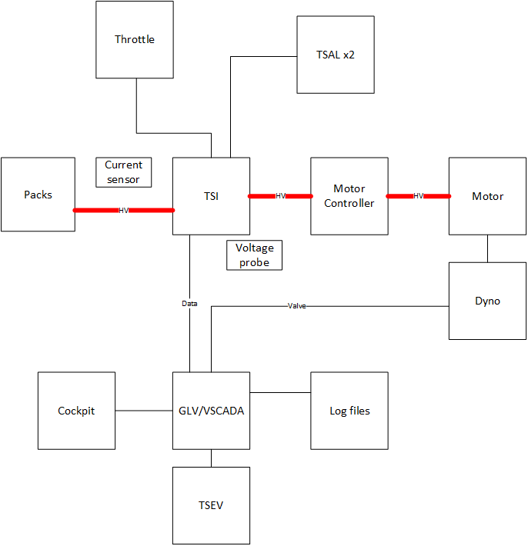

Figure - ATP-01 block diagram

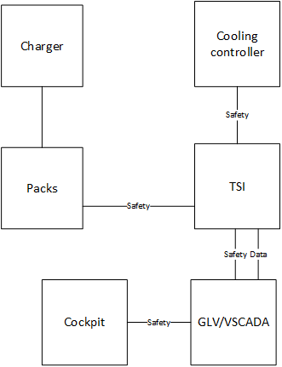

Figure - ATP-02 block diagram

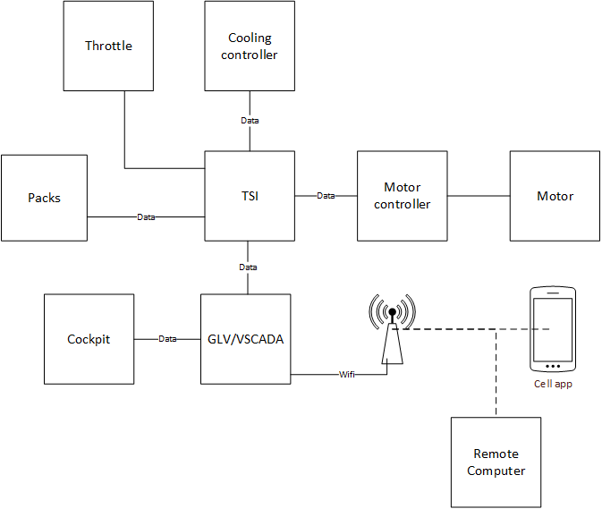

Figure - ATP-03 block diagram

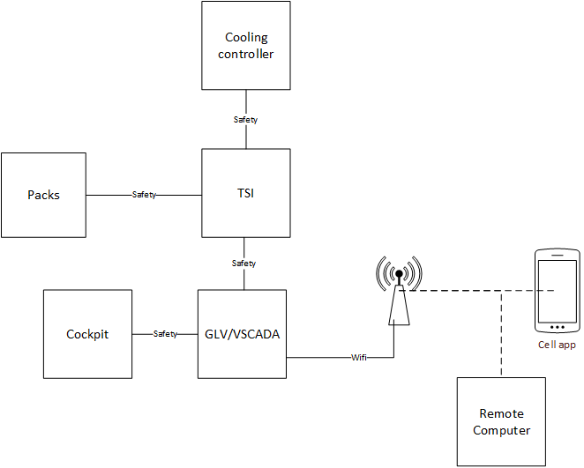

Figure - ATP-04 block diagram